UNITED STATES
SECURITIES AND EXCHANGE COMMISSION
WASHINGTON, D.C. 20549

FORM 6-K

REPORT OF FOREIGN PRIVATE ISSUER
PURSUANT TO RULE 13a-16 OR 15d-16
UNDER THE SECURITIES EXCHANGE ACT OF 1934

For the Month of August 2026

Commission File Number: 001-38097

ARGENX SE
(Translation of registrant’s name into English)

Laarderhoogtweg 25
1101 EB Amsterdam, the Netherlands
(Address of principal executive offices)

Indicate by check mark whether the registrant files or will file annual reports under cover of Form 20-F or Form 40-F.

Form 20-F ☒ Form 40-F ☐

Indicate by check mark if the registrant is submitting the Form 6-K in paper as permitted by Regulation S-T Rule 101(b)(1): ☐

Indicate by check mark if the registrant is submitting the Form 6-K in paper as permitted by Regulation S-T Rule 101(b)(7): ☐

EXPLANATORY NOTE

On August 17, 2026, argenx SE (the “Company”) issued a press release and an investor presentation, copies of which are attached hereto as Exhibits 99.1 and 99.2, respectively, and are incorporated by reference herein.

The information contained in this Current Report on Form 6-K, including Exhibit 99.1, shall be deemed to be incorporated by reference into the Company’s Registration Statements on Forms S-8 (File Nos. 333-225375, 333-258253, 333-274721, and 333-292200), and to be part thereof from the date on which this Current Report on Form 6-K is filed, to the extent not superseded by documents or reports subsequently filed or furnished.

Exhibit |  | Description
99.1 |  | Press Release August 17, 2026
99.2 |  | Investor Presentation dated August 17, 2026

SIGNATURES

Pursuant to the requirements of the Securities Exchange Act of 1934, the registrant has duly caused this report to be signed on its behalf by the undersigned, thereunto duly authorized.

 | ARGENX SE
Date: August 17, 2026 | By: | /s/ Hemamalini (Malini) Moorthy
 |  | Name: Hemamalini (Malini) Moorthy
 |  | Title: General Counsel

Exhibit 99.1



argenx Announces Positive Topline Results from Phase 3 ALKIVIA Trial of
Efgartigimod in Autoimmune Myositis

 | • | Study met primary endpoint of mean Total Improvement Score (TIS) at Week 52 in the combined study population of IMNM and DM patients (p=0.0011)

 | • | Patient improvements observed early and sustained throughout study; consistent treatment effect across IMNM and DM

 | • | First Phase 3 study to show statistically significant and clinically meaningful improvements in disease activity in IMNM, a subtype with no approved therapy

 | • | argenx to host a conference call on August 17th at 2:30 PM CET/ 8:30 AM ET

August 17, 2026, 7:00 AM CET

Amsterdam, the Netherlands – argenx SE (Euronext & Nasdaq: ARGX), a global immunology innovation company, today announced positive topline results from the ALKIVIA Phase 3 study evaluating VYVGART® Hytrulo (efgartigimod alfa and hyaluronidase-qvfc) in adults with autoimmune myositis.

Study met its primary endpoint (p=0.0011)

 | • | In the combined immune-mediated necrotizing myopathy (IMNM) and dermatomyositis (DM) population, patients treated with efgartigimod demonstrated statistically significant and clinically meaningful 15.4-point greater improvement in mean Total Improvement Score (TIS) at Week 52 versus placebo (47.95 vs 32.56).

Rapid and sustained treatment benefit

 | • | In the combined population, patients treated with efgartigimod consistently showed improvements over placebo starting at Week 4 that were statistically significant and sustained through the full year of treatment, even with steroid tapering.

Magnitude of clinical improvement consistent across both IMNM and DM

 | • | In prespecified subtype analyses, the primary endpoint of Mean TIS at 52 weeks was also met in IMNM patients treated with efgartigimod (p=0.0048), with a 14.8-point greater improvement over placebo (45.05 vs 30.24). In DM, a similar clinically meaningful improvement of 14.5 points (p=0.1093) was observed (51.51 vs 36.96), though statistical significance was not reached in this smaller cohort.

Clinical impact observed in both muscle and skin measures

 | • | In both IMNM and DM, all six core set measures of TIS contributed to the treatment effect, each favoring efgartigimod over placebo, spanning muscle strength, everyday physical function, and disease activity beyond the muscle. In DM, improvement in skin disease activity was also observed.

Efgartigimod was well-tolerated by patients in the ALKIVIA study. The observed safety profile was consistent with prior studies and the known safety profile of efgartigimod.

“For decades, people living with autoimmune myositis have relied on corticosteroids and broad immunosuppression, and those with IMNM have had no approved option at all. These are the first Phase 3 results to show that precision targeting of FcRn with efgartigimod can deliver meaningful benefit in this disease,” said Luc Truyen, M.D., Ph.D., Chief Medical Officer at argenx. “The patient response to efgartigimod was durable and multidimensional: separation from placebo emerged early and held through a full year of treatment, with a treatment effect of comparable magnitude in IMNM and DM. This confirms that pathogenic IgG autoantibodies are key drivers of autoimmune myositis. We are grateful to the patients, caregivers, and investigators who made this pioneering study possible.”

“For people living with myositis, the goal is straightforward: regain strength and function, and get off long-term steroids. Until now we have had limited targeted therapies to offer patients,” said Rohit Aggarwal, M.D., M.S., Professor of Medicine and Co-Director of the Myositis Center at the University of Pittsburgh, and an ALKIVIA investigator. “IMNM is the most refractory form of this disease and many of these patients carry irreversible muscle damage, which makes meaningful improvement genuinely difficult to achieve. That is what makes these results so compelling and groundbreaking. In DM, the magnitude of improvement was comparable – and for a community where treatment options remain limited and the burden of chronic steroids is just as heavy, that matters. Together, these results tell us that reducing pathogenic autoantibodies is clinically meaningful and a major step forward for patients who are in need of a targeted treatment.”

Detailed results from the ALKIVIA study will be presented at an upcoming medical meeting.

Efgartigimod continues to be evaluated as a potential treatment in other autoimmune rheumatologic diseases, including Sjögren’s disease and systemic sclerosis.

argenx Conference Call Details

argenx will host an investor conference call and webcast today at 2:30 PM CET/ 8:30 AM ET to discuss the results. A webcast of the conference call may be accessed on the Investors section of the argenx website at argenx.com/investors.

Participants can access the conference call by dialing 800-590-8290 (United States and Canada) or 240-690-8800 (International). Country specific dial-in numbers are listed below:

Belgium | 32 2290 4635
France | 33 172 001717
Netherlands | 31 20 795 2683
United Kingdom | 44 203 393 1560
Japan | 81 3 4520 9761
Switzerland | 41 43 210 51 68

Use the access code 3810049 to join the call. Please dial in 15 minutes prior to the live call.

A replay of the webcast will be available on the argenx website.

About the ALKIVIA Study

The ALKIVIA study was a global, randomized, double-blind, placebo-controlled, multicenter, operationally seamless Phase 2/3 study of efgartigimod SC for the treatment of autoimmune myositis across IMNM, DM and PM. The ALKIVIA study enrolled 264 patients who had active disease and were on background treatment. Participants were randomized (1:1) to receive weekly injections of efgartigimod PH20 SC or matched to placebo PH20 SC. The study was conducted in two phases, with an analysis of the Phase 2 portion of the clinical trial after the first 89 patients completed the study, followed by Phase 3. The Phase 3 study enrolled 175 patients and included a protocol-mandated corticosteroid taper throughout the study. The primary endpoint of Phase 3 was the mean Total Improvement Score (TIS) at the end of the treatment period of 52 weeks of all treated patients compared to placebo. Prespecified analyses evaluated the combined IMNM and DM population and each subtype separately.

ALKIVIA was conducted globally across North America, Europe, the Middle East, and Asia-Pacific, including China and Japan. argenx has an exclusive license agreement with Zai Lab for the development and commercialization of VYVGART and VYVGART Hytrulo in Greater China. Through this agreement, Zai Lab recruited Chinese patients into the ALKIVIA trial.

About Autoimmune Myositis

Autoimmune myositis is a heterogenous disease spectrum with autoimmune-mediated pathophysiology, characterized by chronic inflammation and progressive muscle weakness, and in some subtypes by skin involvement and other extramuscular manifestations. Proximal muscle weakness is a hallmark clinical feature across subtypes.

Approximately 100,000 people in the United States live with autoimmune myositis, including approximately 20,000 with IMNM and approximately 40,000 with DM. Up to 80 percent of patients report long-term disability despite treatment. There are currently no targeted treatments available, and care and treatment relies primarily on corticosteroids and broad immunosuppressants, which are associated with significant cumulative toxicity, including metabolic, cardiovascular, musculoskeletal and infectious complications.

Advances in the understanding of autoimmune myositis biology have highlighted the central role of antibody-mediated immunity, with pathogenic IgG autoantibodies contributing to muscle fiber damage and extramuscular manifestations across subtypes. FcRn maintains circulating IgG levels by recycling IgG antibodies, including pathogenic autoantibodies. Efgartigimod is designed to selectively block FcRn, reducing pathogenic IgG autoantibodies while preserving other aspects of immune function.

About VYVGART

VYVGART® (efgartigimod alfa fcab) is a first-in-class human IgG1 antibody fragment that binds to the neonatal Fc receptor (FcRn), resulting in the reduction of circulating IgG autoantibodies. VYVGART Hytrulo® is a subcutaneous combination of efgartigimod alfa (VYVGART) and recombinant human hyaluronidase PH20 (rHuPH20), Halozyme’s ENHANZE® drug delivery technology to facilitate subcutaneous injection delivery of biologics. VYVGART is approved for generalized myasthenia gravis (gMG) and immune thrombocytopenia (Japan only). VYVGART Hytrulo is approved for gMG and chronic inflammatory demyelinating polyneuropathy (CIDP). VYVGART Hytrulo may be marketed under different proprietary names in other regions.

About argenx

argenx is a global immunology innovation company committed to improving the lives of people suffering from severe autoimmune diseases. Partnering with leading academic researchers through its Immunology Innovation Program (IIP), argenx aims to translate immunology breakthroughs into a world-class portfolio of novel antibody-based medicines. argenx developed and is commercializing the first approved neonatal Fc receptor (FcRn) blocker and is evaluating its broad potential in multiple serious autoimmune diseases while advancing several earlier stage experimental medicines within its therapeutic franchises. For more information, visit www.argenx.com and follow us on LinkedIn, Instagram, Facebook, and YouTube.

This press release contains inside information within the meaning of Article 7(1) of the EU Market Abuse Regulation (Regulation 596/2014).

Media Contact
Colin McBean
cmcbean@argenx.com

Investor Contact
Alexandra Roy
aroy@argenx.com

Forward-Looking Statements

The contents of this press release include statements that are, or may be deemed to be, “forward-looking statements.” These forward-looking statements generally can be identified by the use of forward-looking words, such as “aim”, “anticipate”, “aspire”, “believe”, “can”, “continue”, “could”, “estimate”, “expect”, “entail”, “forecast”, “future”, “goals”, “hope”, “intend”, “is designed to”, “likely”, “may”, “might”, “objective”, “plan”, “possible”, “potential”, “pursue”, “project”, “predict”, “seek”, “should”, “strategy”, “target”, “will” and other words and terms of similar meaning and expression, including in connection with any discussion of future operating or financial performance. By their nature, forward-looking statements involve risks and uncertainties and readers are cautioned that any such forward-looking statements are not guarantees of future performance. argenx’s actual results may differ materially from those predicted by the forward-looking statements as a result of various important factors, including but not limited to, the results of argenx’s clinical trials; uncertainties associated with the development of novel drug therapies; preclinical and clinical trial and product development risks and setbacks; interpretation of argenx’s clinical trial data by regulatory authorities and argenx’s ability to obtain regulatory approval; the risk that early stage clinical trials may not be predictive of results in later stage or large scale clinical trials; the occurrence of adverse safety events or participant dropouts; the acceptance of its products and product candidates by its patients as safe, effective, and cost-effective; the impact of governmental laws and regulations, including tariffs, export controls, sanctions and other regulations on its business; the impact of healthcare regulations, including rules on reimbursement for argenx’s products; competition in drug discovery, development and commercialization efforts; its reliance on third-party suppliers, service providers and manufacturers; and instability and conflicts in the regions in which the company has suppliers or markets for its products. A further list and description of these and other risks, uncertainties, and factors that could cause actual results to differ materially from those referred to in the forward-looking statements can be found in argenx’s U.S. Securities and Exchange Commission (SEC) filings and reports, including in argenx’s most recent annual report on Form 20-F filed with the SEC as well as subsequent filings and reports filed by argenx with the SEC. Given these risks and uncertainties, the reader is advised not to place undue reliance on such forward-looking statements. These forward-looking statements speak only as of the date of publication of this press release. argenx undertakes no obligation to publicly update or revise the information in this press release, including any forward-looking statements, except as may be required by law.

Exhibit 99.2
 |  | ALKIVIA Study Topline Results August 17, 2026
 | 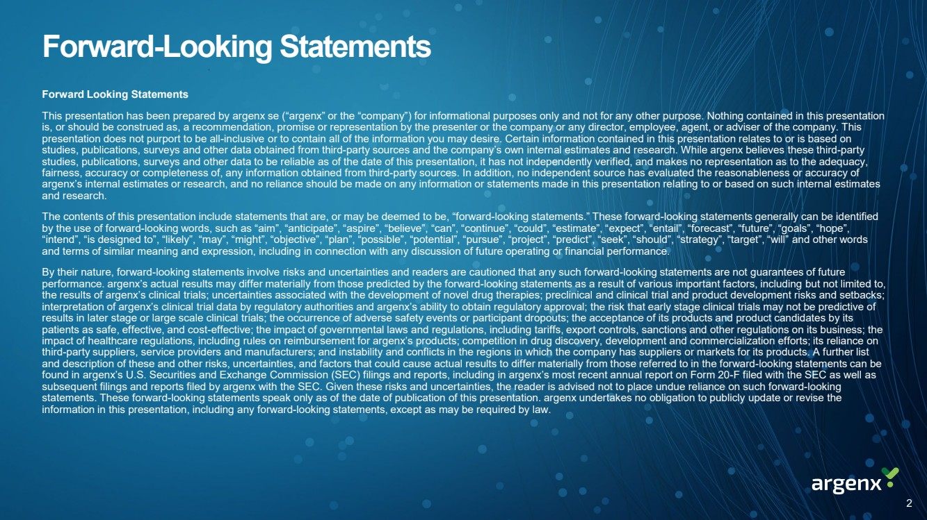 | Forward-Looking Statements Forward Looking Statements This presentation has been prepared by argenx se (“argenx” or the “company”) for informational purposes only and not for any other purpose. Nothing contained in this presentation is, or should be construed as, a recommendation, promise or representation by the presenter or the company or any director, employee, agent, or adviser of the company. This presentation does not purport to be all-inclusive or to contain all of the information you may desire. Certain information contained in this presentation relates to or is based on studies, publications, surveys and other data obtained from third-party sources and the company’s own internal estimates and research. While argenx believes these third-party studies, publications, surveys and other data to be reliable as of the date of this presentation, it has not independently verified, and makes no representation as to the adequacy, fairness, accuracy or completeness of, any information obtained from third-party sources. In addition, no independent source has evaluated the reasonableness or accuracy of argenx’s internal estimates or research, and no reliance should be made on any information or statements made in this presentation relating to or based on such internal estimates and research. The contents of this presentation include statements that are, or may be deemed to be, “forward-looking statements.” These forward-looking statements generally can be identified by the use of forward-looking words, such as “aim”, “anticipate”, “aspire”, “believe”, “can”, “continue”, “could”, “estimate”, “expect”, “entail”, “forecast”, “future”, “goals”, “hope”, “intend”, “is designed to”, “likely”, “may”, “might”, “objective”, “plan”, “possible”, “potential”, “pursue”, “project”, “predict”, “seek”, “should”, “strategy”, “target”, “will” and other words and terms of similar meaning and expression, including in connection with any discussion of future operating or financial performance. By their nature, forward-looking statements involve risks and uncertainties and readers are cautioned that any such forward-looking statements are not guarantees of future performance. argenx’s actual results may differ materially from those predicted by the forward-looking statements as a result of various important factors, including but not limited to, the results of argenx’s clinical trials; uncertainties associated with the development of novel drug therapies; preclinical and clinical trial and product development risks and setbacks; interpretation of argenx’s clinical trial data by regulatory authorities and argenx’s ability to obtain regulatory approval; the risk that early stage clinical trials may not be predictive of results in later stage or large scale clinical trials; the occurrence of adverse safety events or participant dropouts; the acceptance of its products and product candidates by its patients as safe, effective, and cost-effective; the impact of governmental laws and regulations, including tariffs, export controls, sanctions and other regulations on its business; the impact of healthcare regulations, including rules on reimbursement for argenx’s products; competition in drug discovery, development and commercialization efforts; its reliance on third-party suppliers, service providers and manufacturers; and instability and conflicts in the regions in which the company has suppliers or markets for its products. A further list and description of these and other risks, uncertainties, and factors that could cause actual results to differ materially from those referred to in the forward-looking statements can be found in argenx’s U.S. Securities and Exchange Commission (SEC) filings and reports, including in argenx’s most recent annual report on Form 20-F filed with the SEC as well as subsequent filings and reports filed by argenx with the SEC. Given these risks and uncertainties, the reader is advised not to place undue reliance on such forward-looking statements. These forward-looking statements speak only as of the date of publication of this presentation. argenx undertakes no obligation to publicly update or revise the information in this presentation, including any forward-looking statements, except as may be required by law. 2
 | 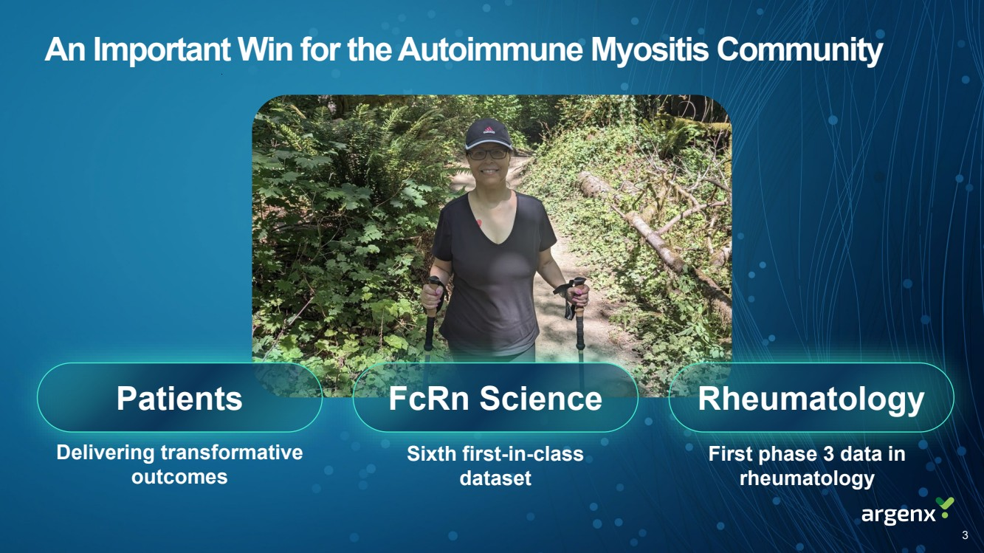 | An Important Win for the Autoimmune Myositis Community Patients FcRn Science Rheumatology Delivering transformative outcomes Sixth first-in-class dataset First phase 3 data in rheumatology 3
 | 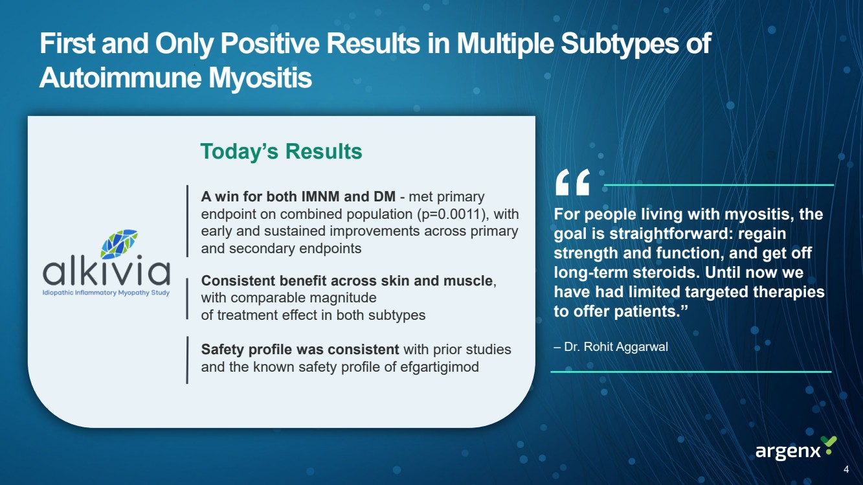 | A win for both IMNM and DM - met primary endpoint on combined population (p=0.0011), with early and sustained improvements across primary and secondary endpoints Consistent benefit across skin and muscle, with comparable magnitude of treatment effect in both subtypes Safety profile was consistent with prior studies and the known safety profile of efgartigimod First and Only Positive Results in Multiple Subtypes of Autoimmune Myositis Today’s Results For people living with myositis, the goal is straightforward: regain strength and function, and get off long-term steroids. Until now we have had limited targeted therapies to offer patients.” “ – Dr. Rohit Aggarwal 4
 | 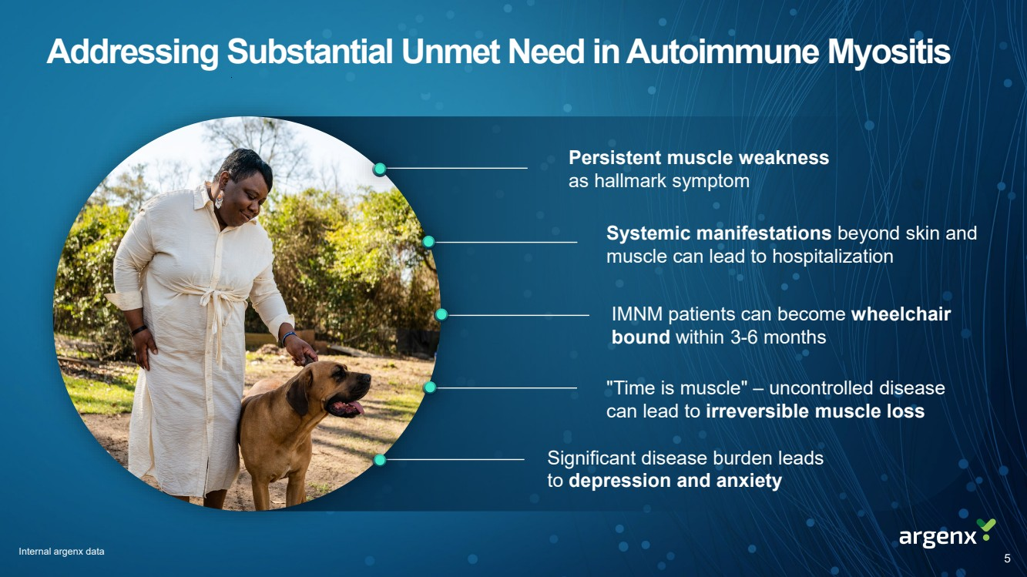 | Addressing Substantial Unmet Need in Autoimmune Myositis Internal argenx data IMNM patients can become wheelchair bound within 3-6 months Persistent muscle weakness as hallmark symptom Systemic manifestations beyond skin and muscle can lead to hospitalization "Time is muscle" – uncontrolled disease can lead to irreversible muscle loss Significant disease burden leads to depression and anxiety 5
 | 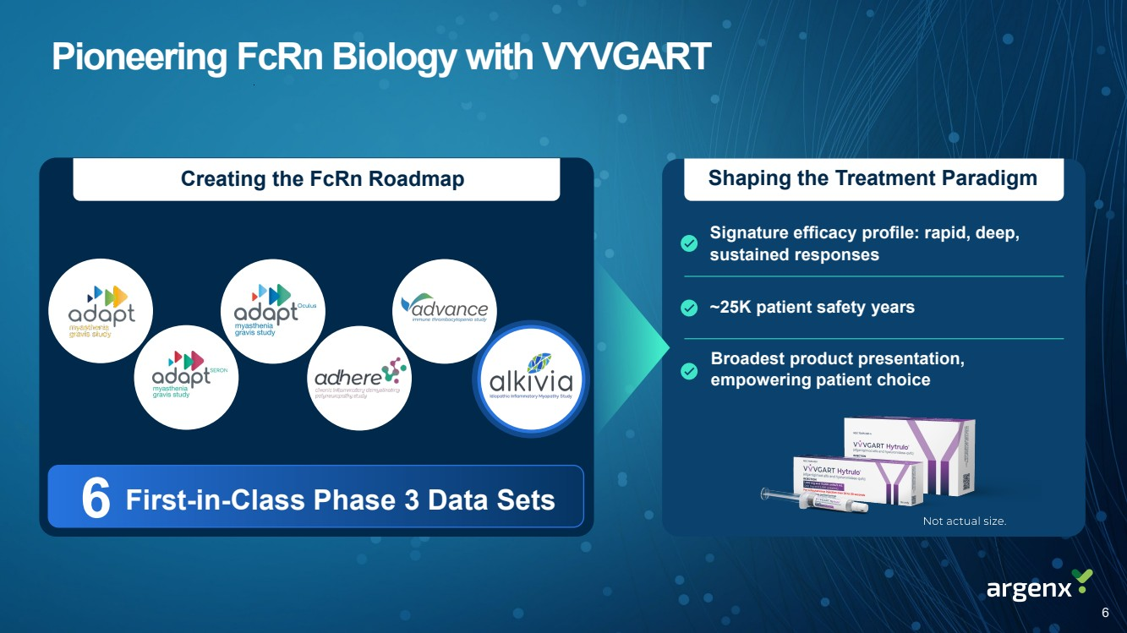 | Pioneering FcRn Biology with VYVGART Shaping the Treatment Paradigm Signature efficacy profile: rapid, deep, sustained responses Broadest product presentation, empowering patient choice ~25K patient safety years Creating the FcRn Roadmap 6 First-in-Class Phase 3 Data Sets 6
 | 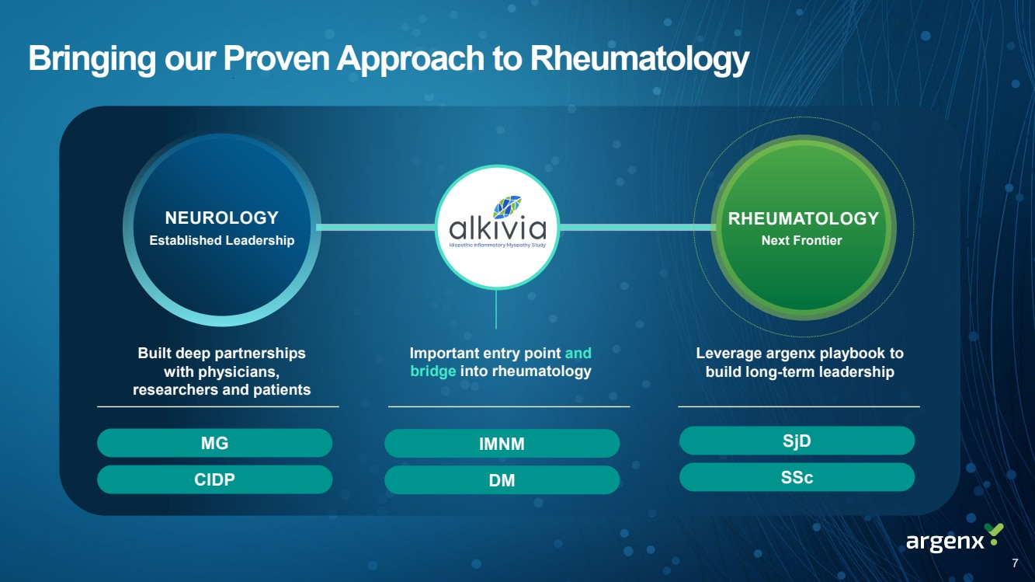 | Bringing our Proven Approach to Rheumatology NEUROLOGY Established Leadership RHEUMATOLOGY Next Frontier Built deep partnerships with physicians, researchers and patients Leverage argenx playbook to build long-term leadership SSc SjD Important entry point and bridge into rheumatology 7 IMNM DM MG CIDP
 |  | This is an invisible disease. You think you’re the only one, but once you start talking to people with similar experiences it’s amazing. Melissa, living with autoimmune myositis “ 8
 | 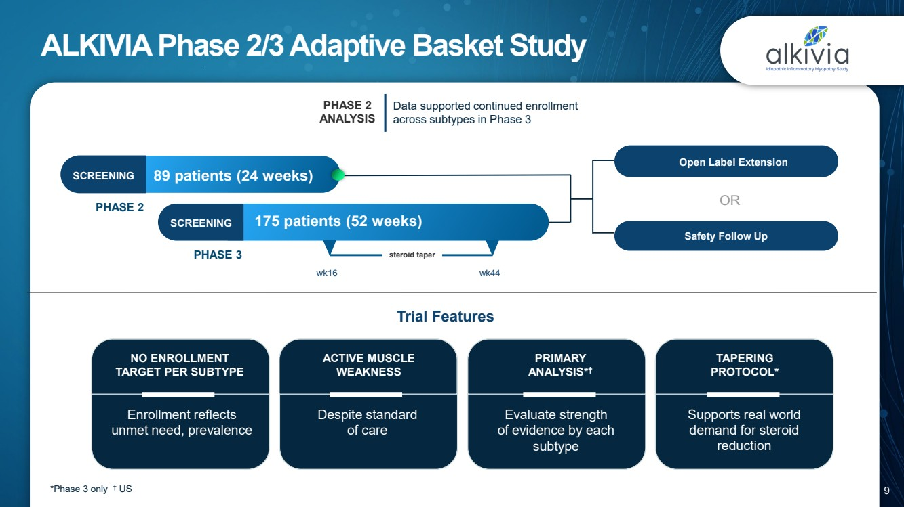 | ALKIVIA Phase 2/3 Adaptive Basket Study 89 patients (24 weeks) SCREENING 175 patients (52 weeks) steroid taper wk16 wk44 Open Label Extension - OR PHASE 2 ANALYSIS SCREENING PHASE 2 PHASE 3 Data supported continued enrollment across subtypes in Phase 3 Safety Follow Up Enrollment reflects unmet need, prevalence NO ENROLLMENT TARGET PER SUBTYPE ACTIVE MUSCLE WEAKNESS Trial Features *Phase 3 only † US PRIMARY ANALYSIS*† Evaluate strength of evidence by each subtype TAPERING PROTOCOL* Supports real world demand for steroid reduction Despite standard of care 9
 | 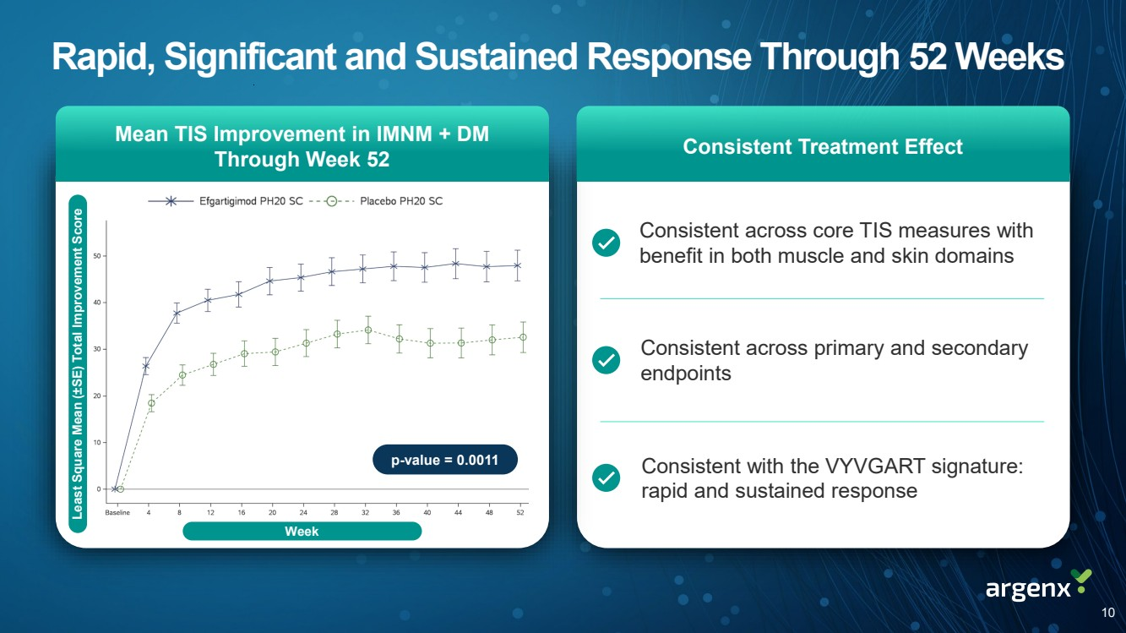 | Rapid, Significant and Sustained Response Through 52 Weeks Consistent across primary and secondary endpoints Consistent across core TIS measures with benefit in both muscle and skin domains Consistent with the VYVGART signature: rapid and sustained response Consistent Treatment Effect Mean TIS Improvement in IMNM + DM Through Week 52 Least Square Mean ( ±SE) Total Improvement Score Week 10 p-value = 0.0011
 | 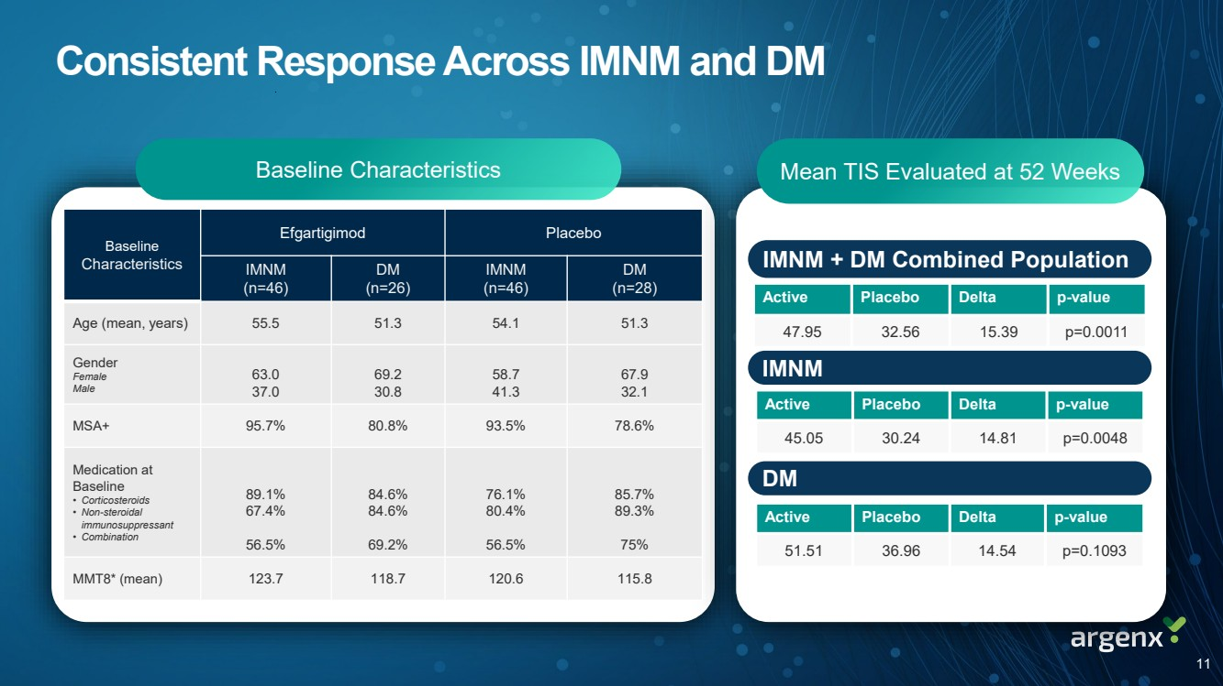 | Consistent Response Across IMNM and DM Baseline Characteristics Mean TIS Evaluated at 52 Weeks IMNM DM Active Placebo Delta p-value 45.05 30.24 14.81 p=0.0048 Active Placebo Delta p-value 51.51 36.96 14.54 p=0.1093 IMNM + DM Combined Population Active Placebo Delta p-value 47.95 32.56 15.39 p=0.0011 Baseline Characteristics Efgartigimod Placebo IMNM (n=46) DM (n=26) IMNM (n=46) DM (n=28) Age (mean, years) 55.5 51.3 54.1 51.3 Gender Female Male 63.0 37.0 69.2 30.8 58.7 41.3 67.9 32.1 MSA+ 95.7% 80.8% 93.5% 78.6% Medication at Baseline • Corticosteroids • Non-steroidal immunosuppressant • Combination 89.1% 67.4% 56.5% 84.6% 84.6% 69.2% 76.1% 80.4% 56.5% 85.7% 89.3% 75% MMT8* (mean) 123.7 118.7 120.6 115.8 11
 | 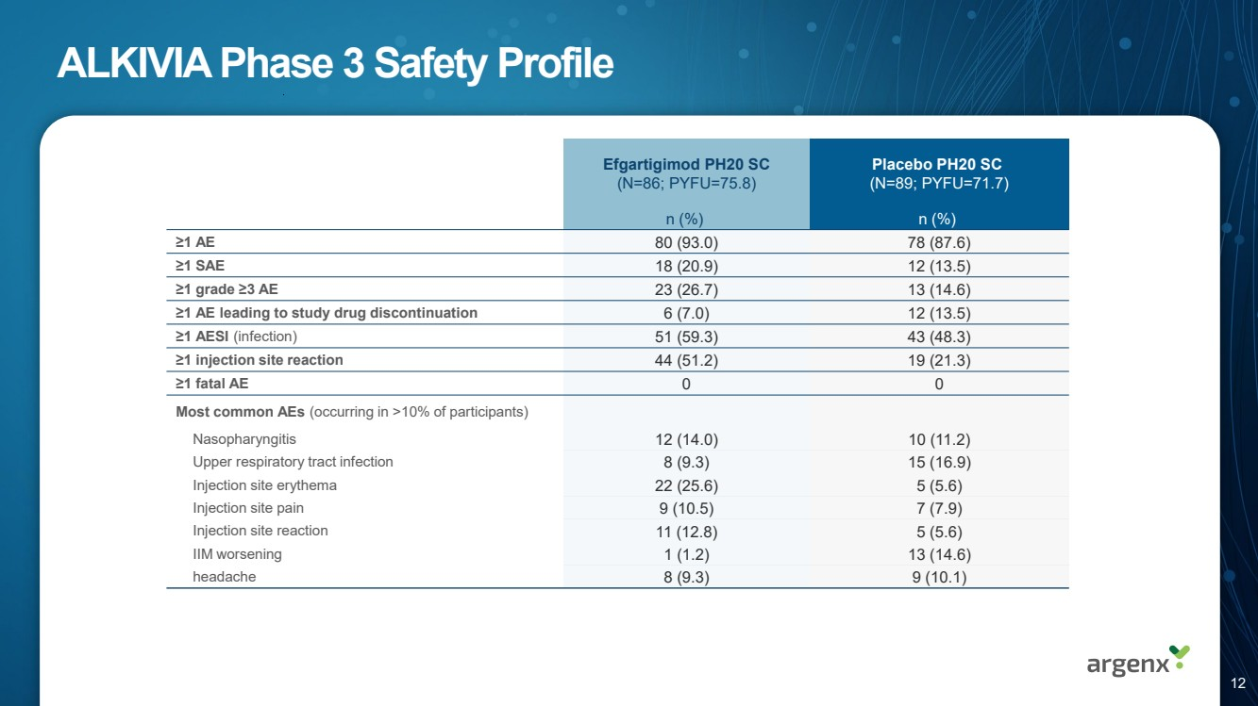 | ALKIVIA Phase 3 Safety Profile Efgartigimod PH20 SC (N=86; PYFU=75.8) Placebo PH20 SC (N=89; PYFU=71.7) n (%) n (%) ≥1 AE 80 (93.0) 78 (87.6) ≥1 SAE 18 (20.9) 12 (13.5) ≥1 grade ≥3 AE 23 (26.7) 13 (14.6) ≥1 AE leading to study drug discontinuation 6 (7.0) 12 (13.5) ≥1 AESI (infection) 51 (59.3) 43 (48.3) ≥1 injection site reaction 44 (51.2) 19 (21.3) ≥1 fatal AE 0 0 Most common AEs (occurring in >10% of participants) Nasopharyngitis 12 (14.0) 10 (11.2) Upper respiratory tract infection 8 (9.3) 15 (16.9) Injection site erythema 22 (25.6) 5 (5.6) Injection site pain 9 (10.5) 7 (7.9) Injection site reaction 11 (12.8) 5 (5.6) IIM worsening 1 (1.2) 13 (14.6) headache 8 (9.3) 9 (10.1) 12
 | 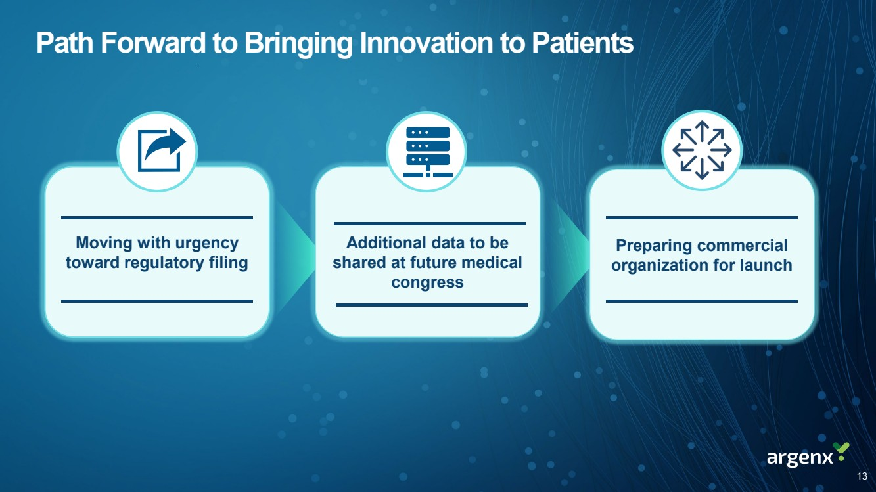 | 13 Path Forward to Bringing Innovation to Patients Moving with urgency toward regulatory filing Additional data to be shared at future medical congress Preparing commercial organization for launch
 | 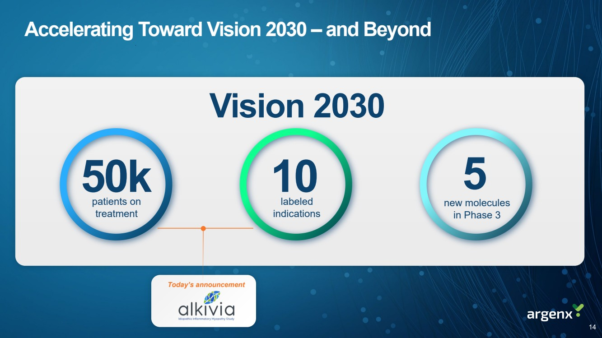 | 50k 10 5 patients on treatment labeled indications new molecules in Phase 3 Vision 2030 Today’s announcement 14 Accelerating Toward Vision 2030 – and Beyond
 | 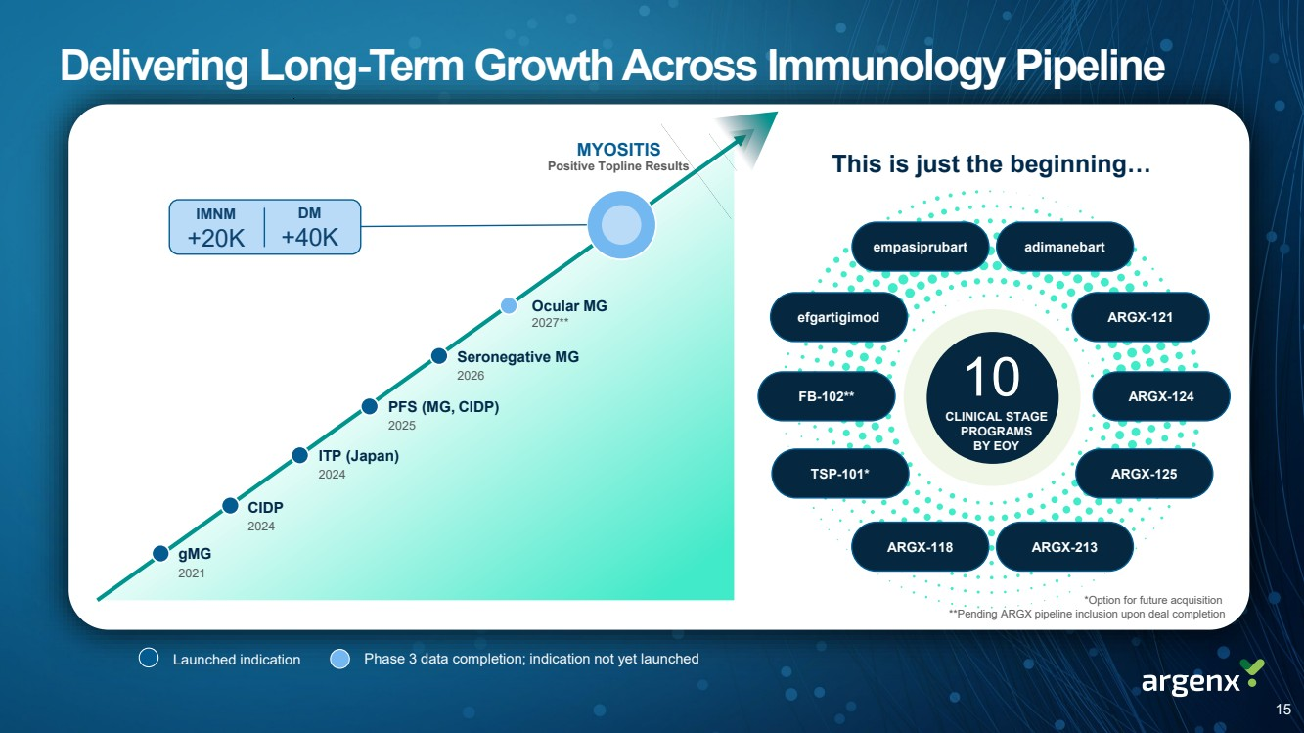 | Delivering Long-Term Growth Across Immunology Pipeline gMG 2021 CIDP 2024 ITP (Japan) 2024 PFS (MG, CIDP) 2025 Seronegative MG 2026 MYOSITIS Ocular MG 2027** Positive Topline Results This is just the beginning… efgartigimod empasiprubart ARGX-121 ARGX-124 ARGX-125 ARGX-213 TSP-101* FB-102** ARGX-118 adimanebart Launched indication Phase 3 data completion; indication not yet launched IMNM +20K DM +40K 10 CLINICAL STAGE PROGRAMS BY EOY *Option for future acquisition **Pending ARGX pipeline inclusion upon deal completion 15

