UNITED STATES
SECURITIES AND EXCHANGE COMMISSION
WASHINGTON, D.C. 20549

FORM 6-K

REPORT OF FOREIGN PRIVATE ISSUER
PURSUANT TO RULE 13a-16 OR 15d-16
UNDER THE SECURITIES EXCHANGE ACT OF 1934

For the Month of July 2026

Commission File Number: 001-38097

ARGENX SE
(Translation of registrant’s name into English)
Laarderhoogtweg 25
1101 EB Amsterdam, the Netherlands.
(Address of principal executive offices)
Indicate by check mark whether the registrant files or will file annual reports under cover of Form 20-F or Form 40-F.

Form 20-F ⌧ Form 40-F ☐

Indicate by check mark if the registrant is submitting the Form 6-K in paper as permitted by Regulation S-T Rule 101(b) (1): ☐
Indicate by check mark if the registrant is submitting the Form 6-K in paper as permitted by Regulation S-T Rule 101(b)(7): ☐

argenx SE
On July 23, 2026, argenx SE (the “Company) issued a press release, unaudited first half-year financial results for 2026, which are further described in an Unaudited Interim Report for the Six Months Ended June 30, 2026, and an investor presentation copies of which are attached hereto as Exhibits 99.1, 99.2 and 99.3, respectively, and are incorporated by reference herein.

The information contained in this Current Report on Form 6-K, including Exhibit 99.1 and Exhibit 99.2, shall be deemed to be incorporated by reference into the Company’s Registration Statements on Form S-8 (File Nos. 333-225375, 333-258253, 333-274721, and 333-292200), and to be part thereof from the date on which this Current Report on Form 6-K is filed, to the extent not superseded by documents or reports subsequently filed or furnished.

EXHIBITS
Exhibit |  |  |  |  |  | Description
99.1 |  |  |  |  |  | Press Release dated July 23, 2026
99.2 |  |  |  |  |  | Unaudited Interim Report for the Six Months Ended June 30, 2026
99.3 |  |  |  |  |  | Investor Presentation dated July 23, 2026
101.INS |  |  |  |  |  | Inline XBRL Instance Document
101.SCH |  |  |  |  |  | Inline XBRL Taxonomy Extension Schema Document
101.CAL |  |  |  |  |  | Inline XBRL Taxonomy Extension Calculation Linkbase Document
101.DEF |  |  |  |  |  | Inline XBRL Taxonomy Extension Definition Linkbase Document
101.LAB |  |  |  |  |  | Inline XBRL Taxonomy Extension Label Linkbase Document
101.PRE |  |  |  |  |  | Inline XBRL Taxonomy Extension Presentation Linkbase Document
104 |  |  |  |  |  | Cover Page Interactive Data File (formatted as Inline XBRL)

SIGNATURES

Pursuant to the requirements of the Securities Exchange Act of 1934, the registrant has duly caused this report to be signed on its behalf by the undersigned, thereunto duly authorized.
 |  |  |  |  |  | ARGENX SE
Date: July 23, 2026 |  |  | By: |  |  | /s/ Hemamalini (Malini) Moorthy
 |  |  |  |  |  | Hemamalini (Malini) Moorthy
 |  |  |  |  |  | General Counsel



argenx Reports Half Year 2026 Financial Results and Provides Second Quarter Business Update
Strong second quarter performance with $1.5 billion in global product net sales, representing 60% year-over-year growth and 17% quarter-over-quarter growth

Successfully launched VYVGART and VYVGART Hytrulo in anti-AChR antibody negative (“seronegative”) gMG, expanding patient reach to all gMG serotypes

Registrational autoimmune myositis study readout on track for 3Q26, marking a key milestone for VYVGART expansion into rheumatology

Registrational MMN study readout for empasiprubart on track for 4Q26, supporting a second pipeline-in-a-product opportunity

Management to host conference call today at 2:30 PM CET (8:30 AM ET)

July 23, 2026 7:00 AM CET

Amsterdam, the Netherlands – argenx SE (Euronext & Nasdaq: ARGX), a global immunology innovation company, today announced its half year 2026 results and provided a second quarter business update.

“Our strong second quarter performance reflects continued execution of our Vision 2030 strategy and our commitment to accelerate immunology innovation,” said Karen Massey, Chief Executive Officer. “During the quarter, we further strengthened our leadership in FcRn with the launch of the expanded label for VYVGART and VYVGART Hytrulo to now include all gMG serotypes, providing physicians with a single treatment option for the broadest adult gMG patient population. With important registrational study readouts in the second half, as well as continued progress with our early-stage pipeline, we are advancing the next wave of innovation, reinforcing our ambition to build a leading multi-asset immunology company.”
Vision 2030
argenx continues to advance its ‘Vision 2030’ anchored in the ambition to treat 50,000 patients globally with its medicines, secure 10 labeled indications, and progress five pipeline candidates into registrational development by 2030.

Expanding global VYVGART opportunity and shaping the long-term future of FcRn

VYVGART® (IV: efgartigimod alfa-fcab; SC: efgartigimod alfa and hyaluronidase-qvfc) is the first-and-only approved treatment for all serotypes of adult patients living with generalized myasthenia gravis (gMG). It is also approved for chronic inflammatory demyelinating polyneuropathy (CIDP) globally, and primary immune thrombocytopenia (ITP) in Japan. As the leading targeted biologic in MG and CIDP, argenx is progressing multiple label expansions while building the future of FcRn by advancing novel FcRn pipeline candidates and new delivery modalities.

•Generated $1.5 billion in global product net sales in the second quarter of 2026, representing 17% quarter-over-quarter growth, and a year-over-year increase of 60% or $0.6 billion
•Launched expanded label for VYVGART and VYVGART Hytrulo® in the U.S., which now includes all gMG serotypes (anti-AChR-Ab positive, anti-MuSK-Ab positive, anti-LRP4-Ab positive, and triple seronegative)
•On track with plans to expand VYVGART into ocular myasthenia gravis (oMG) following positive ADAPT OCULUS results
•Topline results from registrational ALKIVIA study (myositis) expected in third quarter of 2026
•Topline results from registrational ADVANCE-NEXT study (primary ITP) expected in first half of 2027
•Topline results from registrational UNITY study (Sjogren’s disease) expected in second half of 2027

•Registrational study in Graves’ disease (GD) ongoing, expanding development into thyroid-driven autoimmunity
•VYVGART SC autoinjector positioned to launch in 2027 for all approved indications
•Progressing two future FcRn molecules: ARGX-213, designed for monthly dosing, is Phase 3 ready, and ARGX-124 is expected to complete Phase 1 evaluation by end of 2026
Advancing empasiprubart, argenx’s second pipeline-in-a-product opportunity

Empasiprubart (anti-C2) is argenx’s second pipeline-in-a-product opportunity and is being evaluated in registrational studies in multifocal motor neuropathy (MMN) and CIDP, and in a combination study with VYVGART in gMG.

•Topline results from registrational EMPASSION study (MMN) expected in fourth quarter of 2026
•Topline results from registrational EMVIGORATE and EMNERGIZE studies (CIDP) expected in second half of 2027
•Data from Phase 2 VARVARA study (delayed graft function, DGF) support further evaluation of empasiprubart in transplant setting based on signal at 52 weeks
•Advancing ADAPT-Forward combination study, evaluating empasiprubart as a potential add-on therapy to efgartigimod in gMG

Delivering next wave of immunology innovation

By the end of 2026, argenx expects to have ten molecules in clinical development across its immunology pipeline, including adimanebart (MuSK agonist), ARGX-121 (anti-IgA), ARGX-109 (anti-IL-6) and additional candidates emerging from the Immunology Innovation Program. Together, these programs support argenx's goal of building a durable pipeline of differentiated medicines.

•Phase 2 study of adimanebart in spinal muscular atrophy (SMA) ongoing; registrational study in congenital myasthenic syndromes (CMS) expected to begin in 2026
•Phase 2 study of ARGX-121 in IgA nephropathy (IgAN) expected to start in 2026
•First-in-human Phase 1 study of TSP-101 (Fn14 inhibitor) is ongoing
•ARGX-118 (Galectin-10 inhibitor) and ARGX-125 (first-in-class bispecific antibody against an undisclosed target) are on track to enter Phase 1 studies in 2026

SECOND QUARTER 2026 FINANCIAL RESULTS
argenx SE
UNAUDITED CONDENSED CONSOLIDATED INTERIM STATEMENTS OF PROFIT OR LOSS
 |  |  |  |  |  | Three Months Ended |  |  |  |  |  |  |  |  |  |  |  |  |  |  |  |  |  | Six Months Ended
 |  |  |  |  |  | 30 June, |  |  |  |  |  |  |  |  |  |  |  |  |  |  |  |  |  | 30 June,
(in millions of $ except per share data) |  |  |  |  |  | 2026 |  |  |  |  |  |  |  |  | 2025 |  |  |  |  |  |  |  |  | 2026 |  |  |  |  |  |  |  |  |  |  |  | 2025
Product net sales |  |  |  |  |  | $ |  |  | 1,516 |  |  |  |  |  | $ |  |  | 949 |  |  |  |  |  | $ |  |  | 2,813 |  |  |  |  |  | $ |  |  | 1,739
Other operating income |  |  |  |  |  |  |  |  | 26 |  |  |  |  |  |  |  |  | 19 |  |  |  |  |  |  |  |  | 41 |  |  |  |  |  |  |  |  | 36
Total operating income |  |  |  |  |  | $ |  |  | 1,542 |  |  |  |  |  | $ |  |  | 967 |  |  |  |  |  | $ |  |  | 2,854 |  |  |  |  |  | $ |  |  | 1,775
Cost of sales |  |  |  |  |  | $ |  |  | (145) |  |  |  |  |  | $ |  |  | (111) |  |  |  |  |  | $ |  |  | (266) |  |  |  |  |  | $ |  |  | (192)
Research and development expenses* |  |  |  |  |  |  |  |  | (486) |  |  |  |  |  |  |  |  | (330) |  |  |  |  |  |  |  |  | (929) |  |  |  |  |  |  |  |  | (642)
Selling, general and administrative expenses |  |  |  |  |  |  |  |  | (417) |  |  |  |  |  |  |  |  | (325) |  |  |  |  |  |  |  |  | (772) |  |  |  |  |  |  |  |  | (601)
Total operating expenses |  |  |  |  |  | $ |  |  | (1,048) |  |  |  |  |  | $ |  |  | (766) |  |  |  |  |  | $ |  |  | (1,967) |  |  |  |  |  | $ |  |  | (1,435)
Operating profit |  |  |  |  |  | $ |  |  | 494 |  |  |  |  |  | $ |  |  | 201 |  |  |  |  |  | $ |  |  | 887 |  |  |  |  |  | $ |  |  | 340
Financial income |  |  |  |  |  | $ |  |  | 48 |  |  |  |  |  | $ |  |  | 38 |  |  |  |  |  | $ |  |  | 92 |  |  |  |  |  | $ |  |  | 76
Financial expense |  |  |  |  |  |  |  |  | (1) |  |  |  |  |  |  |  |  | (1) |  |  |  |  |  |  |  |  | (2) |  |  |  |  |  |  |  |  | (2)
Exchange (losses)/gains |  |  |  |  |  |  |  |  | (8) |  |  |  |  |  |  |  |  | 49 |  |  |  |  |  |  |  |  | (19) |  |  |  |  |  |  |  |  | 76
Profit for the period before taxes |  |  |  |  |  | $ |  |  | 532 |  |  |  |  |  | $ |  |  | 287 |  |  |  |  |  | $ |  |  | 958 |  |  |  |  |  | $ |  |  | 489
Income tax expense |  |  |  |  |  | $ |  |  | (59) |  |  |  |  |  | $ |  |  | (42) |  |  |  |  |  | $ |  |  | (119) |  |  |  |  |  | $ |  |  | (74)
Profit for the period |  |  |  |  |  | $ |  |  | 472 |  |  |  |  |  | $ |  |  | 245 |  |  |  |  |  | $ |  |  | 838 |  |  |  |  |  | $ |  |  | 415
Profit for the period attributable to:
Owners of the parent |  |  |  |  |  | $ |  |  | 472 |  |  |  |  |  | $ |  |  | 245 |  |  |  |  |  | $ |  |  | 838 |  |  |  |  |  | $ |  |  | 415
Weighted average number of shares used for basic profit per share |  |  |  |  |  |  |  |  | 62,312,606 |  |  |  |  |  |  |  |  | 61,084,250 |  |  |  |  |  |  |  |  | 62,185,445 |  |  |  |  |  |  |  |  | 61,034,202
Basic profit per share (in $) |  |  |  |  |  |  |  |  | 7.58 |  |  |  |  |  |  |  |  | 4.02 |  |  |  |  |  |  |  |  | 13.47 |  |  |  |  |  |  |  |  | 6.80
Weighted average number of shares used for diluted profit per share |  |  |  |  |  |  |  |  | 64,524,979 |  |  |  |  |  |  |  |  | 65,639,446 |  |  |  |  |  |  |  |  | 64,409,488 |  |  |  |  |  |  |  |  | 65,653,007
Diluted profit per share (in $) |  |  |  |  |  |  |  |  | 7.32 |  |  |  |  |  |  |  |  | 3.74 |  |  |  |  |  |  |  |  | 13.00 |  |  |  |  |  |  |  |  | 6.32
*Comparative figures have been aligned with the presentation adopted in the current period, reflecting the combination of research and development expenses and loss from investment in a joint venture.

DETAILS OF THE FINANCIAL RESULTS
Total operating income for the three and six months ended June 30, 2026, was $1.5 billion and $2.9 billion, respectively, compared to $1.0 billion and $1.8 billion, respectively, for the same periods in 2025, and mainly consists of:
•Product net sales of VYVGART for the three and six months ended June 30, 2026, were $1.5 billion and $2.8 billion, respectively, compared to $0.9 billion and $1.7 billion, respectively, for the same periods in 2025.

•Other operating income for the three and six months ended June 30, 2026, was $26 million and $41 million, respectively, compared to $19 million and $36 million, respectively, for the same periods in 2025. The other operating income for the three and six months ended June 30, 2026 and 2025, primarily relates to research and development tax incentives and payroll tax rebates.

Total operating expenses for the three and six months ended June 30, 2026 were $1.0 billion and $2.0 billion, respectively, compared to $0.8 billion and $1.4 billion, respectively, for the same periods in 2025, and mainly consist of:
•Cost of sales for the three and six months ended June 30, 2026, was $145 million and $266 million, respectively, compared to $111 million and $192 million for the same periods in 2025, respectively. The cost of sales was related to the sale of VYVGART.
•Research and development expenses for the three and six months ended June 30, 2026, were $0.5 billion and $0.9 billion, respectively, compared to $0.3 billion and $0.6 billion, respectively, for the same periods in 2025. The research and development expenses mainly relate to advancing efgartigimod, empasiprubart, and adimanebart across multiple registrational studies, plus early-stage pipeline and preclinical programs.
•Selling, general and administrative expenses for the three and six months ended June 30, 2026, were $0.4 billion and $0.8 billion, respectively, compared to $0.3 billion and $0.6 billion, respectively, for the same periods in 2025. The selling, general and administrative expenses mainly relate to professional and marketing fees linked to the global commercialization of the VYVGART franchise, and personnel expenses.
Financial income for the three and six months ended June 30, 2026, was $48 million and $92 million, respectively, compared to $38 million and $76 million, respectively, for the same periods in 2025.

Income tax for the three and six months ended June 30, 2026 and 2025 is detailed below:
 |  |  |  |  |  | Three Months Ended |  |  |  |  |  |  |  |  |  |  |  |  |  |  |  |  |  | Six Months Ended
 |  |  |  |  |  | 30 June, |  |  |  |  |  |  |  |  |  |  |  |  |  |  |  |  |  | 30 June,
(in millions of $) |  |  |  |  |  | 2026 |  |  |  |  |  |  |  |  | 2025 |  |  |  |  |  |  |  |  | 2026 |  |  |  |  |  |  |  |  | 2025
Current tax expense |  |  |  |  |  | $ |  |  | (128) |  |  |  |  |  | $ |  |  | (41) |  |  |  |  |  | $ |  |  | (230) |  |  |  |  |  | $ |  |  | (70)
Deferred tax benefit/(expense) |  |  |  |  |  |  |  |  | 68 |  |  |  |  |  |  |  |  | (1) |  |  |  |  |  |  |  |  | 110 |  |  |  |  |  |  |  |  | (4)
Income tax expense |  |  |  |  |  | $ |  |  | (59) |  |  |  |  |  | $ |  |  | (42) |  |  |  |  |  | $ |  |  | (119) |  |  |  |  |  | $ |  |  | (74)
Profit for the three and six-month periods ended June 30, 2026, was $0.5 billion and $0.8 billion, respectively, compared to a profit of $0.2 billion and $0.4 billion, respectively, for the same periods in 2025. The basic profit per share was $7.58 for the three months ended June 30, 2026, compared to a basic profit per share of $4.02 for the same period in 2025. The basic profit per share was $13.47 for the six months ended June 30, 2026, compared to a basic profit per share of $6.80 for the same period in 2025.
Cash flow from operating activities for the six months ended June 30, 2026 was $0.7 billion compared to a cash flow used in operating activities for the same period in 2025 of $0.4 billion.

Cash, cash equivalents and current financial assets1 consisted of $3.6 billion in cash, cash equivalents and $1.6 billion in current financial assets which totaled $5.2 billion as of June 30, 2026, compared to $3.5 billion in cash and cash equivalents and $0.9 billion in current financial assets which totaled $4.4 billion as of December 31, 2025.

EXPECTED FINANCIAL CALENDAR
•October 22, 2026: Third Quarter 2026 Financial Results and Business Update
•February 25, 2027: Full-year 2026 Financial Results and Fourth Quarter 2026 Business Update

CONFERENCE CALL DETAILS
The half-year 2026 financial results and second quarter business update will be discussed during a conference call and webcast presentation today at 2:30 PM CET/8:30 AM ET. A webcast of the live call may be accessed on the Investors section of the argenx website at argenx.com/investors.

Participants can access the conference call by dialing 800-590-8290 (United States and Canada) or 240-690-8800 (International). Country specific dial-in numbers are listed below:
Belgium |  |  | 32 2290 4635
France |  |  | 33 172 001717
Netherlands |  |  | 31 20 795 2683
United Kingdom |  |  | 44 203 393 1560
Japan |  |  | 81 3 4520 9761
Switzerland |  |  | 41 43 210 51 68
Use the access code 3810049 to join the call. Please dial in 15 minutes prior to the live call.

A replay of the webcast will be available on the argenx website.

About VYVGART
VYVGART® (efgartigimod alfa fcab) is a first-in-class human IgG1 antibody fragment that binds to the neonatal Fc receptor (FcRn), resulting in the reduction of circulating IgG autoantibodies. VYVGART Hytrulo® is a subcutaneous combination of efgartigimod alfa (VYVGART) and recombinant human hyaluronidase PH20 (rHuPH20), Halozyme’s ENHANZE® drug delivery technology to facilitate subcutaneous injection delivery of biologics. VYVGART is approved for generalized myasthenia gravis (gMG) and immune thrombocytopenia (Japan only). VYVGART Hytrulo is approved for gMG and chronic inflammatory demyelinating polyneuropathy (CIDP). VYVGART Hytrulo may be marketed under different proprietary names in other regions.

About argenx
argenx is a global immunology company committed to improving the lives of people suffering from severe autoimmune diseases. Partnering with leading academic researchers through its Immunology Innovation Program (IIP), argenx aims to translate immunology breakthroughs into a world-class portfolio of novel antibody-based medicines. argenx developed and is commercializing the first approved neonatal Fc receptor (FcRn) blocker and is evaluating its broad potential in multiple serious autoimmune diseases while advancing several earlier stage experimental medicines within its therapeutic franchises. For more information, visit www.argenx.com and follow us on LinkedIn, Instagram, Facebook, and YouTube.

This press release contains inside information within the meaning of Article 7(1) of the EU Market Abuse Regulation (Regulation 596/2014).

1 A non-IFRS Alternative Performance Measure (APM). Refer to the “Alternative Performance Measures Statement” below for a reconciliation to the IFRS financial information.

Contacts:
Media:
Ben Petok
bpetok@argenx.com
Investors:
Alexandra Roy
aroy@argenx.com

Forward Looking Statements
The contents of this announcement include statements that are, or may be deemed to be, “forward-looking statements.” These forward-looking statements generally can be identified by the use of forward-looking words, such as “aim”, “anticipate”, “aspire”, “believe”, “can”, “continue”, “could”, “estimate”, “expect”, “entail”, “forecast”, “future”, “goals”, “hope”, “intend”, “is designed to”, “likely”, “may”, “might”, “objective”, “plan”, “possible”, “potential”, “pursue”, “project”, “predict”, “seek”, “should”, “strategy”, “target”, “will” and other words and terms of similar meaning and expression, including in connection with any discussion of future operating or financial performance. By their nature, forward-looking statements involve risks and uncertainties and readers are cautioned that any such forward-looking statements are not guarantees of future performance. argenx’s actual results may differ materially from those predicted by the forward-looking statements as a result of various important factors, including but not limited to, the initiation, timing, progress, development and results of preclinical and clinical trials of argenx’s product candidates, including new indications, alternative dosing regimens, treatment modalities, and methods of administration, including statements regarding when results or interim analysis of the clinical trials will be available or made public; the expansion of argenx’s business, including the further development of argenx’s sales and marketing abilities and its Immunology Innovation Program, and the value of its pipeline; the potential attributes, benefits, and side effects of argenx’s products and product candidates, including new indications, alternative dosing regimens and treatment modalities, and their competitive position with respect to other alternative treatments; argenx’s ability to advance product candidates into, and successfully complete, clinical trials; argenx’s estimates of the number of patients who suffer from the diseases it is targeting and the number of patients that will enroll in its clinical trials; the demand and commercialization of argenx’s products and product candidates, including new indications, alternative dosing regimens, treatment modalities, and methods of administration, if approved; the anticipated timing or likelihood of market or regulatory decisions relating to or of argenx’s products, including new indications, alternative dosing regimens, treatment modalities, and methods of administration; the anticipated pricing and reimbursement of argenx’s products and product candidates, if approved; argenx’s plans to have various programs to help patients afford its products, including patient assistance and co-pay coupon programs for eligible patients; argenx’s ability to establish sales, marketing and distribution capabilities for any of its products and product candidates that achieve regulatory approval; argenx’s regulatory strategy and its ability to establish and maintain manufacturing arrangements for its products and product candidates; the scope and duration of protection, including any exclusivity period, argenx is able to establish and maintain for intellectual property rights covering its products and product candidates, platform and technology, including its intention to seek patent term extensions where available; argenx’s estimates regarding expenses, future revenues, cash flow, capital requirements and its needs for additional financing; argenx’s expectation that it will benefit from the Belgian innovation income deduction; argenx’s financial performance, including potential volatility in the price of its ordinary shares and American Depositary Shares; the competition argenx faces in its drug discovery, development, and commercialization efforts; the rate and degree of market acceptance of argenx’s products and product candidates, if approved, by its patients as safe, effective and cost-effective; the potential benefits of argenx’s current collaborations, including the possibility to access partner technology platforms or capabilities; argenx’s plans and ability to enter into or maintain current collaborations for additional programs or product candidates; argenx’s plans and ability to enter into or maintain current new distribution partnerships; argenx’s long-term growth strategy to develop and market additional products and product candidates, including efgartigimod for new indications, empasiprubart and adimanebart; the impact of government laws and regulations, including tariffs, export controls, sanctions and other regulations on argenx’s business; argenx’s expectations with respect to the timing and amount of any dividends (if any); argenx’s plans regarding its supply chain, including its reliance on third parties, service providers and manufacturers; inflation and deflation and the corresponding fluctuations in interest rates; regional instability and conflicts; and argenx’s business strategies, including Vision 2030, plans, projects, goals and targets and the timing, outcomes and benefits thereof. A further list and description of these and other risks,

uncertainties, and factors that could cause actual results to differ materially from those referred to in the forward-looking statements can be found in argenx’s U.S. Securities and Exchange Commission (SEC) filings and reports, including in argenx’s most recent annual report on Form 20-F filed with the SEC as well as subsequent filings and reports filed by argenx with the SEC. Given these risks and uncertainties, the reader is advised not to place undue reliance on such forward-looking statements. These forward-looking statements speak only as of the date of publication of this press release. argenx undertakes no obligation to publicly update or revise the information in this press release, including any forward-looking statements, except as may be required by law.

Alternative Performance Measures Statement
In this document, argenx's financial results are provided in accordance with IFRS® Accounting Standards (IFRS) and using a non-IFRS financial measure, cash, cash equivalents and current financial assets.
This value should not be viewed as a substitute for the company’s IFRS financial information and is provided as a complement to financial information provided in accordance with IFRS and should be read in conjunction with the most directly comparable IFRS financial information as set out below.
Management believes this non-IFRS financial measure is useful for securities analysts, investors and other interested parties to gain a more complete understanding of the company's available financial liquidities given that the company’s current financial assets are held in term accounts with an initial maturity of more than three months but less than twelve that may be used to meet its financial obligations. Such non-IFRS financial information, as calculated herein, may not be comparable to similarly named measures used by other companies and should not be considered comparable to IFRS financial measures. Non-IFRS financial measures have limitations as an analytical tool and should not be considered in isolation from, or as a substitute for, an analysis of the company's financial results as reported under IFRS.
A reconciliation of the IFRS financial information to non-IFRS financial information is included below:
Cash, cash equivalents and current financial assets totaled $5.2 billion as of June 30, 2026, compared to $4.4 billion as of December 31, 2025. The balance as of the period ended June 30, 2026 consisted of $3.6 billion in cash, cash equivalents and $1.6 billion in current financial assets and the balance as of the period ended December 31, 2025 consisted of $3.5 billion in cash and cash equivalents and $0.9 billion in current financial assets.



2026
Half-Year
Financial
Report
argenx Half-Year 2026 Financial Report |  | 1

Table of Contents
Management report | 2
1Main events in the first six months of 2026 | 2
2Financial highlights | 3
3Risk factors | 4
4Forward-looking statements | 4
5Statement of the board of directors | 5
Unaudited condensed consolidated interim financial statements | 6
Unaudited condensed consolidated interim statements of financial position | 6
Unaudited condensed consolidated interim statements of profit or loss | 8
Unaudited condensed consolidated interim statements of comprehensive income or loss | 9
Unaudited condensed consolidated interim statements of cash flows | 10
Unaudited condensed consolidated interim statements of changes in equity | 11
Notes to the unaudited condensed consolidated interim financial  statements | 12
1General information about the Company | 12
2Basis of preparation and changes to the Company's accounting policies | 12
3Inventories | 13
4Trade and other receivables | 13
5Financial assets - Current | 13
6Cash and cash equivalents | 14
7Share capital and share premium | 14
8Share-based payments | 14
9Trade and other payables | 16
10Segment reporting | 17
11Research and development expenses | 18
12Selling, general and administrative expenses | 18
13Income taxes | 18
14Earnings per share | 19
15Related party transactions | 19
16Commitments | 19
17Events after the balance sheet date | 20
argenx Half-Year 2026 Financial Report | Management report | 2
 | Table of Contents | Management Report | Financial Statements | Notes

Management Report

1Main events in the first six months of 2026
FIRST QUARTER OF 2026
Refer to our Q1 2026 press release.
SECOND QUARTER OF 2026 AND RECENT BUSINESS UPDATE
“Our strong second quarter performance reflects continued execution of our Vision 2030 strategy and our
commitment to accelerate immunology innovation,” said Karen Massey, Chief Executive Officer. “During the quarter,
we further strengthened our leadership in FcRn with the launch of the expanded label for VYVGART and VYVGART
Hytrulo to now include all gMG serotypes, providing physicians with a single treatment option for the broadest adult
gMG patient population. With important registrational study readouts in the second half, as well as continued progress
with our early-stage pipeline, we are advancing the next wave of innovation, reinforcing our ambition to build a
leading multi-asset immunology company.”
Vision 2030
argenx continues to advance its ‘Vision 2030’ anchored in the ambition to treat 50,000 patients globally with its
medicines, secure 10 labeled indications, and progress five pipeline candidates into registrational development by
2030.
Expanding global VYVGART opportunity and shaping the long-term future of FcRn
VYVGART® (IV: efgartigimod alfa-fcab; SC: efgartigimod alfa and hyaluronidase-qvfc) is the first-and-only approved
treatment for all serotypes of adult patients living with generalized myasthenia gravis (gMG). It is also approved for
chronic inflammatory demyelinating polyneuropathy (CIDP) globally, and primary immune thrombocytopenia (ITP) in
Japan. As the leading targeted biologic in MG and CIDP, argenx is progressing multiple label expansions while
building the future of FcRn by advancing novel FcRn pipeline candidates and new delivery modalities.
•Generated $2.8 billion in global product net sales, representing a year-over-year increase of $1.1 billion
•Launched expanded label for VYVGART and VYVGART Hytrulo® in the U.S., which now includes all gMG
serotypes (anti-AChR-Ab positive, anti-MuSK-Ab positive, anti-LRP4-Ab positive, and triple seronegative)
•On track with plans to expand VYVGART into ocular myasthenia gravis (oMG) following positive ADAPT OCULUS
results
•Topline results from registrational ALKIVIA study (myositis) expected in third quarter of 2026
•Topline results from registrational ADVANCE-NEXT study (primary ITP) expected in first half of 2027
•Topline results from registrational UNITY study (Sjogren’s disease) expected in second half of 2027
•Registrational study in Graves’ disease (GD) ongoing, expanding development into thyroid-driven autoimmunity
•VYVGART SC autoinjector positioned to launch in 2027 for all approved indications
•Progressing two future FcRn molecules: ARGX-213, designed for monthly dosing, is Phase 3 ready, and
ARGX-124 is expected to complete Phase 1 evaluation by end of 2026
argenx Half-Year 2026 Financial Report | Management report | 3
 | Table of Contents | Management Report | Financial Statements | Notes
Advancing empasiprubart, argenx’s second pipeline-in-a-product opportunity
Empasiprubart (anti-C2) is argenx’s second pipeline-in-a-product opportunity and is being evaluated in registrational
studies in multifocal motor neuropathy (MMN) and CIDP, and in a combination study with VYVGART in gMG.
•Topline results from registrational EMPASSION study (MMN) expected in fourth quarter of 2026
•Topline results from registrational EMVIGORATE and EMNERGIZE studies (CIDP) expected in second half of
2027
•Data from Phase 2 VARVARA study (delayed graft function, DGF) support further evaluation of empasiprubart in
transplant setting based on signal at 52 weeks
•Advancing ADAPT-Forward combination study, evaluating empasiprubart as a potential add-on therapy to
efgartigimod in gMG
Delivering next wave of immunology innovation
By the end of 2026, argenx expects to have ten molecules in clinical development across its immunology pipeline,
including adimanebart (MuSK agonist), ARGX-121 (anti-IgA), ARGX-109 (anti-IL-6) and additional candidates
emerging from the Immunology Innovation Program. Together, these programs support argenx's goal of building a
durable pipeline of differentiated medicines.
•Phase 2 study of adimanebart in spinal muscular atrophy (SMA) ongoing; registrational study in congenital
myasthenic syndromes (CMS) expected to begin in 2026
•Phase 2 study of ARGX-121 in IgA nephropathy (IgAN) expected to start in 2026
•First-in-human Phase 1 study of TSP-101 (Fn14 inhibitor) is ongoing
•ARGX-118 (Galectin-10 inhibitor) and ARGX-125 (first-in-class bispecific antibody against an undisclosed target)
are on track to enter Phase 1 studies in 2026

2Financial highlights
Total operating income for the six months ended June 30, 2026, was $2.9 billion compared to $1.8 billion for the
same period in 2025, and mainly consists of:
•Product net sales of VYVGART for the six months ended June 30, 2026, were $2.8 billion compared to
$1.7 billion for the same period in 2025.
•Other operating income for the six months ended June 30, 2026, was $41 million compared to $36 million for the
same period in 2025. The other operating income for the six months ended June 30, 2026 and 2025, primarily
relates to research and development tax incentives and payroll tax rebates.
Total operating expenses for the six months ended June 30, 2026 were $2.0 billion compared to $1.4 billion for the
same period in 2025, and mainly consist of:
•Cost of sales for the six months ended June 30, 2026, was $266 million compared to $192 million for the same
period in 2025. The cost of sales was related to the sale of VYVGART.
•Research and development expenses for the six months ended June 30, 2026, were $0.9 billion compared to
$0.6 billion for the same period in 2025. The research and development expenses mainly relate to advancing
efgartigimod, empasiprubart, and adimanebart across multiple registrational studies, plus early-stage pipeline and
preclinical programs.
•Selling, general and administrative expenses for the six months ended June 30, 2026, were $0.8 billion
compared to $0.6 billion for the same period in 2025. The selling, general and administrative expenses mainly
argenx Half-Year 2026 Financial Report | Management report | 4
 | Table of Contents | Management Report | Financial Statements | Notes
relate to professional and marketing fees linked to the global commercialization of the VYVGART franchise, and
personnel expenses.
Financial income for the six months ended June 30, 2026, was $92 million compared to $76 million for the same
period in 2025.
Exchange losses for the six months ended June 30, 2026, were $19 million compared to $76 million of exchange
gains for the same period in 2025. Exchange gains/losses are mainly attributable to unrealized exchange rate gains
or losses on the cash, cash equivalents and current financial assets denominated in Euro.
Income tax for the six months ended June 30, 2026, consisted of $119 million of income tax expense compared to
$74 million for the same period in 2025. Income tax expense for the six months ended June 30, 2026 consists of
$230 million of current income tax expense and $110 million of deferred tax benefit, compared to $70 million of
current income tax expense and $4 million of deferred tax expense for the comparable prior period.
Profit for the period of six months ended June 30, 2026 was $0.8 billion compared to $0.4 billion for the same
period in 2025. The basic profit per share was $13.47 compared to $6.80 for the six months ended June 30, 2026 and
2025, respectively.
Cash flow from operating activities for the six months ended June 30, 2026 was $0.7 billion million compared to
$0.4 billion million for the same period in 2025.

3Risk factors
We refer to the description of risk factors in the 2025 annual report, pp. 62-97 as supplemented by the description of
risk factors in our annual report on Form 20-F filed with the U.S. Securities and Exchange Commission, pp. 1-28. In
summary, the principal risks and uncertainties faced by us relate to: commercialization of our products and product
candidates, including new indications, development and clinical testing of our products and product candidates,
dependence on third parties, government regulations, financial position, business and industry, intellectual property,
our organization and operations, ADSs, and being a Foreign Private Issuer or a Dutch Company.
We also refer to the description of our financial risk management given in the 2025 annual report, pp. 248-251, which
remains valid.

4Forward-looking statements
The contents of this announcement include statements that are, or may be deemed to be, “forward-looking
statements.” These forward-looking statements generally can be identified by the use of forward-looking words, such
as “aim”, “anticipate”, “aspire”, “believe”, “can”, “continue”, “could”, “estimate”, “expect”, “entail”, “forecast”, “future”,
“goals”, “hope”, “intend”, “is designed to”, “likely”, “may”, “might”, “objective”, “plan”, “possible”, “potential”, “pursue”,
“project”, “predict”, “seek”, “should”, “strategy”, “target”, “will” and other words and terms of similar meaning and
expression, including in connection with any discussion of future operating or financial performance. By their nature,
forward-looking statements involve risks and uncertainties and readers are cautioned that any such forward-looking
statements are not guarantees of future performance. argenx’s actual results may differ materially from those
predicted by the forward-looking statements as a result of various important factors, including but not limited to, the
initiation, timing, progress, development and results of preclinical and clinical trials of argenx’s product candidates,
including new indications, alternative dosing regimens, treatment modalities, and methods of administration, including
statements regarding when results or interim analysis of the clinical trials will be available or made public; the
expansion of argenx’s business, including the further development of argenx’s sales and marketing abilities and its
Immunology Innovation Program, and the value of its pipeline; the potential attributes, benefits, and side effects of
argenx’s products and product candidates, including new indications, alternative dosing regimens and treatment
modalities, and their competitive position with respect to other alternative treatments; argenx’s ability to advance
argenx Half-Year 2026 Financial Report | Management report | 5
 | Table of Contents | Management Report | Financial Statements | Notes
product candidates into, and successfully complete, clinical trials; argenx’s estimates of the number of patients who
suffer from the diseases it is targeting and the number of patients that will enroll in its clinical trials; the demand and
commercialization of argenx’s products and product candidates, including new indications, alternative dosing
regimens, treatment modalities, and methods of administration, if approved; the anticipated timing or likelihood of
market or regulatory decisions relating to or of argenx’s products, including new indications, alternative dosing
regimens, treatment modalities, and methods of administration; the anticipated pricing and reimbursement of argenx’s
products and product candidates, if approved; argenx’s plans to have various programs to help patients afford its
products, including patient assistance and co-pay coupon programs for eligible patients; argenx’s ability to establish
sales, marketing and distribution capabilities for any of its products and product candidates that achieve regulatory
approval; argenx’s regulatory strategy and its ability to establish and maintain manufacturing arrangements for its
products and product candidates; the scope and duration of protection, including any exclusivity period, argenx is
able to establish and maintain for intellectual property rights covering its products and product candidates, platform
and technology, including its intention to seek patent term extensions where available; argenx’s estimates regarding
expenses, future revenues, cash flow, capital requirements and its needs for additional financing; argenx’s
expectation that it will benefit from the Belgian innovation income deduction; argenx’s financial performance, including
potential volatility in the price of its ordinary shares and American Depositary Shares; the competition argenx faces in
its drug discovery, development, and commercialization efforts; the rate and degree of market acceptance of argenx’s
products and product candidates, if approved, by its patients as safe, effective and cost-effective; the potential
benefits of argenx’s current collaborations, including the possibility to access partner technology platforms or
capabilities; argenx’s plans and ability to enter into or maintain current collaborations for additional programs or
product candidates; argenx’s plans and ability to enter into or maintain current new distribution partnerships; argenx’s
long-term growth strategy to develop and market additional products and product candidates, including efgartigimod
for new indications, empasiprubart and adimanebart; the impact of government laws and regulations, including tariffs,
export controls, sanctions and other regulations on argenx’s business; argenx’s expectations with respect to the
timing and amount of any dividends (if any); argenx’s plans regarding its supply chain, including its reliance on third
parties, service providers and manufacturers; inflation and deflation and the corresponding fluctuations in interest
rates; regional instability and conflicts; and argenx’s business strategies, including Vision 2030, plans, projects, goals
and targets and the timing, outcomes and benefits thereof. A further list and description of these and other risks,
uncertainties, and factors that could cause actual results to differ materially from those referred to in the forward-
looking statements can be found in argenx’s U.S. Securities and Exchange Commission (SEC) filings and reports,
including in argenx’s most recent annual report on Form 20-F filed with the SEC as well as subsequent filings and
reports filed by argenx with the SEC. Given these risks and uncertainties, the reader is advised not to place undue
reliance on such forward-looking statements. These forward-looking statements speak only as of the date of
publication of this press release. argenx undertakes no obligation to publicly update or revise the information in this
press release, including any forward-looking statements, except as may be required by law.

5Statement of the board of directors
We hereby certify that, to the best of our knowledge, the unaudited condensed consolidated interim financial
statements of argenx SE as of and for the six months ended June 30, 2026, prepared in accordance with IFRS®
Accounting Standards (IFRS) namely IAS 34 “Interim Financial Reporting” as adopted by the European Union, gives
a true and fair view of the assets, liabilities, financial position and total comprehensive income of the Company and
the undertakings included in the consolidation as a whole, and that the management report includes a fair review of
the development and performance of the business and the position of the Company and the undertakings included in
the consolidation taken as a whole, together with a description of the principal risks and uncertainties that they face.
On behalf of the Board of Directors
Karen Massey, CEO
argenx Half-Year 2026 Financial Report | Unaudited condensed consolidated interim statements of financial position | 6
 | Table of Contents | Management Report | Financial Statements | Notes

Unaudited condensed consolidated
interim financial statements

Unaudited condensed consolidated interim
statements of financial position
 |  |  |  | As of
 |  |  |  | June 30, |  | December 31,
(in millions of $) |  | Note |  | 2026 |  | 2025
Assets
Non-current assets
Property, plant and equipment |  |  |  | 52 |  | 48
Intangible assets |  |  |  | 266 |  | 272
Deferred tax assets |  | 13 |  | 1,429 |  | 1,296
Research and development incentive receivables |  |  |  | 69 |  | 86
Prepaid expenses |  |  |  | 24 |  | 26
Other non-current assets1) |  |  |  | 124 |  | 55
Total non-current assets |  |  |  | 1,964 |  | 1,784
Current assets
Inventories |  | 3 |  | 371 |  | 474
Prepaid expenses |  |  |  | 572 |  | 328
Trade and other receivables |  | 4 |  | 1,931 |  | 1,647
Research and development incentive receivables |  |  |  | 10 |  | 10
Financial assets |  | 5 |  | 1,600 |  | 949
Cash and cash equivalents |  | 6 |  | 3,584 |  | 3,491
Total current assets |  |  |  | 8,068 |  | 6,899
Total assets |  |  |  | 10,032 |  | 8,683
The accompanying notes form an integral part of these unaudited condensed consolidated interim financial statements.
1)Comparative figures have been aligned with the presentation adopted in the current period, reflecting the combination of investment in a joint venture and other
non-current assets.
argenx Half-Year 2026 Financial Report | Unaudited condensed consolidated interim statements of financial position | 7
 | Table of Contents | Management Report | Financial Statements | Notes

 |  |  |  | As of
 |  |  |  | June 30, |  | December 31,
(in millions of $) |  | Note |  | 2026 |  | 2025
Equity and Liabilities
Equity |  | 7
Equity attributable to owners of the parent
Share capital |  |  |  | 7 |  | 7
Share premium |  |  |  | 6,308 |  | 6,187
Translation differences |  |  |  | 138 |  | 139
Retained earnings/(accumulated losses) |  |  |  | 558 |  | (280)
Other reserves |  |  |  | 1,406 |  | 1,270
Total equity |  |  |  | 8,417 |  | 7,323
Non-current liabilities
Provisions for employee benefits |  |  |  | 4 |  | 3
Lease liabilities |  |  |  | 36 |  | 36
Total non-current liabilities |  |  |  | 40 |  | 39
Current liabilities
Lease liabilities |  |  |  | 11 |  | 11
Trade and other payables |  | 9 |  | 1,515 |  | 1,267
Tax liabilities |  |  |  | 49 |  | 42
Total current liabilities |  |  |  | 1,575 |  | 1,320
Total liabilities |  |  |  | 1,615 |  | 1,360
Total equity and liabilities |  |  |  | 10,032 |  | 8,683
The accompanying notes form an integral part of these unaudited condensed consolidated interim financial statements.
argenx Half-Year 2026 Financial Report | Unaudited condensed consolidated interim statements of profit or loss | 8
 | Table of Contents | Management Report | Financial Statements | Notes

Unaudited condensed consolidated interim
statements of profit or loss
 |  |  |  | Six Months Ended
 |  |  |  | June 30,
(in millions of $ except per share data) |  | Note |  | 2026 |  | 2025
Product net sales |  | 10 |  | 2,813 |  | 1,739
Other operating income |  |  |  | 41 |  | 36
Total operating income |  |  |  | 2,854 |  | 1,775
Cost of sales |  | 3 |  | (266) |  | (192)
Research and development expenses1) |  | 11 |  | (929) |  | (642)
Selling, general and administrative expenses |  | 12 |  | (772) |  | (601)
Total operating expenses |  |  |  | (1,967) |  | (1,435)
Operating profit |  |  |  | 887 |  | 340
Financial income |  |  |  | 92 |  | 76
Financial expense |  |  |  | (2) |  | (2)
Exchange (losses)/gains |  |  |  | (19) |  | 76
Profit for the period before taxes |  |  |  | $958 |  | $489
Income tax expense |  | 13 |  | (119) |  | (74)
Profit for the period |  |  |  | $838 |  | $415
Profit for the period attributable to:
Owners of the parent |  |  |  | 838 |  | 415
Weighted average number of shares used for basic profit per share |  | 14 |  | 62,185,445 |  | 61,034,202
Basic profit per share (in $) |  | 14 |  | 13.47 |  | 6.80
Weighted average number of shares used for diluted profit per share |  | 14 |  | 64,409,488 |  | 65,653,007
Diluted profit per share (in $) |  | 14 |  | 13.00 |  | 6.32
The accompanying notes form an integral part of these unaudited condensed consolidated interim financial statements.
1)Comparative figures have been presented to be consistent with the one adopted in the current period with respect to the combination of research and
development expenses and loss from investment in a joint venture.
argenx Half-Year 2026 Financial Report | Unaudited condensed consolidated interim statements of comprehensive income or loss | 9
 | Table of Contents | Management Report | Financial Statements | Notes

Unaudited condensed consolidated interim
statements of comprehensive income or loss
 |  |  |  | Six Months Ended
 |  |  |  | June 30,
(in millions of $) |  | Note |  | 2026 |  | 2025
Profit for the period |  |  |  | 838 |  | 415
Items that may be reclassified subsequently to profit or loss, net of tax
Currency translation differences, arisen from translating foreign activities |  |  |  | (1) |  | 7
Items that will not be reclassified subsequently to profit or loss, net of tax
Fair value (loss) or gain on investments in equity instruments designated as  FVTOCI |  |  |  | (10) |  | 5
Other comprehensive income/(loss), net of income tax |  |  |  | (11) |  | 12
Total comprehensive income/(loss) attributable to:
Owners of the parent |  |  |  | 827 |  | 426
The accompanying notes form an integral part of these unaudited condensed consolidated interim financial statements.
argenx Half-Year 2026 Financial Report | Unaudited condensed consolidated interim statements of cash flows | 10
 | Table of Contents | Management Report | Financial Statements | Notes

Unaudited condensed consolidated interim
statements of cash flows
 |  |  |  | Six Months Ended
 |  |  |  | June 30,
(in millions of $) |  | Note |  | 2026 |  | 20251)
Operating profit |  |  |  | 887 |  | 340
Adjustments for non-cash items
Amortization of intangible assets |  |  |  | 9 |  | 6
Depreciation of property, plant and equipment |  |  |  | 8 |  | 7
Provisions for employee benefits |  |  |  | 1 |  | –
Expense recognized in respect of share-based payments |  | 8 |  | 117 |  | 111
Fair value gains on financial assets at fair value through profit or loss |  |  |  | 4 |  | –
Other non-cash expenses/(benefit)1) |  |  |  | 48 |  | 36
 |  |  |  | 1,073 |  | 500
Movements in current assets/liabilities
(Increase)/decrease in trade and other receivables |  | 4 |  | (377) |  | (360)
(Increase)/decrease in inventories |  | 3 |  | 60 |  | 35
(Increase)/decrease in current prepaid expenses1) |  |  |  | (244) |  | (174)
(Increase)/decrease in other current assets1) |  |  |  | 1 |  | 3
Increase/(decrease) in trade and other payables |  | 9 |  | 251 |  | 360
Movements in non-current assets/liabilities
(Increase)/decrease in other non-current assets |  |  |  | 11 |  | 7
(Increase)/decrease in non-current prepaid expense |  |  |  | 2 |  | –
Net cash flows from operating activities, before interest and taxes |  |  |  | 778 |  | 372
Interest paid |  |  |  | – |  | (1)
Income taxes paid |  | 13 |  | (127) |  | (10)
Net cash flows from operating activities |  |  |  | 651 |  | 362
Purchase of intangible assets |  |  |  | (5) |  | (44)
Purchase of property, plant and equipment |  |  |  | (3) |  | (5)
Purchase of other non-current assets |  |  |  | (84) |  | –
Purchase of current financial assets |  | 5 |  | (1,650) |  | (1,109)
Sale of current financial assets |  | 5 |  | 988 |  | 1,154
Interest received |  |  |  | 100 |  | 73
Investment in a joint venture |  |  |  | (4) |  | (7)
Net cash flows (used in)/from investing activities |  |  |  | (658) |  | 62
Principal elements of lease payments |  |  |  | (7) |  | (1)
Payment of employee withholding taxes relating to restricted stock unit awards |  |  |  | (8) |  | (5)
Proceeds from exercise of stock options |  |  |  | 119 |  | 79
Net cash flows from financing activities |  |  |  | 104 |  | 73
Increase in cash and cash equivalents |  |  |  | 97 |  | 498
Cash and cash equivalents at the beginning of the period |  | 6 |  | 3,491 |  | 1,500
Exchange (losses)/gains on cash and cash equivalents |  |  |  | (4) |  | 88
Cash and cash equivalents at the end of the period |  | 6 |  | 3,584 |  | 2,086
The accompanying notes form an integral part of these unaudited condensed consolidated interim financial statements.
1)Comparative figures have been presented to be consistent with the one adopted in the current period
argenx Half-Year 2026 Financial Report | Unaudited condensed consolidated interim statements of changes in equity | 11
 | Table of Contents | Management Report | Financial Statements | Notes

Unaudited condensed consolidated interim statements of changes in equity
 |  | Attributable to owners of the parent
(in millions of $) |  | Share capital |  | Share  premium |  | Retained  earnings/  (accumulated  losses) |  | Translation  differences |  | Share-based  payment and  income tax  deduction on  share-based  payments |  | Fair value  movement on  investment in  equity  instruments  designated as  FVTOCI |  | Total equity  attributable to  owners of the  parent |  | Total equity
Balance on January 1, 2025 |  | 7 |  | 5,949 |  | (1,572) |  | 127 |  | 1,047 |  | (60) |  | 5,498 |  | 5,498
Profit for the period |  |  |  |  |  | 415 |  |  |  |  |  |  |  | 415 |  | 415
Other comprehensive income or loss |  |  |  |  |  |  |  | 7 |  |  |  | 5 |  | 12 |  | 12
Total comprehensive income for the period |  | – |  | – |  | 415 |  | 7 |  | – |  | 5 |  | 426 |  | 426
Income tax benefit from excess tax deductions related to share-based  payments |  |  |  |  |  |  |  |  |  | (17) |  |  |  | (17) |  | (17)
Share-based payments |  |  |  |  |  |  |  |  |  | 111 |  |  |  | 111 |  | 111
Exercise of stock options |  | – |  | 81 |  |  |  |  |  |  |  |  |  | 81 |  | 81
Ordinary shares withheld for payment of employees’ withholding tax liability |  |  |  | (5) |  |  |  |  |  |  |  |  |  | (5) |  | (5)
Balance on June 30, 2025 |  | 7 |  | 6,026 |  | (1,157) |  | 133 |  | 1,141 |  | (55) |  | 6,096 |  | 6,096
Balance on January 1, 2026 |  | 7 |  | 6,187 |  | (280) |  | 139 |  | 1,335 |  | (65) |  | 7,323 |  | 7,323
Profit for the period |  |  |  |  |  | 838 |  |  |  |  |  |  |  | 838 |  | 838
Other comprehensive income or loss |  |  |  |  |  |  |  | (1) |  |  |  | (10) |  | (11) |  | (11)
Total comprehensive income for the period |  | – |  | – |  | 838 |  | (1) |  | – |  | (10) |  | 827 |  | 827
Income tax benefit from excess tax deductions related to share-based  payments |  |  |  |  |  |  |  |  |  | 28 |  |  |  | 28 |  | 28
Share-based payments |  |  |  |  |  |  |  |  |  | 117 |  |  |  | 117 |  | 117
Exercise of stock options |  | – |  | 129 |  |  |  |  |  |  |  |  |  | 129 |  | 129
Ordinary shares withheld for payment of employees’ withholding tax liability |  |  |  | (8) |  |  |  |  |  |  |  |  |  | (8) |  | (8)
Balance on June 30, 2026 |  | 7 |  | 6,308 |  | 558 |  | 138 |  | 1,481 |  | (75) |  | 8,417 |  | 8,417
Please refer to ‘‘Note 7 Share capital and share premium’’ for more information on the share capital. Share capital exercise amounts are rounded to zero in the statement.
The accompanying notes form an integral part of these unaudited condensed consolidated interim financial statements.
argenx Half-Year 2026 Financial Report | Notes to the unaudited condensed consolidated interim financial statements | 12
 | Table of Contents | Management Report | Financial Statements | Notes

Notes to the unaudited condensed
consolidated interim financial
statements

1General information about the Company
argenx SE (‘‘the Company’’) is a Dutch European public company with limited liability incorporated under the laws of
the Netherlands. The Company (COC 24435214) has its official seat in Amsterdam, the Netherlands and its
registered office is at Laarderhoogtweg 25, 1101 EB Amsterdam, the Netherlands.
argenx SE is a publicly traded company with ordinary shares listed on Euronext Brussels under the symbol “ARGX”
since July 2014 and with American Depositary Shares listed on Nasdaq under the symbol “ARGX” since May 2017.
The unaudited condensed consolidated financial statements have been approved for issue by the Company’s Board
of Directors (the “Board”) on July 21, 2026.

2Basis of preparation and changes to the
Company's accounting policies

2.1. Basis of preparation
The unaudited condensed consolidated interim financial statements for the six months ended June 30, 2026 have
been prepared in accordance with IAS 34 Interim Financial Reporting under IFRS® Accounting Standards (IFRS) as
adopted by the European Union (EU-IFRS). The unaudited condensed consolidated interim financial statements
should be read in conjunction with the annual consolidated financial statements for the year ended December 31,
2025.
All amounts herein are presented in millions of US dollars ($), unless otherwise indicated, rounded to the nearest
million. Due to rounding, amounts presented may not add up precisely to the totals shown.

2.2. New standards, interpretations and amendments adopted by the
Company
The accounting policies adopted in the preparation of the unaudited interim condensed consolidated financial
statements are consistent with those followed in the preparation of the Company’s annual consolidated financial
statements for the year ended December 31, 2025, except for the adoption of new standards effective as of
January 1, 2026. The Company has not early adopted any standards, interpretation or amendment that has been
issued but is not yet effective.
argenx Half-Year 2026 Financial Report | Notes to the unaudited condensed consolidated interim financial statements | 13
 | Table of Contents | Management Report | Financial Statements | Notes
Classification and Measurement of Financial Instruments - Amendments to IFRS 9 and
IFRS 7
Issued in May 2024 and effective as of January 1, 2026, the amendments address matters identified during the post-
implementation review of the classification and measurement requirements of IFRS 9 Financial Instruments. The
amendments had no material impact on the Company’s interim condensed financial statements.
Annual Improvements to IFRS accounting Standards – Volume 11
Issued in July 2024 and effective as of January 1, 2026, the volume contains amendments to five standards as result
of the IASB's annual improvements project. The amendments had no material impact on the Company’s interim
condensed financial statements.

3Inventories
 |  | As of June 30, |  | As of December 31,
(in millions of $) |  | 2026 |  | 2025
Raw materials and consumables |  | 252 |  | 336
Inventories in process |  | 34 |  | 56
Finished goods |  | 85 |  | 82
Total inventories |  | 371 |  | 474
The cost of inventories, which is recognized under “Cost of sales” on the unaudited condensed consolidated
statements of profit or loss, amounted to $114 million for the six months ended June 30, 2026 (compared to $119
million for the six months ended June 30, 2025).

4Trade and other receivables
Trade and other receivables are composed of receivables which are detailed below:
 |  | As of June 30, |  | As of December 31,
(in millions of $) |  | 2026 |  | 2025
Trade receivables |  | 1,832 |  | 1,490
Tax receivables |  | 75 |  | 123
Interest receivables |  | 24 |  | 34
Other receivables |  | – |  | –
Total trade and other receivables |  | 1,931 |  | 1,647
The carrying amounts of trade and other receivables approximate their respective fair values. On June 30, 2026 and
December 31, 2025, the Company did not have a material provision for expected credit losses.

5Financial assets - Current
 |  | As of June 30, |  | As of December 31,
(in millions of $) |  | 2026 |  | 2025
Term accounts |  | 1,600 |  | 949
Total current financial assets |  | 1,600 |  | 949
argenx Half-Year 2026 Financial Report | Notes to the unaudited condensed consolidated interim financial statements | 14
 | Table of Contents | Management Report | Financial Statements | Notes
On June 30, 2026, the Company held no current financial assets denominated in foreign currencies. As of the year
ended December 31, 2025 the Company held $59 million (€50 million) current financial assets denominated in EUR
which could generate a foreign currency exchange gain or loss in the financial results in accordance with the
fluctuations of the USD/EUR exchange rate as the Company’s functional currency is USD.

6Cash and cash equivalents
 |  | As of June 30, |  | As of December 31,
(in millions of $) |  | 2026 |  | 2025
Money market funds |  | 3,068 |  | 2,541
Term accounts |  | 500 |  | 945
Cash and bank balances |  | 16 |  | 5
Total cash and cash equivalents |  | 3,584 |  | 3,491
Cash and cash equivalents comprise cash and bank balances, term accounts with an original maturity not exceeding
three months, and money market funds that are readily convertible to cash and are subject to an insignificant risk of
changes in value.
Cash positions are invested with preferred financial partners, which are considered to be high quality financial
institutions with sound credit ratings to reduce credit risk.
On June 30, 2026, cash and cash equivalents included $214 million (€188 million) held in EUR (compared to
$97 million (€83 million) for the period ended December 31, 2025) which could generate a foreign currency exchange
gain or loss in the financial results in accordance with the fluctuations of the USD/EUR exchange rate as the
Company’s functional currency is USD.

7Share capital and share premium
On June 30, 2026, the Company’s share capital was represented by 62,537,923 shares. All shares were issued, fully
paid up and of the same class. The table below summarizes the share issuances as a result of the exercise of stock
options and vesting of restricted stock units under the Company’s Employee Stock Option Plan, for the period ended
June 30, 2026.
Number of shares outstanding on December 31, 2025 |  | 61,883,306
Exercise of stock options |  | 564,463
Vesting of RSUs |  | 90,154
Number of shares outstanding on June 30, 2026 |  | 62,537,923

8Share-based payments
The Company has an equity incentive plan for the employees, key consultants, board members, senior managers
and key outside advisors (“key persons”) of the Company and its subsidiaries. In accordance with the term of the
plan, as approved by shareholders, employees may be granted stock options and/or restricted stock units and/or
performance stock units.
argenx Half-Year 2026 Financial Report | Notes to the unaudited condensed consolidated interim financial statements | 15
 | Table of Contents | Management Report | Financial Statements | Notes

8.1Stock options
The stock options are granted to key persons of the Company and its subsidiaries. The stock options may be granted
to purchase ordinary shares at an exercise price. The stock options have been granted free of charge. Each
employee’s stock option converts into one ordinary share of the Company upon exercise. The stock options carry
neither rights to dividends nor voting rights. Stock options may be exercised at any time from the date of vesting to
the date of their expiry.
The stock options granted vest, in principle, as follows:
•1/3rd of the total stock options granted on the first anniversary of the granting of the stock options; and
•1/36th of the total grant on the first day of each month following the first anniversary of the date of grant of the stock
options.
Stock options granted to any non-executive directors vest on the third anniversary of the date of grant. For grants as
of January 1, 2026, stock options granted to an executive director vests on the third anniversary of the date of grant.
Upon leave of the key persons stock options must be exercised before the later of (i) 90 days after the last working
day at argenx, or (ii) March 31 of the 4th year following the date of grant of those stock options, and in any case no
later than the expiration date of the option.
No other conditions are attached to stock options.
Below is an overview of the parameters used in relation to the new grant during the six months ended June 30, 2026:
Stock options granted in |  | March 2026 |  | June 2026 1)
Number of options granted |  | 18,983 |  | 397,549
Average Fair value of options (in $) 2) |  | 250.03 - 308.64 |  | 369.26 - 401.72
Share price (in $) 2) |  | 713.80 - 822.80 |  | 924.51
Exercise price (in $) 2) |  | 704.83 |  | 894.88
Expected volatility |  | 38.81 - 39.99% | % | 38.60%
Average Expected option life (in years) |  | 4.30 - 6.50 |  | 5.34 - 6.36
Risk-free interest rate |  | 2.48 - 2.59% | % | 2.48 - 2.52%
Expected dividends |  | –% | % | –%
1)In June 2026, the Company granted a total of 397,549 stock options of which 109,627 stock options to Belgian taxed beneficiaries. Belgian taxed
beneficiaries can choose between a contractual term of five or ten years. The expected option life ranges between 4.16 and 6.36 years. This estimate will be
reassessed once the acceptance period of 60 days has passed and the beneficiaries will have made a choice between a contractual term of five or ten years.
The total difference in fair value of the grant to Belgian taxed beneficiaries would not be material irrespective of 100% of the stock options of Belgian taxed
beneficiaries with a contractual term of five or ten years.
2)Amounts have been converted to USD at the applicable rate prevailing at the grant date.
The total share-based payment expense related to stock options recognized in the unaudited condensed
consolidated interim statement of profit or loss totaled $52 million for the six months ended June 30, 2026 compared
to $55 million for the six months ended June 30, 2025.

8.2Restricted Stock Units (RSUs)
The RSUs are granted to key persons of the Company and its subsidiaries. The RSUs have been granted free of
charge. Each employee’s RSUs converts into one ordinary share of the Company upon vesting. The RSUs carry
neither rights to dividends nor voting rights. RSUs once converted into ordinary shares, may be sold at any time from
the date of vesting, have no expiry date and may be held by the participant without limitation. The fair value of RSUs
is based on the closing sale price of our Company’s common stock on the day prior to the date of issuance. RSUs
vest over a period of four years with 1/4th of the total grant vesting at each anniversary of the date of grant.
argenx Half-Year 2026 Financial Report | Notes to the unaudited condensed consolidated interim financial statements | 16
 | Table of Contents | Management Report | Financial Statements | Notes
RSUs granted to non-executive directors prior to the year ended December 31, 2024 vest over a period of four years
with 1/4th of the total grant vesting at each anniversary of the date of grant. RSUs granted to non-executive directors
in the year ended December 31, 2024 and 2025 vest at the one year anniversary of the grant and are subject to a
holding period of three years after vesting. RSUs granted to non-executive directors as of January 1, 2026 are not
subject to vesting conditions upon grant, but are subject to a holding period of four years from grant date. The
Company has assessed a reduction in fair value associated to RSUs subject to a holding period.
The total share-based payment expense related to RSUs recognized in the unaudited condensed consolidated
interim statements of profit or loss totaled $59 million for the six months ended June 30, 2026 compared to $56
million for six months ended June 30, 2025.

8.3Performance Stock Units (PSUs)
The PSUs are granted to key persons of the Company and its subsidiaries. The PSUs have been granted free of
charge. Each employee’s PSUs converts into one ordinary share of the Company upon vesting. The PSUs carry
neither rights to dividends nor voting rights. PSUs once converted into ordinary shares have no expiry date and may
be held by the participant without limitation. The fair value of PSUs is based on the closing sale price of our
Company’s common stock on the day prior to the date of issuance.
PSUs vest at the end of their three-year performance period. Pay-out levels depend upon the achievement of
performance measures, subject to threshold, target and maximum levels as determined by the Board. PSUs have a
maximum upside payout opportunity of 150% of target.
The total share-based payment expense related to PSUs recognized in the unaudited condensed consolidated
interim statements of profit or loss totaled $6 million for the six months ended June 30, 2026. The Company’s first
grant of PSUs was on June 30, 2025.

9Trade and other payables
 |  | As of June 30, |  | As of December 31,
(in millions of $) |  | 2026 |  | 2025
Trade payables |  | 718 |  | 554
Sales rebates and reserves |  | 441 |  | 402
Short-term employee benefits |  | 197 |  | 212
Other payables |  | 158 |  | 99
Total trade and other payables |  | 1,515 |  | 1,267
The carrying amounts of trade and other payables approximate their respective fair values. Trade payables
correspond primarily to research & development, commercial and manufacturing activities and include accrued
expenses related to these activities.
Short-term employee benefits include payables and accruals for salaries and bonuses to be paid to the employees of
the Company.
argenx Half-Year 2026 Financial Report | Notes to the unaudited condensed consolidated interim financial statements | 17
 | Table of Contents | Management Report | Financial Statements | Notes
The following table summarizes the movement in the sales rebates and reserves:
(in millions of $) |  | Rebates and  chargebacks |  | Distribution  fees and  product  returns |  | Total sales  rebates and  reserves
Balance on January 1, 2026 |  | 368 |  | 34 |  | 402
Current estimate related to the sales made in the current period |  | 628 |  | 108 |  | 736
Adjustment for prior year sales |  | (44) |  | – |  | (45)
Credits or payments |  | (551) |  | (101) |  | (651)
Foreign currency translation differences |  | (1) |  | – |  | (1)
Balance on June 30, 2026 |  | 400 |  | 41 |  | 441

10Segment reporting
The Company manages its activities and operates as one business unit which is reflected in its organizational
structure and internal reporting. The Company does not distinguish in its internal reporting different segments, neither
business nor geographical segments. The chief operating decision-maker is the Board of Directors.
The following table summarizes the product net sales by country of sales based on the country of the entity that
recognizes product net sales:
 |  | Six Months Ended
 |  | June 30,
(in millions of $) |  | 2026 |  | 20251)
United States |  | 2,380 |  | 1,483
Japan |  | 169 |  | 84
China |  | 17 |  | 33
Rest of the World |  | 247 |  | 139
Total product net sales |  | 2,813 |  | 1,739
1)Comparative figures have been presented to be consistent with the one adopted in the Company’s latest Annual Report.
The Company sells its products through a limited number of distributors and wholesalers. Three U.S. customers
represent approximately 72% of the product net sales during the six months ended June 30, 2026 (compared to five
U.S. customers representing 85% for the same period in 2025). Product net sales in the Netherlands, the Company’s
country of domicile, are not material.
argenx Half-Year 2026 Financial Report | Notes to the unaudited condensed consolidated interim financial statements | 18
 | Table of Contents | Management Report | Financial Statements | Notes

11Research and development expenses
 |  | Six Months Ended
 |  | June 30,
(in millions of $) |  | 2026 |  | 20251)
External research and development expenses |  | 616 |  | 416
Personnel expenses |  | 224 |  | 168
Digital technology expenses |  | 45 |  | 26
Materials and consumables |  | 5 |  | 4
Depreciation and amortization |  | 8 |  | 5
Other expenses |  | 31 |  | 22
Total research and development expenses |  | 929 |  | 642
1)Comparative figures have been presented to be consistent with the one adopted in the current year.

12Selling, general and administrative expenses
 |  | Six Months Ended
 |  | June 30,
(in millions of $) |  | 2026 |  | 2025 1)
Personnel expenses |  | 282 |  | 225
Marketing services |  | 240 |  | 178
Professional fees |  | 145 |  | 106
Digital technology expenses |  | 36 |  | 21
Distribution and commercial support expenses |  | 18 |  | 14
Facilities and occupancy expenses |  | 11 |  | 8
Supervisory board |  | 8 |  | 9
Depreciation and amortization |  | 5 |  | 4
Other expenses |  | 26 |  | 36
Total selling, general and administrative expenses |  | 772 |  | 601
1)Comparative figures have been presented to be consistent with the one adopted in the Company’s latest Annual Report.

13Income taxes
 |  | Six Months Ended
 |  | June 30,
(in millions of $) |  | 2026 |  | 2025
Current income tax expense |  | (230) |  | (70)
Deferred income tax benefit/(expense) |  | 110 |  | (4)
Income tax expense |  | (119) |  | (74)
The key elements impacting the effective tax rate for the six months ended June 30, 2026 were primarily the mix of
income generated among the jurisdictions in which the Company operates and various tax incentives in certain
jurisdictions.
argenx Half-Year 2026 Financial Report | Notes to the unaudited condensed consolidated interim financial statements | 19
 | Table of Contents | Management Report | Financial Statements | Notes

14Earnings per share
 |  | Six Months Ended
 |  | 30 June,
(in millions of $ except for shares and EPS) |  | 2026 |  | 2025
Profit for the period |  | $838 |  | $415
Weighted average number of shares outstanding |  | 62,185,445 |  | 61,034,202
Basic profit per share (in $) |  | 13.47 |  | 6.80
Weighted average number of shares outstanding for purpose of diluted profit per share |  | 64,409,488 |  | 65,653,007
Diluted profit per share (in $) |  | 13.00 |  | 6.32
Profit per ordinary share is calculated by dividing the profit for the period by the weighted average number of ordinary
shares during the period. Diluted profit per share is calculated by adjusting the weighted average number of shares
by in the money outstanding dilutive stock options, RSUs and PSUs.

15Related party transactions
On May 6, 2026, the Annual General Meeting of shareholders voted to appoint Karen Massey as executive director
and Tim Van Hauwermeiren as non-executive director to the Board of Directors. The Board of Directors also
appointed Mr. Van Hauwermeiren as Chairperson of the Board. Upon his resignation as Chief Executive Officer of the
Company, Mr. Van Hauwermeiren’s unvested stock options and RSUs vested on his final day of service as per the
2025 Remuneration Policy. The vested stock options retain their original 10-year exercise period. Mr. Van
Hauwermeiren’s PSUs will be pro-rated to his service period upon the conclusion of the 3-year performance period.
Mr. Van Hauwermeiren did not receive a grant for his services as CEO in 2026.
During the six months ended June 30, 2026 a total of 57,572 stock options and 22,833 PSUs were granted to senior
management members as a group. During the six months ended June 30, 2026 a total of 3,325 restricted stock units
were granted to non-executive board members.

16Commitments
As of the balance sheet date, there were no commitments signed for the acquisition of property, plant and equipment.
In February 2019, the Company entered into a global collaboration and license agreement with Halozyme
Therapeutics, which was later amended in September 2020 and again in September 2024.
Under the terms of the agreement, the Company will pay up to $40 million to achievement of specific regulatory and
sales-based milestones related specifically to its FcRn target. This amount represents the maximum amount that
would be paid if all milestones would be achieved but excludes variable royalty payments based on unit sales.
Further, the Company will pay up to $78 million per other non-FcRn target subject to achievement of specified
development, regulatory and sales-based milestones. This amount represents the maximum amount that would be
paid per target if all milestones would be achieved but excludes variable royalty payments based on unit sales. The
Company has a total of six nominated targets under this agreement including its FcRn target.
The Company’s commercial supply is manufactured in collaboration with Lonza and Fujifilm. In the aggregate, the
Company has outstanding commitments under these commercial supply agreements amounting to approximately
$1.2 billion. These agreements provide commercial supply of efgartigimod to the Company’s global commercial
operations through facilities in the U.S., Europe and Asia.
argenx Half-Year 2026 Financial Report | Notes to the unaudited condensed consolidated interim financial statements | 20
 | Table of Contents | Management Report | Financial Statements | Notes

17Events after the balance sheet date
No events have occurred after the balance sheet date that could have a material impact on the unaudited condensed
consolidated financial statements.
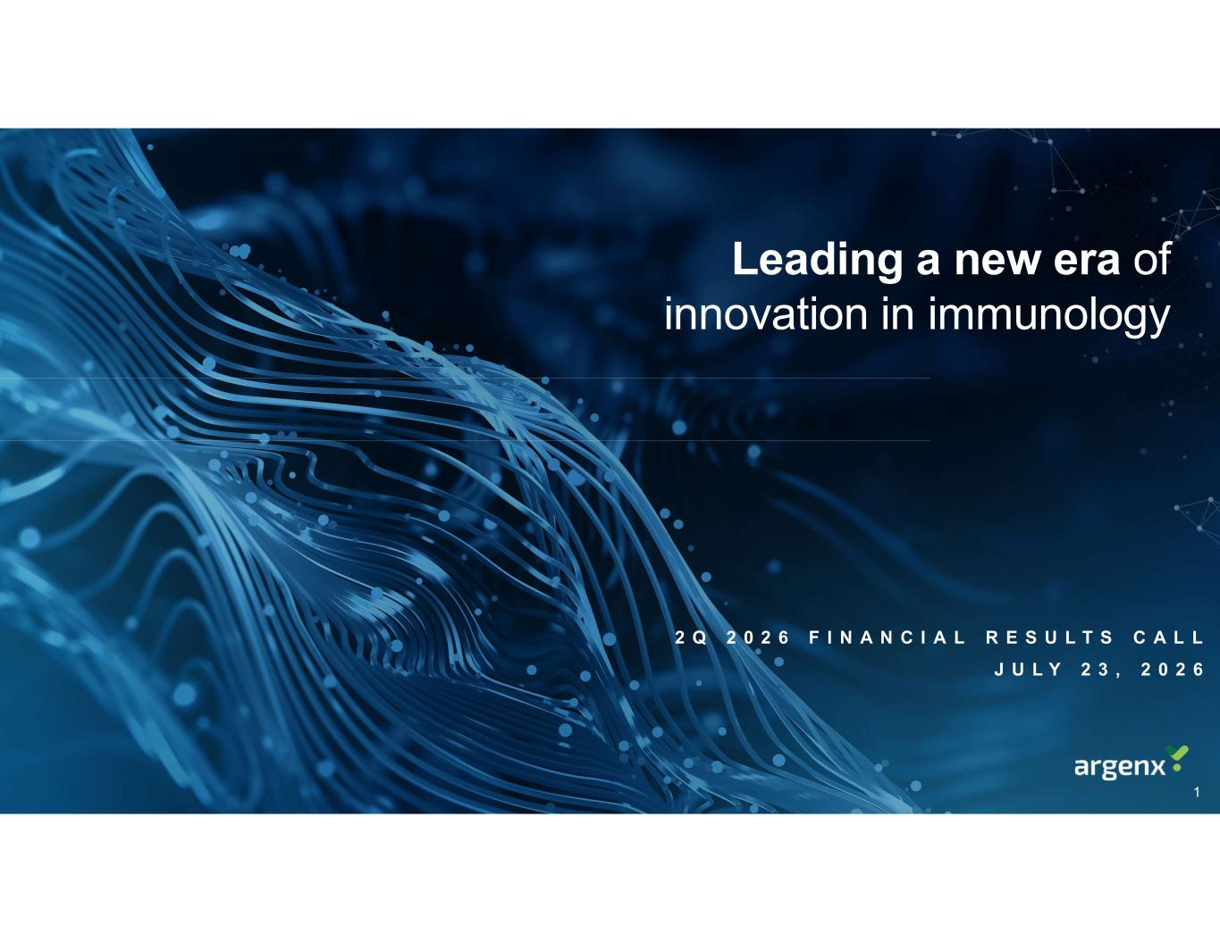
Leading a new era of innovation in immunology 2 Q 2 0 2 6 F I N A N C I A L R E S U L T S C A L L J U L Y 2 3 , 2 0 2 6 1

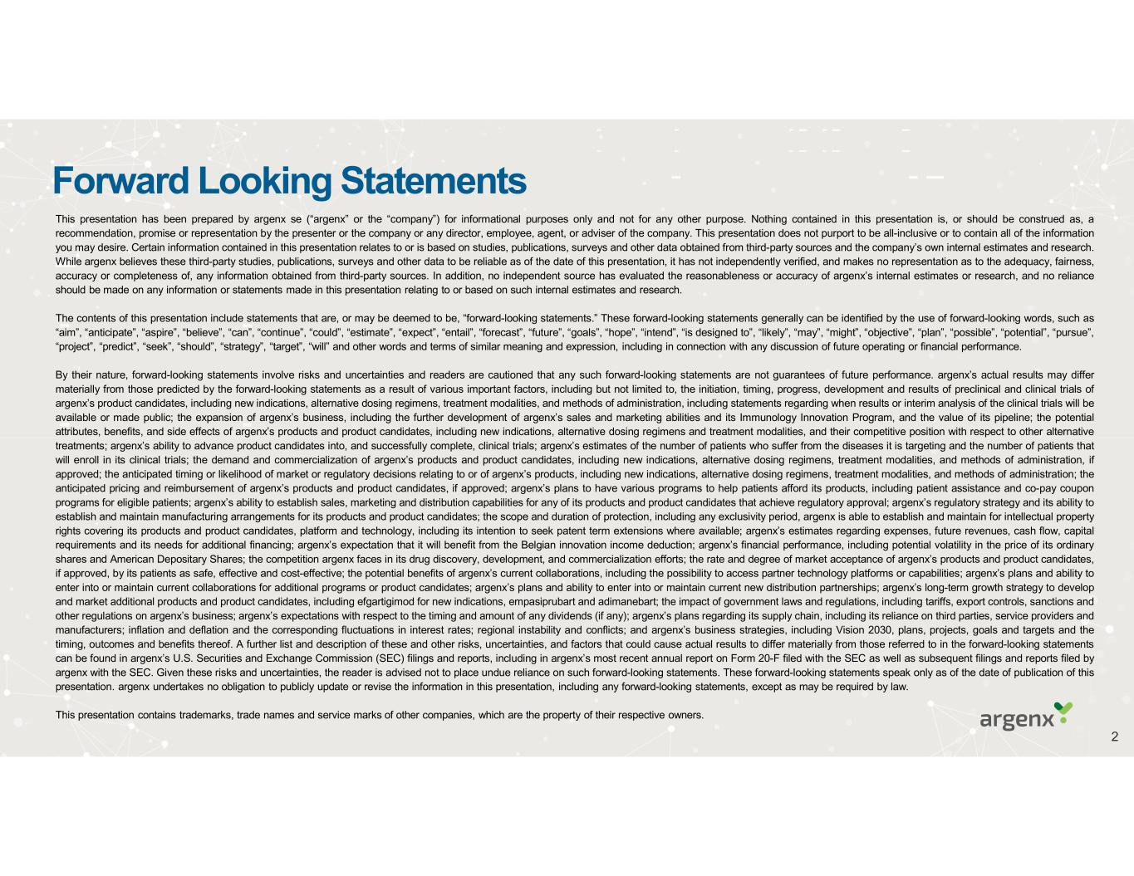
Forward Looking Statements This presentation has been prepared by argenx se (“argenx” or the “company”) for informational purposes only and not for any other purpose. Nothing contained in this presentation is, or should be construed as, a recommendation, promise or representation by the presenter or the company or any director, employee, agent, or adviser of the company. This presentation does not purport to be all-inclusive or to contain all of the information you may desire. Certain information contained in this presentation relates to or is based on studies, publications, surveys and other data obtained from third-party sources and the company’s own internal estimates and research. While argenx believes these third-party studies, publications, surveys and other data to be reliable as of the date of this presentation, it has not independently verified, and makes no representation as to the adequacy, fairness, accuracy or completeness of, any information obtained from third-party sources. In addition, no independent source has evaluated the reasonableness or accuracy of argenx’s internal estimates or research, and no reliance should be made on any information or statements made in this presentation relating to or based on such internal estimates and research. The contents of this presentation include statements that are, or may be deemed to be, “forward-looking statements.” These forward-looking statements generally can be identified by the use of forward-looking words, such as “aim”, “anticipate”, “aspire”, “believe”, “can”, “continue”, “could”, “estimate”, “expect”, “entail”, “forecast”, “future”, “goals”, “hope”, “intend”, “is designed to”, “likely”, “may”, “might”, “objective”, “plan”, “possible”, “potential”, “pursue”, “project”, “predict”, “seek”, “should”, “strategy”, “target”, “will” and other words and terms of similar meaning and expression, including in connection with any discussion of future operating or financial performance. By their nature, forward-looking statements involve risks and uncertainties and readers are cautioned that any such forward-looking statements are not guarantees of future performance. argenx’s actual results may differ materially from those predicted by the forward-looking statements as a result of various important factors, including but not limited to, the initiation, timing, progress, development and results of preclinical and clinical trials of argenx’s product candidates, including new indications, alternative dosing regimens, treatment modalities, and methods of administration, including statements regarding when results or interim analysis of the clinical trials will be available or made public; the expansion of argenx’s business, including the further development of argenx’s sales and marketing abilities and its Immunology Innovation Program, and the value of its pipeline; the potential attributes, benefits, and side effects of argenx’s products and product candidates, including new indications, alternative dosing regimens and treatment modalities, and their competitive position with respect to other alternative treatments; argenx’s ability to advance product candidates into, and successfully complete, clinical trials; argenx’s estimates of the number of patients who suffer from the diseases it is targeting and the number of patients that will enroll in its clinical trials; the demand and commercialization of argenx’s products and product candidates, including new indications, alternative dosing regimens, treatment modalities, and methods of administration, if approved; the anticipated timing or likelihood of market or regulatory decisions relating to or of argenx’s products, including new indications, alternative dosing regimens, treatment modalities, and methods of administration; the anticipated pricing and reimbursement of argenx’s products and product candidates, if approved; argenx’s plans to have various programs to help patients afford its products, including patient assistance and co-pay coupon programs for eligible patients; argenx’s ability to establish sales, marketing and distribution capabilities for any of its products and product candidates that achieve regulatory approval; argenx’s regulatory strategy and its ability to establish and maintain manufacturing arrangements for its products and product candidates; the scope and duration of protection, including any exclusivity period, argenx is able to establish and maintain for intellectual property rights covering its products and product candidates, platform and technology, including its intention to seek patent term extensions where available; argenx’s estimates regarding expenses, future revenues, cash flow, capital requirements and its needs for additional financing; argenx’s expectation that it will benefit from the Belgian innovation income deduction; argenx’s financial performance, including potential volatility in the price of its ordinary shares and American Depositary Shares; the competition argenx faces in its drug discovery, development, and commercialization efforts; the rate and degree of market acceptance of argenx’s products and product candidates, if approved, by its patients as safe, effective and cost-effective; the potential benefits of argenx’s current collaborations, including the possibility to access partner technology platforms or capabilities; argenx’s plans and ability to enter into or maintain current collaborations for additional programs or product candidates; argenx’s plans and ability to enter into or maintain current new distribution partnerships; argenx’s long-term growth strategy to develop and market additional products and product candidates, including efgartigimod for new indications, empasiprubart and adimanebart; the impact of government laws and regulations, including tariffs, export controls, sanctions and other regulations on argenx’s business; argenx’s expectations with respect to the timing and amount of any dividends (if any); argenx’s plans regarding its supply chain, including its reliance on third parties, service providers and manufacturers; inflation and deflation and the corresponding fluctuations in interest rates; regional instability and conflicts; and argenx’s business strategies, including Vision 2030, plans, projects, goals and targets and the timing, outcomes and benefits thereof. A further list and description of these and other risks, uncertainties, and factors that could cause actual results to differ materially from those referred to in the forward-looking statements can be found in argenx’s U.S. Securities and Exchange Commission (SEC) filings and reports, including in argenx’s most recent annual report on Form 20-F filed with the SEC as well as subsequent filings and reports filed by argenx with the SEC. Given these risks and uncertainties, the reader is advised not to place undue reliance on such forward-looking statements. These forward-looking statements speak only as of the date of publication of this presentation. argenx undertakes no obligation to publicly update or revise the information in this presentation, including any forward-looking statements, except as may be required by law. This presentation contains trademarks, trade names and service marks of other companies, which are the property of their respective owners. 2

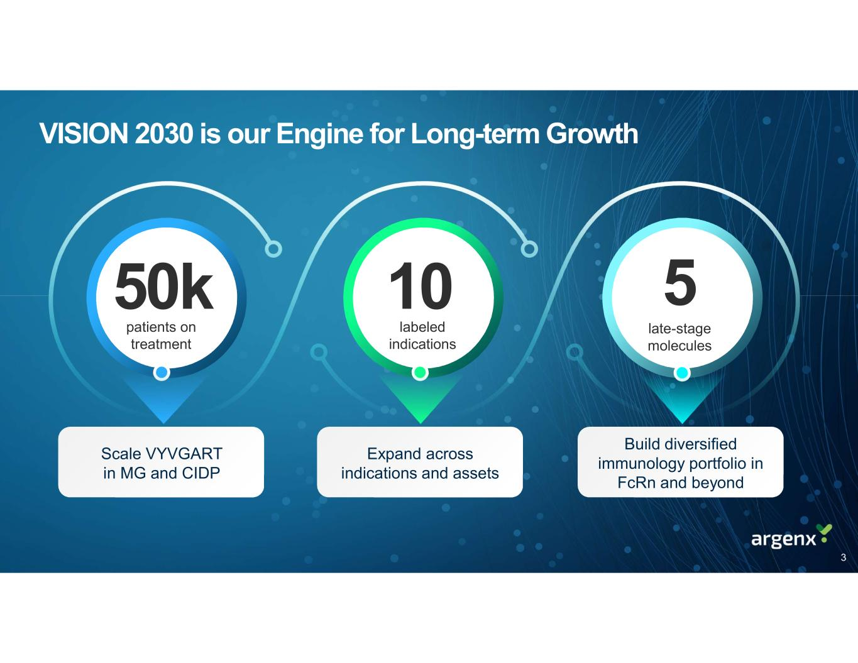
VISION 2030 is our Engine for Long-term Growth 50k 10 5 patients on treatment labeled indications late-stage molecules Scale VYVGART in MG and CIDP Expand across indications and assets Build diversified immunology portfolio in FcRn and beyond 3

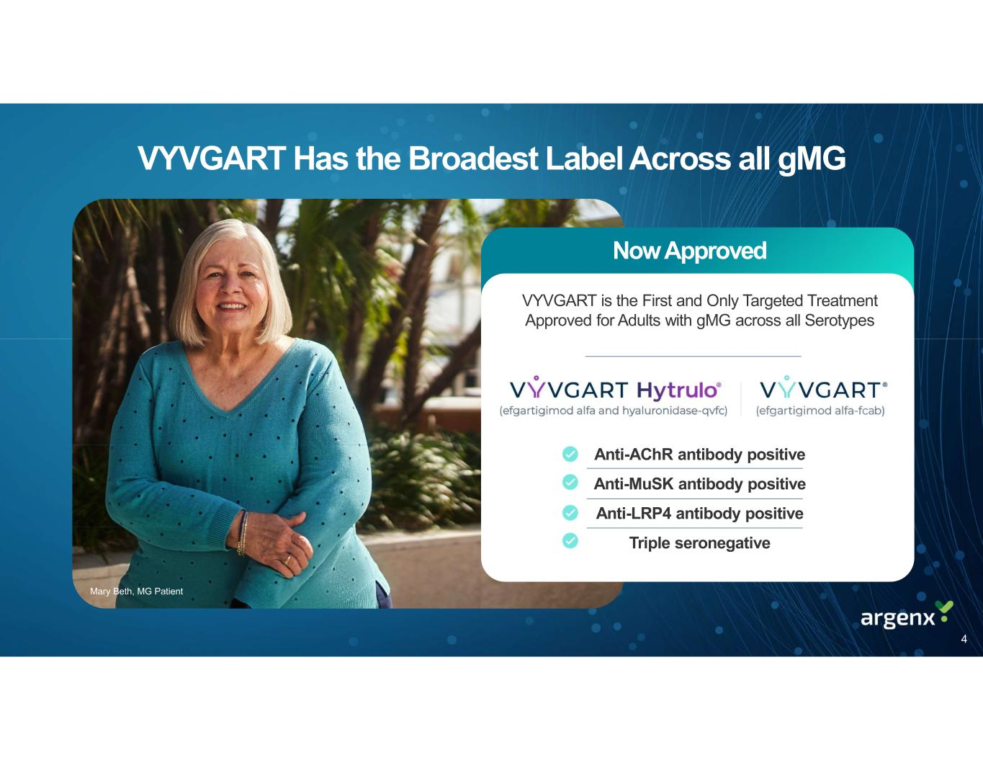
VYVGART Has the Broadest Label Across all gMG Mary Beth, MG Patient Now Approved VYVGART is the First and Only Targeted Treatment Approved for Adults with gMG across all Serotypes Anti-AChR antibody positive Anti-MuSK antibody positive Anti-LRP4 antibody positive Triple seronegative 4

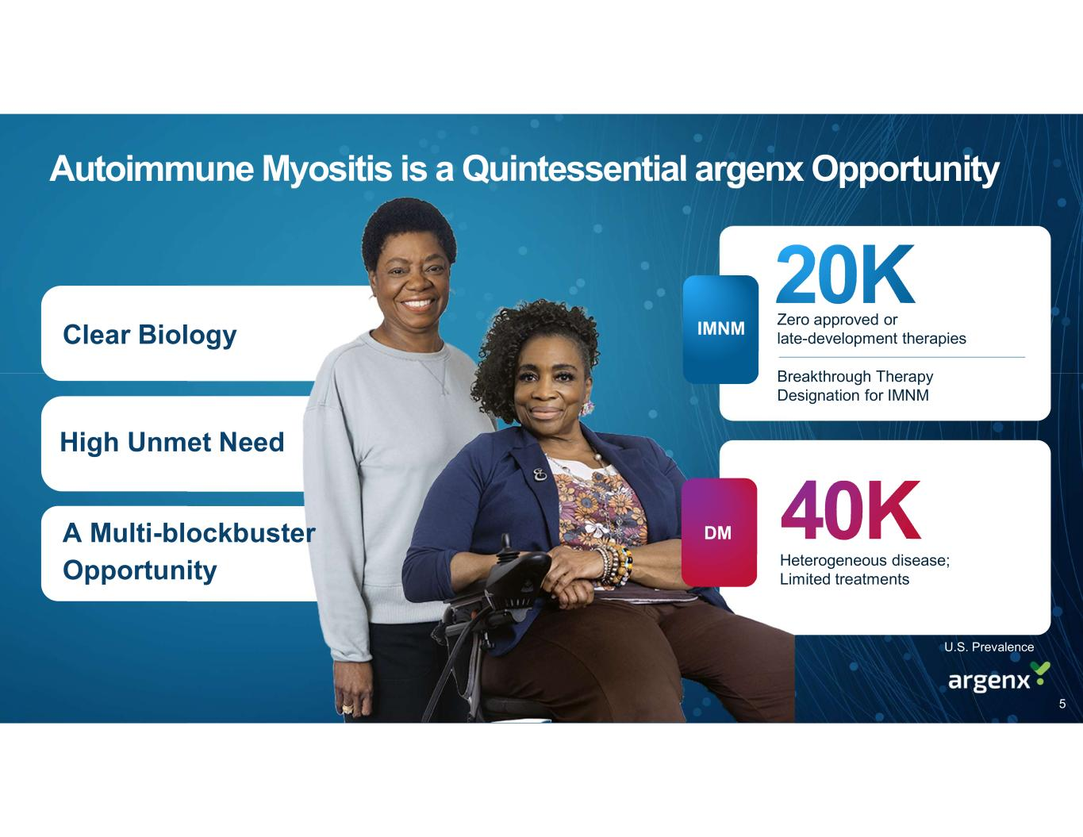
Autoimmune Myositis is a Quintessential argenx Opportunity U.S. Prevalence A Multi-blockbuster Opportunity Clear Biology High Unmet Need Zero approved or late-development therapies Heterogeneous disease; Limited treatments Breakthrough Therapy Designation for IMNM DM IMNM 5

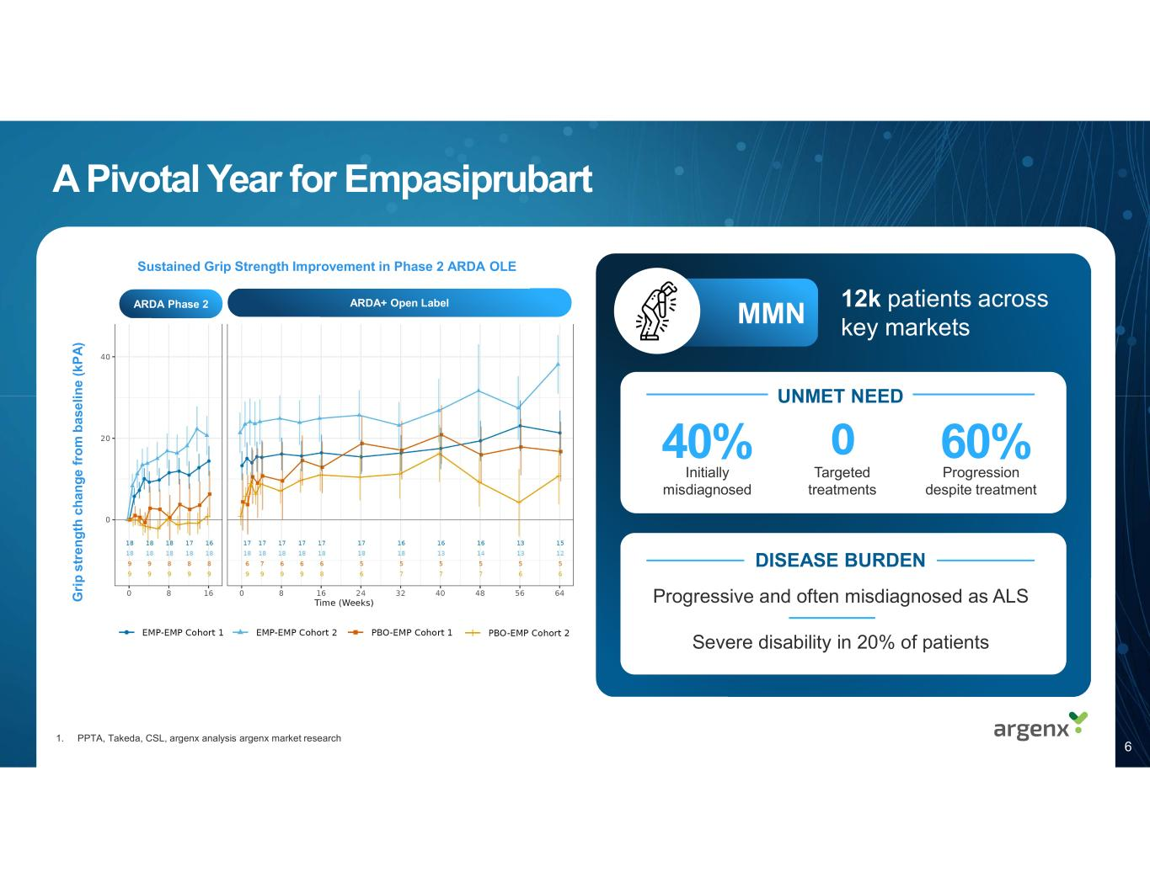
A Pivotal Year for Empasiprubart 12k patients across key markets 1. PPTA, Takeda, CSL, argenx analysis argenx market research MMN G ri p s tr en g th c h an g e f ro m b as e lin e ( kP A ) 60% Progression despite treatment 40% Initially misdiagnosed Targeted treatments 0 UNMET NEED Progressive and often misdiagnosed as ALS Severe disability in 20% of patients DISEASE BURDEN ARDA+ Open LabelARDA Phase 2 6 Sustained Grip Strength Improvement in Phase 2 ARDA OLE

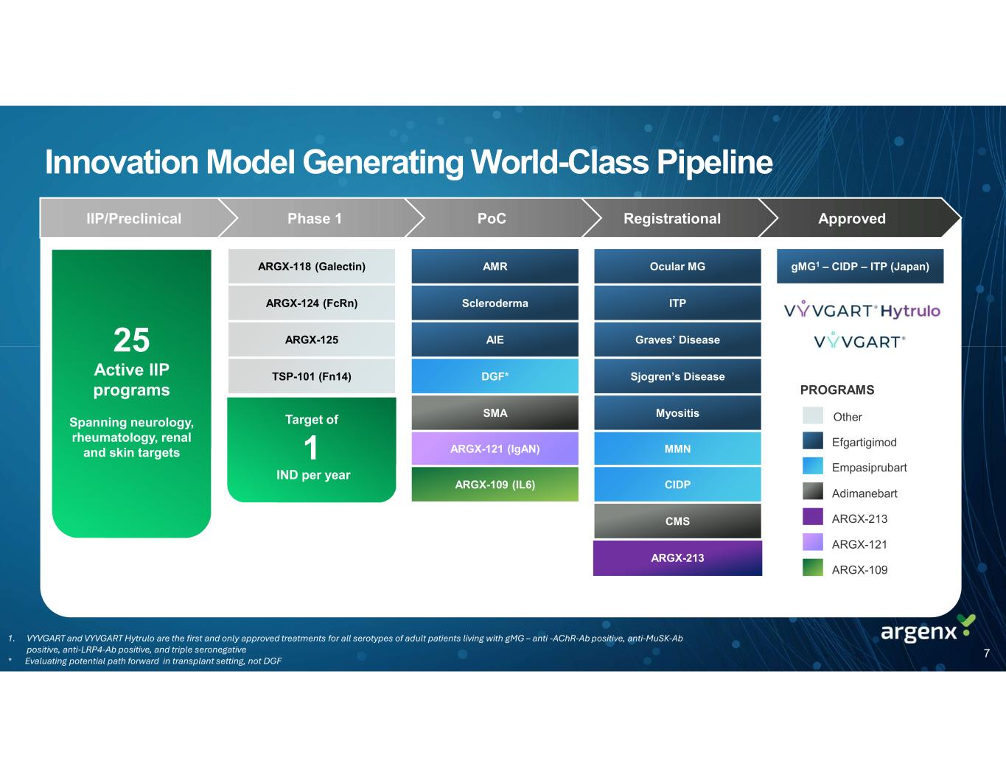
Innovation Model Generating World-Class Pipeline ApprovedRegistrationalPoCPhase 1IIP/Preclinical Ocular MG ITP Graves’ Disease Sjogren’s Disease Myositis MMN CIDP CMS ARGX-213 25 Active IIP programs Spanning neurology, rheumatology, renal and skin targets ARGX-118 (Galectin) ARGX-124 (FcRn) ARGX-125 TSP-101 (Fn14) AMR Scleroderma AIE DGF* SMA ARGX-121 (IgAN) ARGX-109 (IL6) Efgartigimod Empasiprubart Adimanebart Other PROGRAMS ARGX-213 ARGX-121 ARGX-109 Target of 1 IND per year gMG1 – CIDP – ITP (Japan) 1. VYVGART and VYVGART Hytrulo are the first and only approved treatments for all serotypes of adult patients living with gMG – anti -AChR-Ab positive, anti-MuSK-Ab positive, anti-LRP4-Ab positive, and triple seronegative * Evaluating potential path forward in transplant setting, not DGF 7

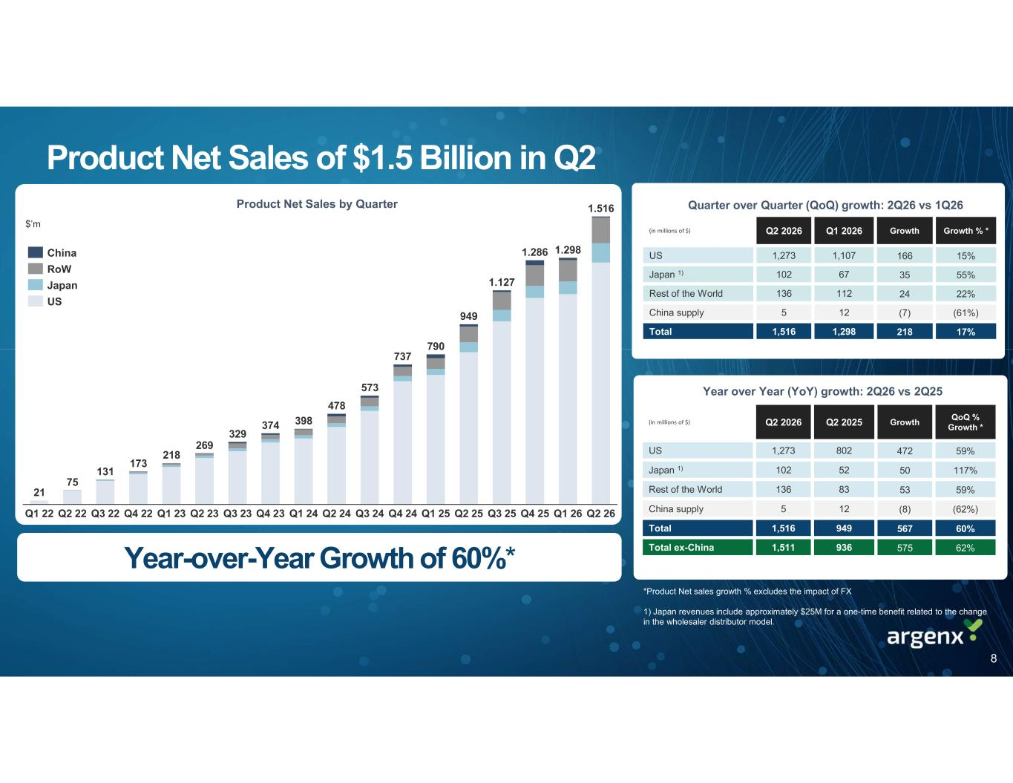
Product Net Sales of $1.5 Billion in Q2 $’m Year over Year (YoY) growth: 2Q26 vs 2Q25 *All growth is operational and excludes the impact of FX QoQ % Growth * GrowthQ2 2025Q2 2026(in millions of $) 59%4728021,273US 117%5052102Japan 1) 59%5383136Rest of the World (62%)(8)125China supply 60%5679491,516Total 62%5759361,511Total ex-China Growth % *GrowthQ1 2026Q2 2026(in millions of $) 15%1661,1071,273US 55%3567102Japan 1) 22%24112136Rest of the World (61%)(7)125China supply 17%2181,2981,516Total Quarter over Quarter (QoQ) growth: 2Q26 vs 1Q26Product Net Sales by Quarter *Product Net sales growth % excludes the impact of FX 1) Japan revenues include approximately $25M for a one-time benefit related to the change in the wholesaler distributor model. Year-over-Year Growth of 60%* Q2 22 Q3 22 Q4 22 Q1 23 Q2 23 Q3 23 Q4 23 Q1 24 Q2 24 Q3 24 Q4 24 Q1 25 Q2 25 Q3 25 Q4 25 Q1 26 Q2 26Q1 22 75 131 173 218 269 329 374 398 478 573 737 790 949 1.127 1.286 1.298 1.516 21 China RoW Japan US 8

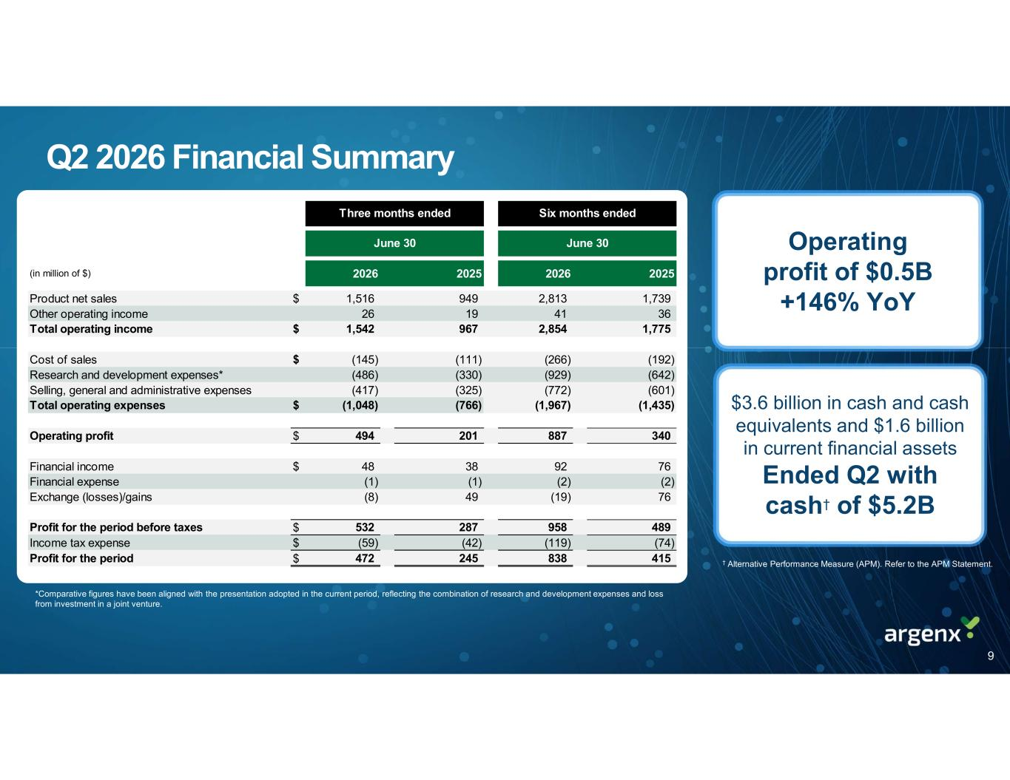
Q2 2026 Financial Summary Operating profit of $0.5B +146% YoY *Comparative figures have been aligned with the presentation adopted in the current period, reflecting the combination of research and development expenses and loss from investment in a joint venture. $3.6 billion in cash and cash equivalents and $1.6 billion in current financial assets Ended Q2 with cash† of $5.2B † Alternative Performance Measure (APM). Refer to the APM Statement. (in million of $) 2026 2025 2026 2025 Product net sales $ 1,516 949 2,813 1,739 Other operating income 26 19 41 36 Total operating income $ 1,542 967 2,854 1,775 Cost of sales $ (145) (111) (266) (192) Research and development expenses* (486) (330) (929) (642) Selling, general and administrative expenses (417) (325) (772) (601) Total operating expenses $ (1,048) (766) (1,967) (1,435) Operating profit $ 494 201 887 340 Financial income $ 48 38 92 76 Financial expense (1) (1) (2) (2) Exchange (losses)/gains (8) 49 (19) 76 Profit for the period before taxes $ 532 287 958 489 Income tax expense $ (59) (42) (119) (74) Profit for the period $ 472 245 838 415 Three months ended Six months ended June 30 June 30 9

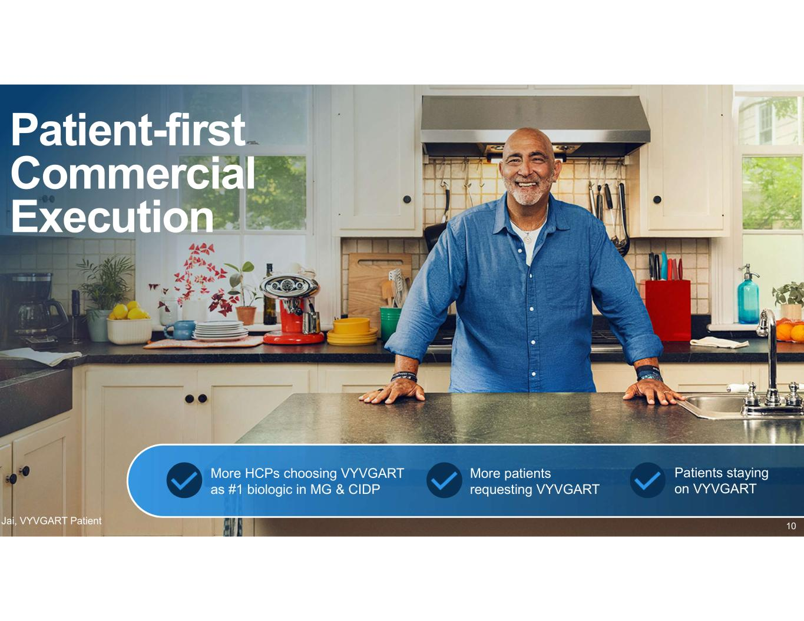
Patient-first Commercial Execution Jai, VYVGART Patient More HCPs choosing VYVGART as #1 biologic in MG & CIDP More patients requesting VYVGART Patients staying on VYVGART 10

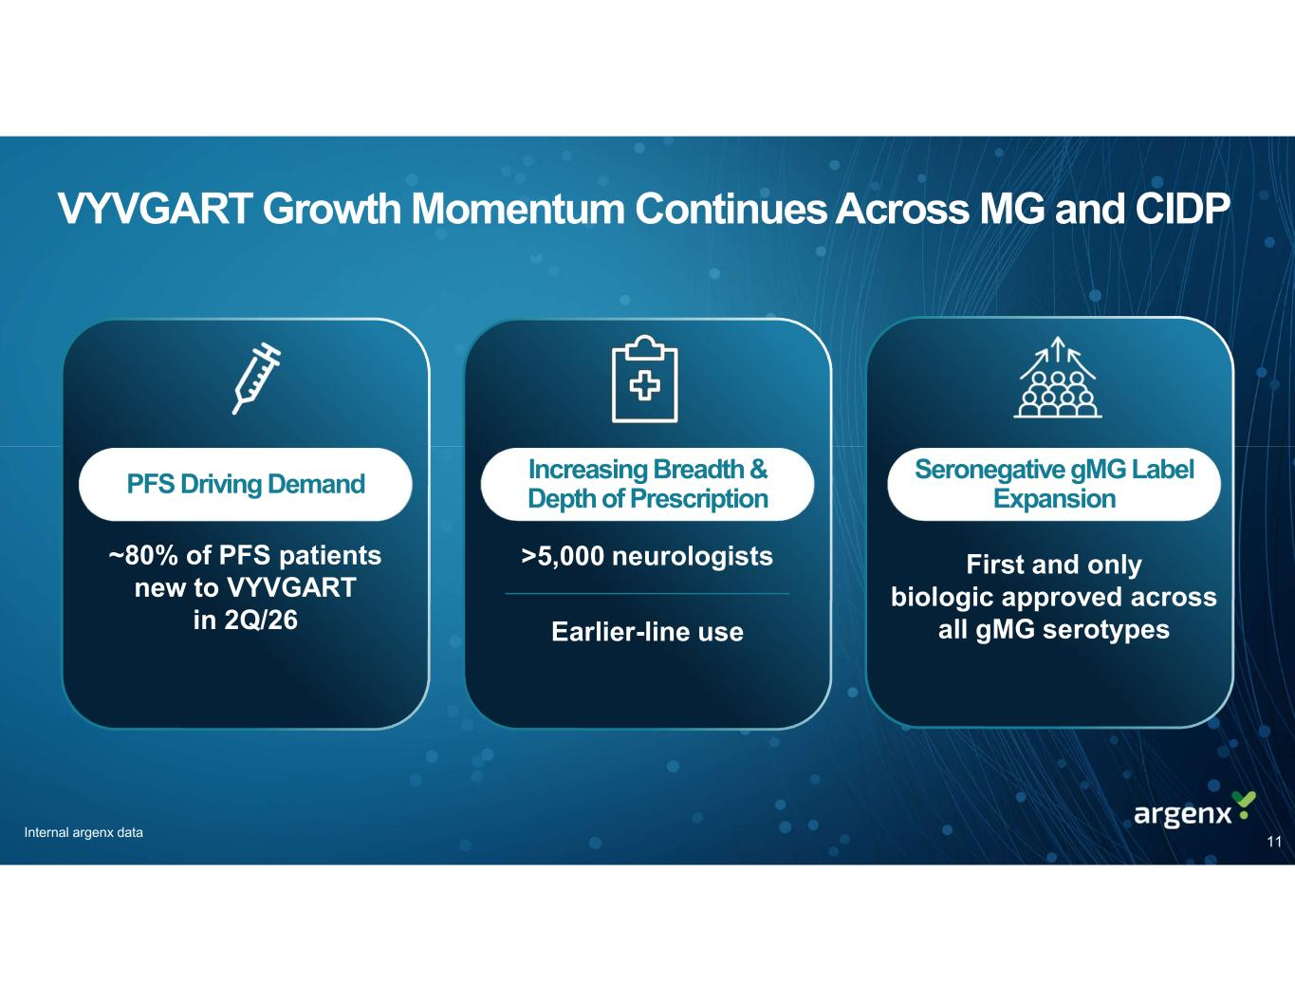
PFS Driving Demand VYVGART Growth Momentum Continues Across MG and CIDP ~80% of PFS patients new to VYVGART in 2Q/26 Increasing Breadth & Depth of Prescription Seronegative gMG Label Expansion >5,000 neurologists Earlier-line use First and only biologic approved across all gMG serotypes 11 Internal argenx data

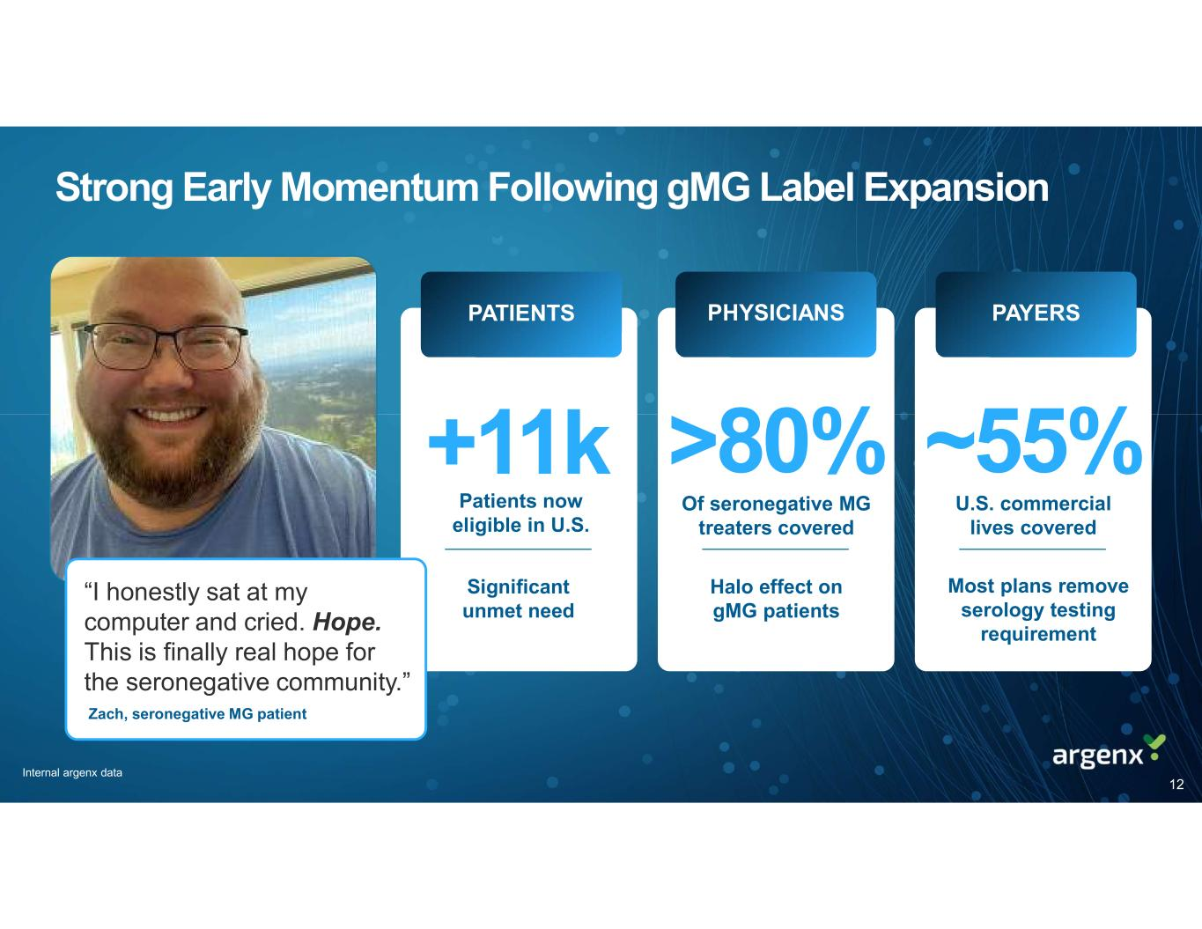
+11k Patients now eligible in U.S. Significant unmet need >80% Of seronegative MG treaters covered ~55% U.S. commercial lives covered Most plans remove serology testing requirement Halo effect on gMG patients PATIENTS PHYSICIANS PAYERS Strong Early Momentum Following gMG Label Expansion 12 “I honestly sat at my computer and cried. Hope. This is finally real hope for the seronegative community.” Zach, seronegative MG patient Internal argenx data

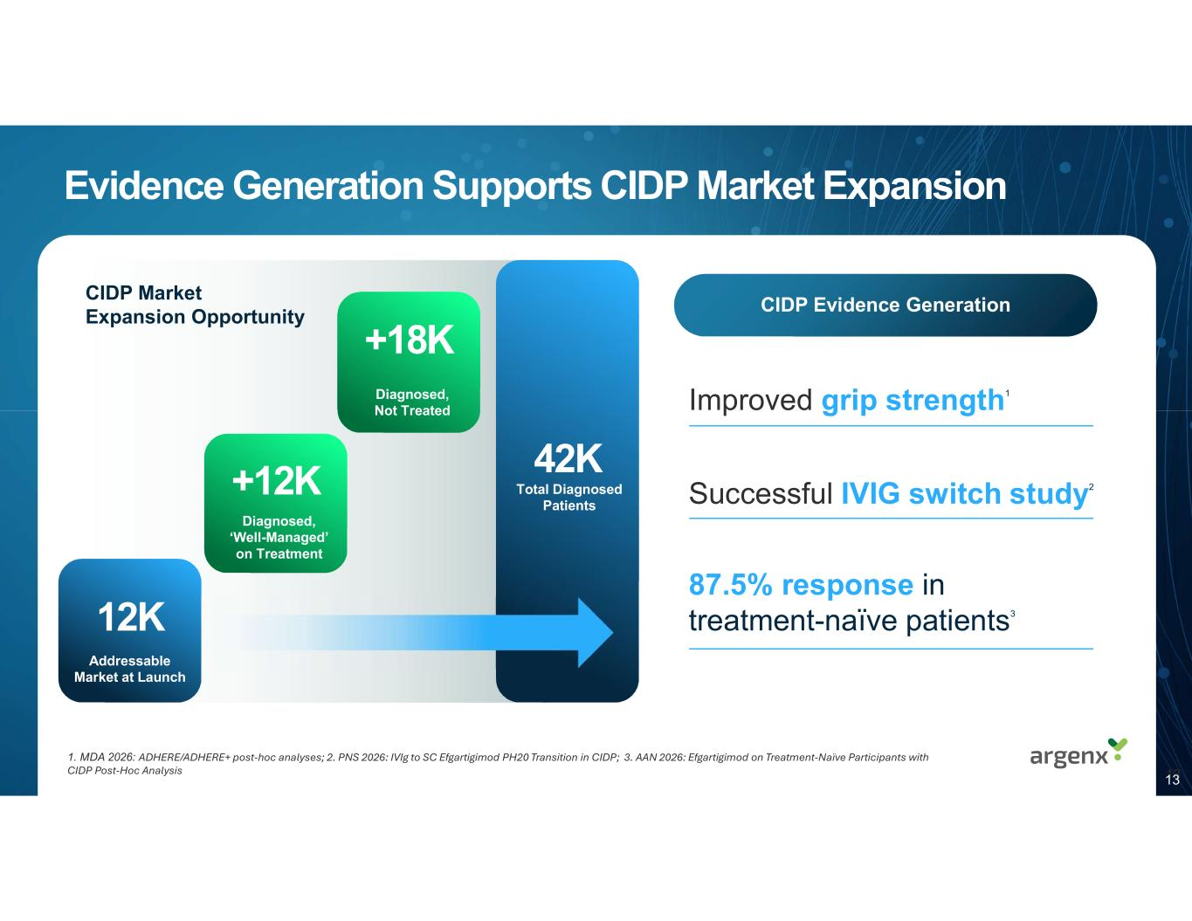
For up to 96 weeks Evidence Generation Supports CIDP Market Expansion 42K 12K +12K Diagnosed, ‘Well-Managed’ on Treatment Addressable Market at Launch Total Diagnosed Patients 13 CIDP Market Expansion Opportunity +18K Diagnosed, Not Treated Improved grip strength1 Successful IVIG switch study2 87.5% response in treatment-naïve patients3 1. MDA 2026: ADHERE/ADHERE+ post-hoc analyses; 2. PNS 2026: IVIg to SC Efgartigimod PH20 Transition in CIDP; 3. AAN 2026: Efgartigimod on Treatment-Naïve Participants with CIDP Post-Hoc Analysis CIDP Evidence Generation 13

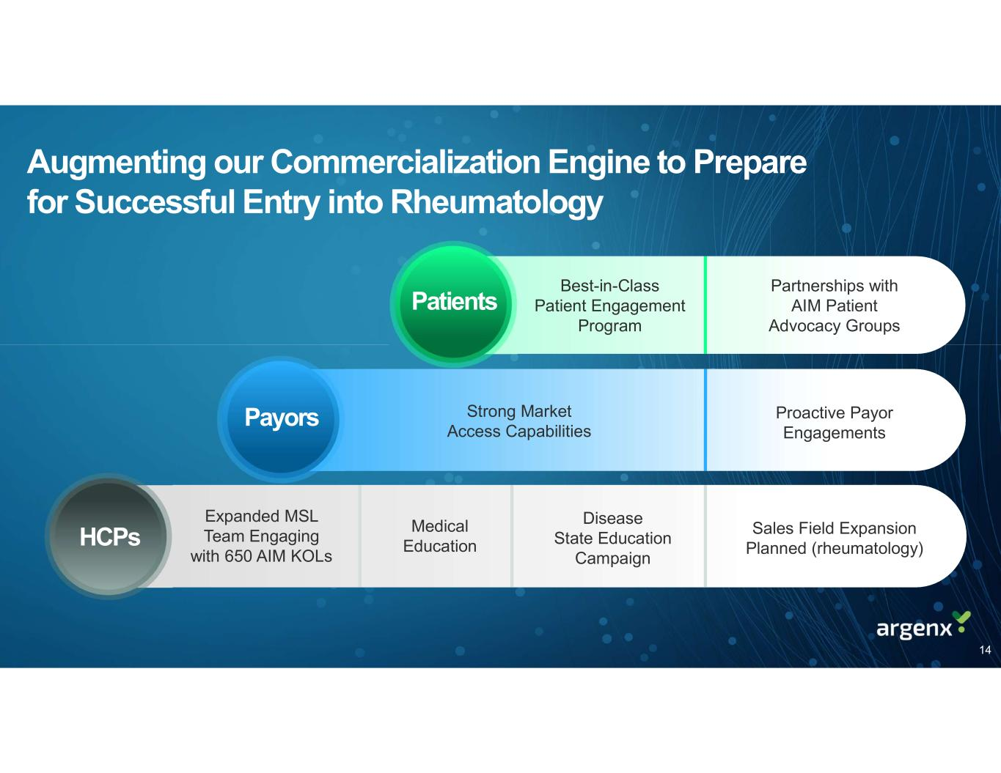
Augmenting our Commercialization Engine to Prepare for Successful Entry into Rheumatology HCPs Payors Patients Proactive Payor Engagements Best-in-Class Patient Engagement Program Strong Market Access Capabilities Partnerships with AIM Patient Advocacy Groups Expanded MSL Team Engaging with 650 AIM KOLs Sales Field Expansion Planned (rheumatology) Disease State Education Campaign Medical Education 14


Innovation Has No Value Unless it Provides Meaningful Benefit to Patients 15

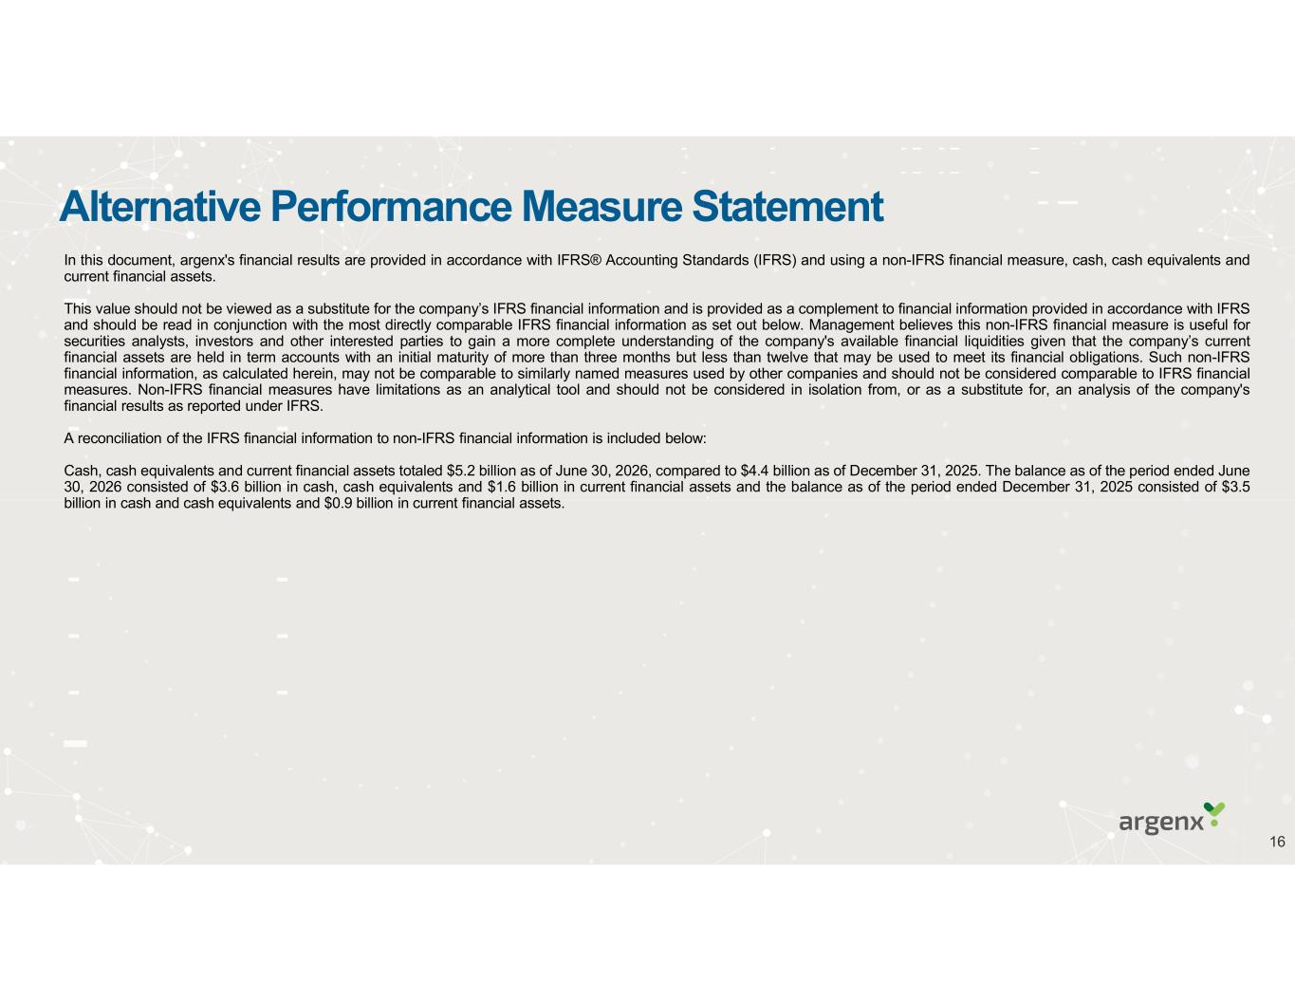
Alternative Performance Measure Statement In this document, argenx's financial results are provided in accordance with IFRS® Accounting Standards (IFRS) and using a non-IFRS financial measure, cash, cash equivalents and current financial assets. This value should not be viewed as a substitute for the company’s IFRS financial information and is provided as a complement to financial information provided in accordance with IFRS and should be read in conjunction with the most directly comparable IFRS financial information as set out below. Management believes this non-IFRS financial measure is useful for securities analysts, investors and other interested parties to gain a more complete understanding of the company's available financial liquidities given that the company’s current financial assets are held in term accounts with an initial maturity of more than three months but less than twelve that may be used to meet its financial obligations. Such non-IFRS financial information, as calculated herein, may not be comparable to similarly named measures used by other companies and should not be considered comparable to IFRS financial measures. Non-IFRS financial measures have limitations as an analytical tool and should not be considered in isolation from, or as a substitute for, an analysis of the company's financial results as reported under IFRS. A reconciliation of the IFRS financial information to non-IFRS financial information is included below: Cash, cash equivalents and current financial assets totaled $5.2 billion as of June 30, 2026, compared to $4.4 billion as of December 31, 2025. The balance as of the period ended June 30, 2026 consisted of $3.6 billion in cash, cash equivalents and $1.6 billion in current financial assets and the balance as of the period ended December 31, 2025 consisted of $3.5 billion in cash and cash equivalents and $0.9 billion in current financial assets. 16

