UNITED STATES
SECURITIES AND EXCHANGE COMMISSION
Washington, D.C. 20549

SCHEDULE TO
Tender Offer Statement Under Section 14(d)(1) or 13(e)(1)
of the Securities Exchange Act of 1934

FORTE BIOSCIENCES, INC.
(Name of Subject Company – Issuer)

AVENA MERGER SUB INC.
a wholly owned subsidiary of

ARGENX BV
a wholly owned subsidiary of

ARGENX SE
(Names of Filing Persons — Offerors)

Common Stock, par value $0.001 per share
(Title of Class of Securities)

34962G208
(CUSIP Number of Class of Securities)

Hemamalini (Malini) Moorthy
argenx BV
Industriepark Zwijnaarde 7
Building C9052 Zwijnaarde(Ghent)
Belgium
+31(0)10 70 38 441
(Name, Address and Telephone Number of Person Authorized to
Receive Notices and Communications on Behalf of Filing Persons)

Copies to:
Damien Zoubek, Esq.
Oliver J. Board, Esq.
Freshfields US LLP
3 World Trade Center
175 Greenwich Street
New York, NY 10007
(212) 277-4000

☒ | Check the box if the filing relates solely to preliminary communications made before the commencement of a tender offer.

Check the appropriate boxes below to designate any transactions to which the statement relates:

 | ☒ | third-party tender offer subject to Rule 14d-1.

 | ☐ | issuer tender offer subject to Rule 13e-4.

 | ☐ | going-private transaction subject to Rule 13e-3.

 | ☐ | amendment to Schedule 13D under Rule 13d-2.

Check the following box if the filing is a final amendment reporting the results of the tender offer. ☐

If applicable, check the appropriate box(es) below to designate the appropriate rule provision(s) relied upon:

 | ☐ | Rule 13e-4(i) (Cross-Border Issuer Tender Offer)

 | ☐ | Rule 14d-1(d) (Cross-Border Third-Party Tender Offer)

This Tender Offer Statement on Schedule TO relates solely to preliminary communications made before the commencement of a planned tender offer for all outstanding shares of common stock, par value $0.001 per share, of Forte Biosciences, Inc., a Delaware corporation (“Forte”), by Avena Merger Sub Inc., a Delaware corporation (“Purchaser”) and a wholly owned subsidiary of argenx BV, a private company with limited liability (besloten vennootschap) organized under Belgian law (“argenx”) to be commenced pursuant to the Agreement and Plan of Merger, dated as of July 26, 2026, by and among Forte, argenx and Purchaser.

Additional Information and Where to Find It

The tender offer has not yet commenced. This document is for informational purposes only and is neither a recommendation, nor an offer to purchase nor a solicitation of an offer to sell any securities of Forte or any other entity, nor is it a substitute for any tender offer materials that argenx, Purchaser or Forte will file with the U.S. Securities and Exchange Commission (“SEC”). A solicitation and an offer to buy securities of Forte will be made only pursuant to an offer to purchase and related materials that argenx and Purchaser intend to file with the SEC. At the time the tender offer is commenced, argenx and Purchaser will file a Tender Offer Statement on Schedule TO, including an offer to purchase, a letter of transmittal and related documents, with the SEC, and Forte thereafter will file a Solicitation/Recommendation Statement on Schedule 14D-9 with the SEC with respect to the tender offer. SECURITYHOLDERS AND OTHER INVESTORS ARE URGED TO READ THE TENDER OFFER MATERIALS (INCLUDING AN OFFER TO PURCHASE, A RELATED LETTER OF TRANSMITTAL AND CERTAIN OTHER TENDER OFFER DOCUMENTS) AND THE SOLICITATION/RECOMMENDATION STATEMENT ON SCHEDULE 14D-9 REGARDING THE OFFER, AS THEY MAY BE AMENDED FROM TIME TO TIME, WHEN THEY BECOME AVAILABLE CAREFULLY AND IN THEIR ENTIRETY BECAUSE THEY WILL CONTAIN IMPORTANT INFORMATION THAT INVESTORS AND SECURITYHOLDERS SHOULD READ CAREFULLY BEFORE ANY DECISION IS MADE WITH RESPECT TO THE TENDER OFFER. The Tender Offer Statement on Schedule TO, the Solicitation/Recommendation Statement on Schedule 14D-9 and other related documents will be made available for free at the SEC’s website at https://www.sec.gov/ and under the “SEC filings” section of argenx’s investor relations website at https://argenx.com/investors/sec-filings. The Solicitation/Recommendation Statement on Schedule 14D-9 and other related documents that Forte has filed with or furnished to the SEC will be made available for free at the SEC’s website at https://www.sec.gov/ and under the “SEC Filings” section of Forte’s investor relations website at https://www.fortebiorx.com/investor-relations/sec-filings/default.aspx.

Forward Looking Statements

The contents of this Tender Offer Statement include statements that are, or may be deemed to be, “forward-looking statements.” These forward-looking statements generally can be identified by the use of forward-looking words, such as “aim”, “anticipate”, “aspire”, “believe”, “can”, “continue”, “could”, “estimate”, “expect”, “entail”, “forecast”, “future”, “goals”, “hope”, “intend”, “is designed to”, “likely”, “may”, “might”, “objective”, “plan”, “possible”, “potential”, “pursue”, “project”, “predict”, “seek”, “should”, “strategy”, “target”, “will” and other words and terms of similar meaning and expression, including in connection with any discussion of future operating or financial performance. By their nature, forward-looking statements involve risks and uncertainties and readers are cautioned that any such forward-looking statements are not guarantees of future performance. Forward-looking statements include, without limitation, statements regarding the tender offer, the merger and other related matters; prospective performance and opportunities; post-closing operations and the outlook for the businesses of Forte and argenx, including, without limitation, results from clinical trials, regulatory applications and related timelines, the ability of argenx to advance Forte’s product pipeline; and any assumptions underlying any of the foregoing. argenx’s actual results may differ materially from those predicted by the forward-looking statements as a result of various important factors, including but not limited to, uncertainties as to the timing of the tender offer and the merger; the risk that the tender offer or the merger may not be completed in a timely manner or at all; uncertainties as to the percentage of Forte’s stockholders tendering their shares in the tender offer; the possibility that competing offers or acquisition proposals for Forte will be made; the possibility that any or all of the various conditions to the consummation of the tender offer or the merger may not be satisfied or waived, including the failure to receive any required regulatory approvals from any applicable governmental entities (or any conditions, limitations or restrictions placed on such approvals); the occurrence of any event, change or other circumstance that could give rise to the termination of the merger agreement, including in circumstances that would require Forte to pay a termination fee or other expenses; the effect of the announcement or pendency of the transactions contemplated by the merger agreement on argenx’s business; the effect of the announcement or pendency of the transactions contemplated by the merger agreement on Forte’s business, its ability to retain and hire key personnel, its ability to maintain relationships with its suppliers and others with whom it does business, or its operating results and business generally; risks related to diverting management’s attention from argenx’s ongoing business operations; the risk that stockholder litigation in connection with the transactions contemplated by the merger agreement may result in significant costs of defense, indemnification and liability.

A further list and description of these and other risks, uncertainties, and factors that could cause actual results to differ materially from those referred to in the forward-looking statements can be found in argenx’s SEC filings and reports, including in argenx’s most recent annual report on Form 20-F filed with the SEC as well as subsequent filings and reports filed by argenx with the SEC. Given these risks and uncertainties, the reader is advised not to place undue reliance on such forward-looking statements. These forward-looking statements speak only as of the date of publication of this Tender Offer Statement. argenx undertakes no obligation to publicly update or revise the information in this Tender Offer Statement, including any forward-looking statements, except as may be required by law.

Item 12. Exhibits.

Exhibit |  | Description
99.1 |  | Joint Press Release, dated July 27, 2026.
99.2 |  | Investor Presentation, dated July 27, 2026.
99.3 |  | Social media posts of argenx BV, dated July 27, 2026.

2

Exhibit 99.1

argenx to Acquire Forte Biosciences, Inc., Adding First-in-Class anti-CD122 Antibody, FB102, to its Immunology Pipeline

 | • | Transaction builds on argenx’s prior strategic investment in Forte Biosciences and reflects a disciplined approach to accessing novel biology that can fuel long-term growth

 | • | FB102 Phase 1b studies in vitiligo and celiac disease validate CD122 biology and pipeline-in-a-product potential to address diseases with high unmet need that have lacked innovation

 | • | Acquisition strengthens argenx’s innovative immunology portfolio with the addition of a differentiated approach to targeting pathogenic T-cell and NK-cell activity through CD122 biology

 | • | argenx will host an investor conference call today at 8:00 a.m. ET to discuss the transaction

July 27, 2026 – 7:00 AM CET

Amsterdam, the Netherlands and Dallas, Texas – argenx (Euronext & Nasdaq: ARGX), a global immunology innovation company, and Forte Biosciences, Inc. (Nasdaq: FBRX) today announced that the companies have entered into a definitive agreement under which argenx will acquire Forte Biosciences for $77 per share in cash, representing a total equity value of approximately $2.2 billion.

FB102, Forte Biosciences’ lead program, expands argenx’s portfolio of differentiated immunology medicines, adding a first-in-class anti-CD122 antibody with clinical proof-of-concept in vitiligo and celiac disease and potential to address multiple autoimmune diseases. The acquisition reflects argenx’s disciplined approach to identifying and advancing breakthrough science for patients with the potential to redefine standards of care in diseases that have lacked meaningful innovation for decades.

“Our Vision 2030 strategy is well-defined and on track, and our discovery, development and commercialization engines are delivering real value for patients,” said Karen Massey, Chief Executive Officer of argenx. “The acquisition of Forte Biosciences builds on the strength of that foundation and advances our ambition to be the leading immunology innovator of the future. The addition of FB102 to our portfolio aligns perfectly with the argenx playbook: compelling biology, strong clinical validation and broad potential to address patient need. I am grateful to the Forte Biosciences team for their outstanding work. Together, we look forward to unlocking the full potential of FB102 and accelerating its impact for patients.”

“We are incredibly proud of what we have achieved in advancing FB102 through clinical development and firmly believe that argenx is the ideal strategic partner to unlock the full potential of this novel anti-CD122 antibody across a broad range of autoimmune diseases,” said Paul A. Wagner, Ph.D., Chief Executive Officer and Chairperson of the Board of Forte Biosciences. “By combining FB102’s promising clinical profile with argenx’s proven development expertise, global reach and commercial capabilities, we have a unique opportunity to accelerate its development and maximize its impact for patients living with vitiligo, celiac disease, alopecia areata and other autoimmune conditions. We are excited about the future of FB102 and the potential to bring this innovative therapy to many more patients worldwide.”

Forte Biosciences recently reported positive Phase 1b data in vitiligo, demonstrating statistically significant treatment benefit. In addition, positive FB102 Phase 1b data in celiac disease was shared last year, with Phase 2 data expected in the second half of this year. These studies were key drivers of argenx’s decision to move from strategic investment to acquisition, providing clinical evidence in indications with significant unmet need and limited treatment options. Beyond celiac disease and vitiligo, FB102 has the potential to address alopecia areata and additional autoimmune diseases, supporting its profile as a potential pipeline-in-a-product opportunity.

FB102 complements argenx’s existing portfolio of antibody-based programs, including efgartigimod, empasiprubart, adimanebart, and ARGX-121, as well as several additional early-stage molecules, by adding a mechanism focused on pathogenic T-cell and NK-cell activity, broadening the company’s ability to pursue diseases driven by different dimensions of the immune system.

Transaction Terms

Under the terms of the merger agreement, argenx, through a wholly owned subsidiary, will commence a cash tender offer to acquire all of the outstanding shares of Forte Biosciences’ common stock at a price of $77 per share, representing a total equity value of approximately $2.2 billion and a premium of approximately 86% to Forte Biosciences’ volume-weighted average price (VWAP) since reporting positive Phase 1b data in vitiligo on July 9, 2026.

The consummation of the tender offer is subject to customary closing conditions, including the tender of at least a majority of the outstanding shares of Forte Biosciences, and the expiration or termination of the waiting period under the Hart-Scott-Rodino Antitrust Improvements Act of 1976. Following the successful completion of the tender offer, a wholly owned subsidiary of argenx will merge with Forte Biosciences and the outstanding Forte Biosciences shares not tendered in the tender offer will be converted into the right to receive the same $77 per share in cash paid in the tender offer. The transaction is not subject to a financing condition and will be funded entirely from cash on hand.

The boards of directors of both companies have approved the transaction. The acquisition is expected to close in Q3 2026, subject to customary closing conditions.

argenx Conference Call Details

argenx will host an investor conference call and webcast today at 8:00 a.m. ET to discuss the transaction. A webcast of the conference call may be accessed on the Investors section of the argenx website at argenx.com/investors.

Participants can access the conference call by dialing 800-590-8290 (United States and Canada) or 240-690-8800 (International). Country specific dial-in numbers are listed below:

Belgium | 32 2290 4635
France | 33 172 001717
Netherlands | 31 20 795 2683
United Kingdom | 44 203 393 1560
Japan | 81 3 4520 9761
Switzerland | 41 43 210 51 68

Use the access code 3810049 to join the call. Please dial in 15 minutes prior to the live call. A replay of the webcast will be available on the argenx website.

Advisors

Goldman Sachs International is serving as exclusive financial advisor and Freshfields LLP is serving as legal advisor to argenx. Guggenheim Securities, LLC is serving as exclusive financial advisor and Wilson Sonsini Goodrich & Rosati, P.C. is serving as legal counsel to Forte Biosciences.

About argenx
argenx is a global immunology innovation company committed to improving the lives of people suffering from severe autoimmune diseases. Partnering with leading academic researchers through its Immunology Innovation Program (IIP), argenx aims to translate immunology breakthroughs into a world-class portfolio of novel antibody-based medicines. argenx developed and is commercializing the first approved neonatal Fc receptor (FcRn) blocker and is evaluating its broad potential in multiple serious autoimmune diseases while advancing several earlier stage experimental medicines within its therapeutic franchises. For more information, visit www.argenx.com and follow us on LinkedIn, Instagram, Facebook, and YouTube.

About Forte Biosciences, Inc.

Forte Biosciences, Inc. is a clinical-stage biopharmaceutical company that is advancing FB102, which is a proprietary anti-CD122 monoclonal antibody therapeutic candidate with potentially broad autoimmune and autoimmune-related indications.

This press release contains inside information within the meaning of Article 7(1) of the EU Market Abuse Regulation (Regulation 596/2014).

Contacts
Media:
Ben Petok
bpetok@argenx.com

Investors:
Alexandra Roy
aroy@argenx.com

Important Information

Goldman Sachs International, which is authorized by the Prudential Regulation Authority and regulated by the Financial Conduct Authority and the Prudential Regulation Authority in the United Kingdom, is acting for argenx and no one else in connection with the transaction and will not be responsible to anyone other than argenx for providing the protections afforded to clients of Goldman Sachs International, or for giving advice in connection with the transaction or any matter referred to herein.

Additional Information and Where to Find It

The tender offer has not yet commenced. This document is for informational purposes only and is neither a recommendation, nor an offer to purchase nor a solicitation of an offer to sell any securities of Forte Biosciences or any other entity, nor is it a substitute for any tender offer materials that argenx, Avena Merger Sub Inc. or Forte Biosciences will file with the U.S. Securities and Exchange Commission (SEC). A solicitation and an offer to buy securities of Forte Biosciences will be made only pursuant to an offer to purchase and related materials that argenx and Avena Merger Sub Inc. intend to file with the SEC. At the time the tender offer is commenced, argenx and Avena Merger Sub Inc. will file a Tender Offer Statement on Schedule TO, including an offer to purchase, a letter of transmittal and related documents, with the SEC, and Forte Biosciences thereafter will file a Solicitation/Recommendation Statement on Schedule 14D-9 with the SEC with respect to the tender offer. SECURITYHOLDERS AND OTHER INVESTORS ARE URGED TO READ THE TENDER OFFER MATERIALS (INCLUDING AN OFFER TO PURCHASE, A RELATED LETTER OF TRANSMITTAL AND CERTAIN OTHER TENDER OFFER DOCUMENTS) AND THE SOLICITATION/RECOMMENDATION STATEMENT ON SCHEDULE 14D-9 REGARDING THE OFFER, AS THEY MAY BE AMENDED FROM TIME TO TIME, WHEN THEY BECOME AVAILABLE CAREFULLY AND IN THEIR ENTIRETY BECAUSE THEY WILL CONTAIN IMPORTANT INFORMATION THAT INVESTORS AND SECURITYHOLDERS SHOULD READ CAREFULLY BEFORE ANY DECISION IS MADE WITH RESPECT TO THE TENDER OFFER. The offer to purchase, the related letter of transmittal and certain other tender offer documents, as well as the Solicitation/Recommendation Statement on Schedule 14D-9, will be sent to all stockholders of Forte Biosciences at no expense to them. The Tender Offer Statement on Schedule TO, the Solicitation/Recommendation Statement on Schedule 14D-9 and other related documents will be made available for free at the SEC’s website at https://www.sec.gov/ and under the “SEC filings” section of argenx’s investor relations website at https://argenx.com/investors/sec-filings. The Solicitation/Recommendation Statement on Schedule 14D-9 and other related documents that Forte Biosciences has filed with or furnished to the SEC will be made available for free at the SEC’s website at https://www.sec.gov/ and under the “SEC Filings” section of Forte Biosciences’ investor relations website at https://www.fortebiorx.com/investor-relations/sec-filings/default.aspx.

Forward Looking Statements of argenx and Forte Biosciences

The contents of this announcement include statements that are, or may be deemed to be, “forward-looking statements.” These forward-looking statements generally can be identified by the use of forward-looking words, such as “aim”, “anticipate”, “aspire”, “believe”, “can”, “continue”, “could”, “estimate”, “expect”, “entail”, “forecast”, “future”, “goals”, “hope”, “intend”, “is designed to”, “likely”, “may”, “might”, “objective”, “plan”, “possible”, “potential”, “pursue”, “project”, “predict”, “seek”, “should”, “strategy”, “target”, “will” and other words and terms of similar meaning and expression, including in connection with any discussion of future operating or financial performance. By their nature, forward-looking statements involve risks and uncertainties and readers are cautioned that any such forward-looking statements are not guarantees of future performance. Forward-looking statements include, without limitation, statements regarding the tender offer, the merger and other related matters; prospective performance and opportunities; post-closing operations and the outlook for the businesses of Forte Biosciences and argenx, including, without limitation, results from clinical trials, regulatory applications and related timelines and the ability of argenx to advance Forte Biosciences’ product pipeline; and any assumptions underlying any of the foregoing. The companies’ actual results may differ materially from those predicted by the forward-looking statements as a result of various important factors, including but not limited to, uncertainties as to the timing of the tender offer and the merger; the risk that the tender offer or the merger may not be completed in a timely manner or at all; uncertainties as to the percentage of Forte Biosciences’ stockholders tendering their shares in the tender offer; the possibility that competing offers or acquisition proposals for Forte Biosciences will be made; the possibility that any or all of the various conditions to the consummation of the tender offer or the merger may not be satisfied or waived, including the failure to receive any required regulatory approvals from any applicable governmental entities (or any conditions, limitations or restrictions placed on such approvals); the occurrence of any event, change or other circumstance that could give rise to the termination of the merger agreement, including in circumstances that would require Forte Biosciences to pay a termination fee or other expenses; the effect of the announcement or pendency of the transactions contemplated by the merger agreement on argenx’s business; the effect of the announcement or pendency of the transactions contemplated by the merger agreement on Forte Biosciences’ business, its ability to retain and hire key personnel, its ability to maintain relationships with its suppliers and others with whom it does business, or its operating results and business generally; risks related to diverting management’s attention from the companies’ ongoing business operations; the risk that stockholder litigation in connection with the transactions contemplated by the merger agreement may result in significant costs of defense, indemnification and liability.

A further list and description of these and other risks, uncertainties, and factors that could cause actual results to differ materially from those referred to in the forward-looking statements can be found in argenx’s SEC filings and reports, including in argenx’s most recent annual report on Form 20-F filed with the SEC as well as subsequent filings and reports filed by argenx with the SEC and Forte Biosciences’ most recent Annual Report on Form 10-K filed with the SEC as well as subsequent filings and reports filed by the companies with the SEC. Given these risks and uncertainties, the reader is advised not to place undue reliance on such forward-looking statements. These forward-looking statements speak only as of the date of publication of this press release. Neither argenx nor Forte Biosciences undertake any obligation to publicly update or revise the information in this press release, including any forward-looking statements, except as may be required by law.

Exhibit 99.2

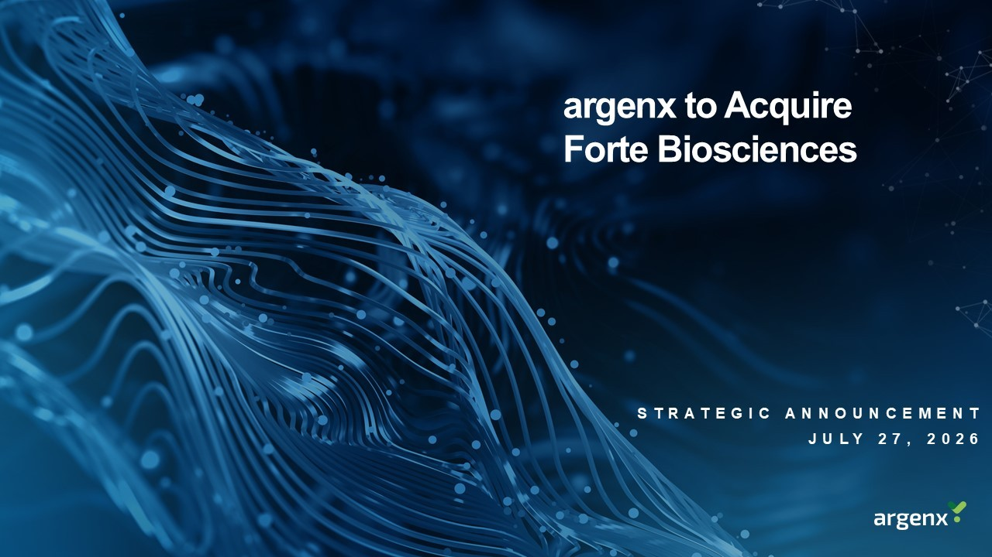
argenx to Acquire Forte Biosciences STRATEGIC ANNOUNCEMENT JULY 27 , 2026

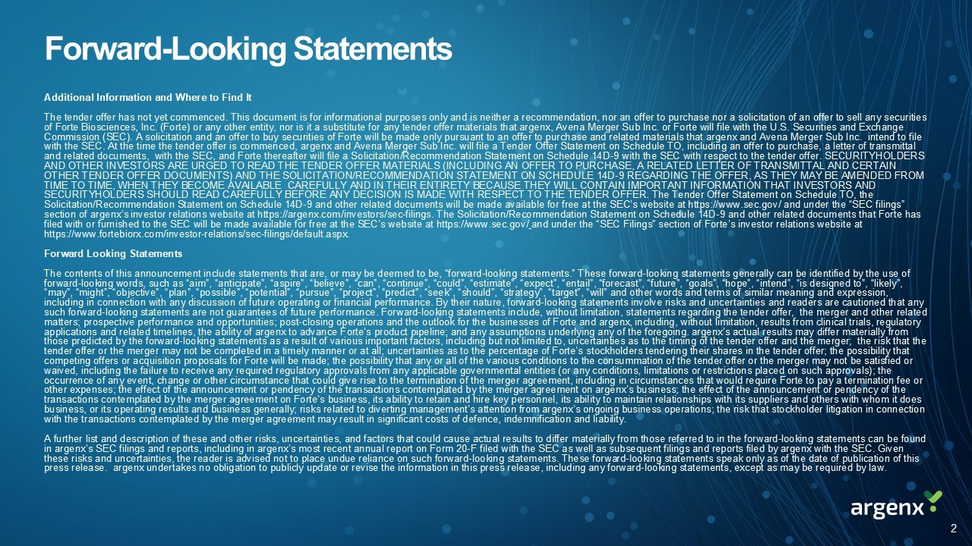
Forward - Looking Statements Additional Information and Where to Find It The tender offer has not yet commenced. This document is for informational purposes only and is neither a recommendation, nor an offer to purchase nor a solicitation of an offer to sell any securities of Forte Biosciences, Inc. (Forte) or any other entity, nor is it a substitute for any tender offer materials that argenx , Avena Merger Sub Inc. or Forte will file with the U.S. Securities and Exchange Commission (SEC). A solicitation and an offer to buy securities of Forte will be made only pursuant to an offer to purchase a nd related materials that argenx and Avena Merger Sub Inc. intend to file with the SEC. At the time the tender offer is commenced, argenx and Avena Merger Sub Inc. will file a Tender Offer Statement on Schedule TO, including an offer to purchase, a letter of tran sm ittal and related documents, with the SEC, and Forte thereafter will file a Solicitation/Recommendation Statement on Schedule 14D - 9 w ith the SEC with respect to the tender offer. SECURITYHOLDERS AND OTHER INVESTORS ARE URGED TO READ THE TENDER OFFER MATERIALS (INCLUDING AN OFFER TO PURCHASE, A RELATED LETTER OF TRANSMI TTA L AND CERTAIN OTHER TENDER OFFER DOCUMENTS) AND THE SOLICITATION/RECOMMENDATION STATEMENT ON SCHEDULE 14D - 9 REGARDING THE OFFER, AS THEY MAY B E AMENDED FROM TIME TO TIME, WHEN THEY BECOME AVAILABLE CAREFULLY AND IN THEIR ENTIRETY BECAUSE THEY WILL CONTAIN IMPORTANT INFORMATION THA T I NVESTORS AND SECURITYHOLDERS SHOULD READ CAREFULLY BEFORE ANY DECISION IS MADE WITH RESPECT TO THE TENDER OFFER. The Tender Offer Statemen t o n Schedule TO, the Solicitation/Recommendation Statement on Schedule 14D - 9 and other related documents will be made available for free at the SEC’s website at https:// www.sec.gov / and under the “SEC filings” section of argenx’s investor relations website at https:// argenx.com /investors/sec - filings. The Solicitation/Recommendation Statement on Schedule 14D - 9 and other related documents that Forte has filed with or furnished to the SEC will be made available for free at the SEC’s website at https:// www.sec.gov / and under the “SEC Filings” section of Forte’s investor relations website at https:// www.fortebiorx.com /investor - relations/sec - filings/ default.aspx . Forward Looking Statements The contents of this announcement include statements that are, or may be deemed to be, “forward - looking statements.” These forwa rd - looking statements generally can be identified by the use of forward - looking words, such as “aim”, “anticipate”, “aspire”, “believe”, “can”, “continue”, “could”, “estimate”, “expect”, “enta il”, “forecast”, “future”, “goals”, “hope”, “intend”, “is designed to”, “likely”, “may”, “might”, “objective”, “plan”, “possible”, “potential”, “pursue”, “project”, “predict”, “seek”, “should”, “strategy”, “ tar get”, “will” and other words and terms of similar meaning and expression, including in connection with any discussion of future operating or financial performance. By their nature, forward - looking state ments involve risks and uncertainties and readers are cautioned that any such forward - looking statements are not guarantees of future performance. Forward - looking statements include, without limitation , statements regarding the tender offer, the merger and other related matters; prospective performance and opportunities; post - closing operations and the outlook for the businesses of Forte and argenx , including, without limitation, results from clinical trials, regulatory applications and related timelines, the ability of argenx to advance Forte’s product pipeline; and any assumptions underlying any of the foregoing. argenx’s actual results may differ materially from those predicted by the forward - looking statements as a result of various important factors, including but not limited to, uncert ainties as to the timing of the tender offer and the merger; the risk that the tender offer or the merger may not be completed in a timely manner or at all; uncertainties as to the percentage of Forte’s s toc kholders tendering their shares in the tender offer; the possibility that competing offers or acquisition proposals for Forte will be made; the possibility that any or all of the various conditions t o t he consummation of the tender offer or the merger may not be satisfied or waived, including the failure to receive any required regulatory approvals from any applicable governmental entities (or any con ditions, limitations or restrictions placed on such approvals); the occurrence of any event, change or other circumstance that could give rise to the termination of the merger agreement, includ ing in circumstances that would require Forte to pay a termination fee or other expenses; the effect of the announcement or pendency of the transactions contemplated by the merger agreement on argenx’s business; the effect of the announcement or pendency of the transactions contemplated by the merger agreement on Forte’s business, its ability to retain and hire key personnel, its abil ity to maintain relationships with its suppliers and others with whom it does business, or its operating results and business generally; risks related to diverting management’s attention from argenx’s ongoing business operations; the risk that stockholder litigation in connection with the transactions contemplated by the merger agreement may result in significant costs of defence, indemnification and li abi lity. A further list and description of these and other risks, uncertainties, and factors that could cause actual results to differ ma terially from those referred to in the forward - looking statements can be found in argenx’s SEC filings and reports, including in argenx’s most recent annual report on Form 20 - F filed with the SEC as well as subsequent filings and reports filed by argenx with the SEC. Given these risks and uncertainties, the reader is advised not to place undue reliance on such forward - looking statements. These forwa rd - looking statements speak only as of the date of publication of this press release. argenx undertakes no obligation to publicly update or revise the information in this press release, including any forward - looking stat ements, except as may be required by law. 2

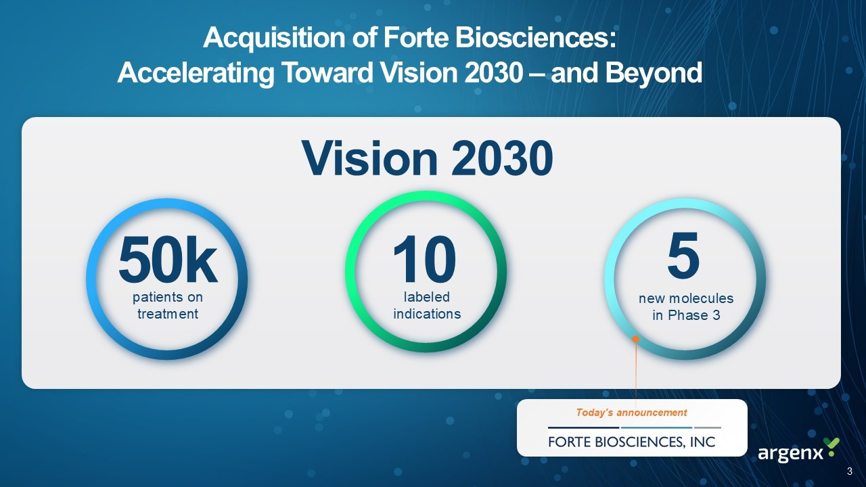
50 k 10 5 patients on treatment labeled indications new molecules in Phase 3 Vision 2030 Today’s announcement 3 Acquisition of Forte Biosciences: Accelerating Toward Vision 2030 – and Beyond

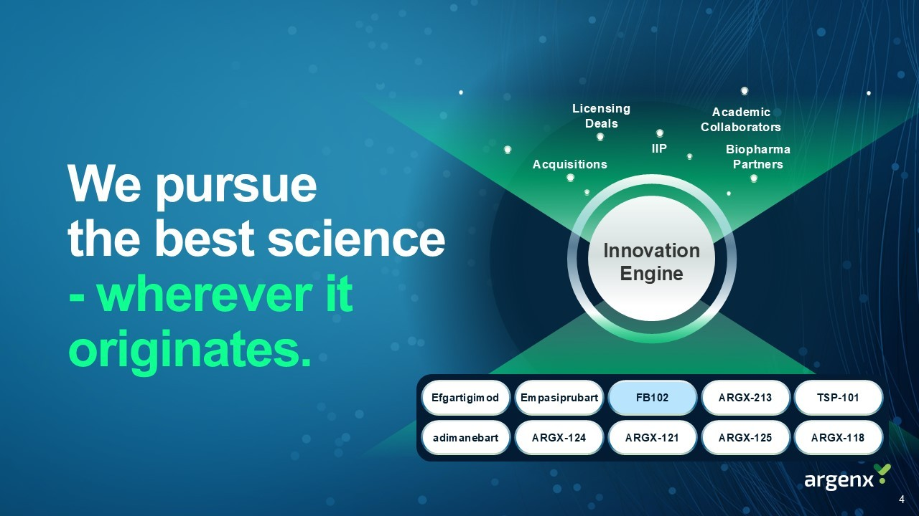
IIP Academic Collaborators Biopharma Partners Acquisitions Licensing Deals We pursue the best science - wherever it originates. Efgartigimod Empasiprubart ARGX - 213 ARGX - 124 ARGX - 121 ARGX - 125 ARGX - 118 FB102 adimanebart TSP - 101 4 Innovation Engine

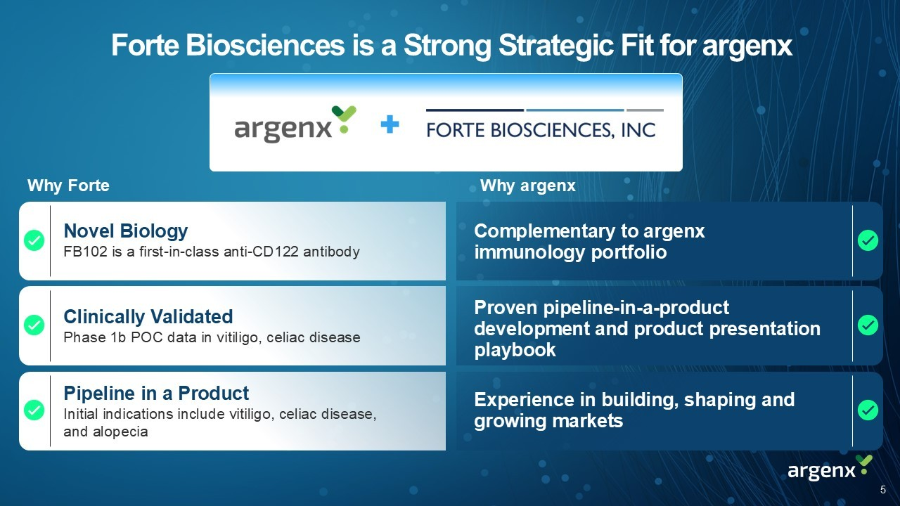
Forte Biosciences is a Strong Strategic Fit for argenx Complementary to argenx immunology portfolio Proven pipeline - in - a - product development and product presentation playbook Experience in building, shaping and growing markets Novel Biology FB102 is a first - in - class anti - CD122 antibody Clinically Validated Phase 1b POC data in vitiligo, celiac disease Pipeline in a Product Initial indications include vitiligo, celiac disease, and alopecia Why argenx Why Forte 5

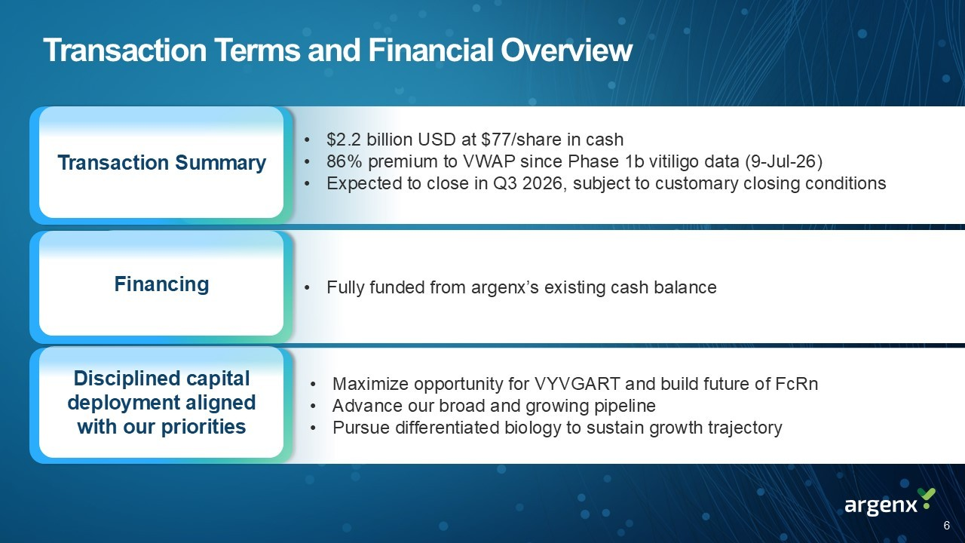
Transaction Terms and Financial Overview Transaction Summary • $2.2 billion USD at $77/share in cash • 86% premium to VWAP since Phase 1b vitiligo data (9 - Jul - 26) • Expected to close in Q3 2026, subject to customary closing conditions • Fully funded from argenx’s existing cash balance • Maximize opportunity for VYVGART and build future of FcRn • Advance our broad and growing pipeline • Pursue differentiated biology to sustain growth trajectory Financing Capital Impact Transaction Summary Financing Disciplined capital deployment aligned with our priorities 6

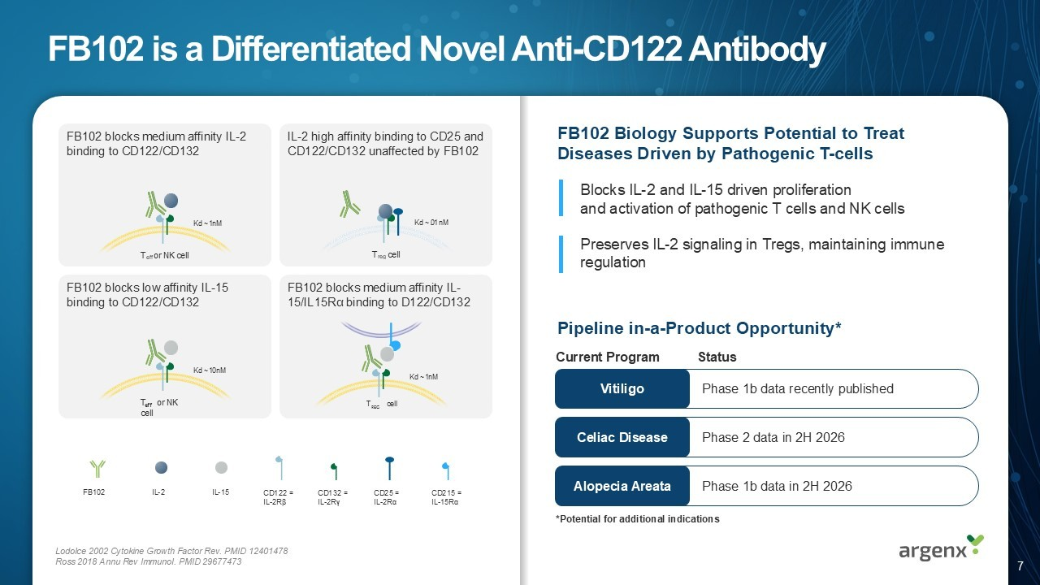
Phase 2 data in 2H 2026 Phase 1b data recently published Phase 1b data in 2H 2026 FB102 is a Differentiated Novel Anti - CD122 Antibody FB102 IL - 2 IL - 15 CD122 = IL - 2R β CD132 = IL - 2R γ CD25 = IL - 2R α CD215 = IL - 15R α Lodolce 2002 Cytokine Growth Factor Rev. PMID 12401478 Ross 2018 Annu Rev Immunol. PMID 29677473 Kd ~ 1 nM T eff or NK cell Kd ~ 1 nM Kd ~ 10 nM eff T or NK cell Kd ~ .01 nM T reg cell FB102 blocks medium affinity IL - 2 binding to CD122/CD132 IL - 2 high affinity binding to CD25 and CD122/CD132 unaffected by FB102 FB102 blocks low affinity IL - 15 binding to CD122/CD132 FB102 blocks medium affinity IL - 15/IL15Rα binding to D122/CD132 REG T cell Blocks IL - 2 and IL - 15 driven proliferation and activation of pathogenic T cells and NK cells Preserves IL - 2 signaling in Tregs , maintaining immune regulation Pipeline in - a - Product Opportunity* Celiac Disease Alopecia Areata Vitiligo Current Program Status FB102 Biology Supports Potential to Treat Diseases Driven by Pathogenic T - cells *Potential for additional indications 7

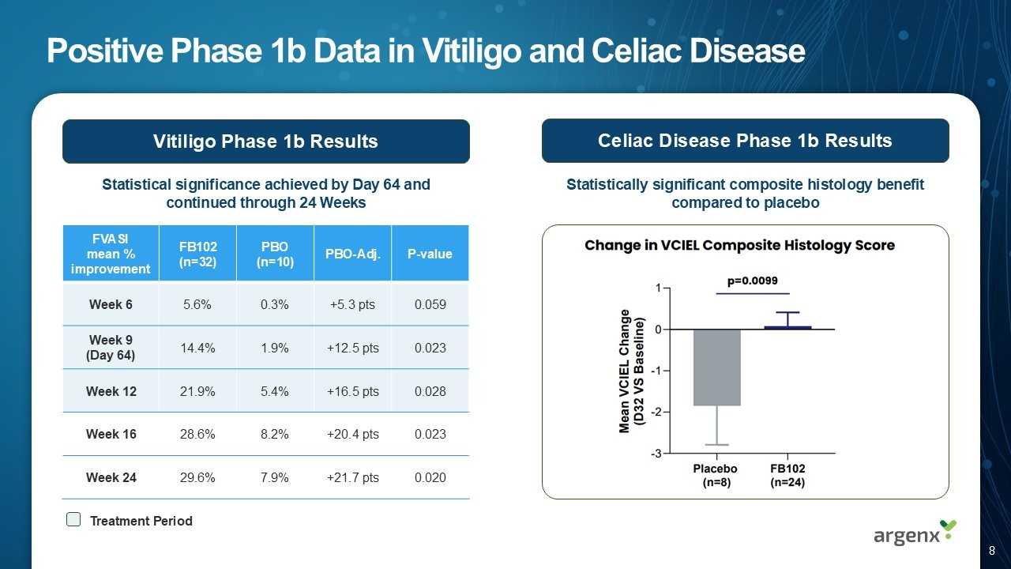
Positive Phase 1b Data in Vitiligo and Celiac Disease P - value PBO - Adj. PBO (n=10) FB102 (n=32) FVASI mean % improvement 0.059 +5.3 pts 0.3% 5.6% Week 6 0.023 +12.5 pts 1.9% 14.4% Week 9 (Day 64) 0.028 +16.5 pts 5.4% 21.9% Week 12 0.023 +20.4 pts 8.2% 28.6% Week 16 0.020 +21.7 pts 7.9% 29.6% Week 24 Statistical significance achieved by Day 64 and continued through 24 Weeks Treatment Period Vitiligo Phase 1b Results Celiac Disease Phase 1b Results Statistically s ignifican t c omposite histology b enefit compared to placebo 8

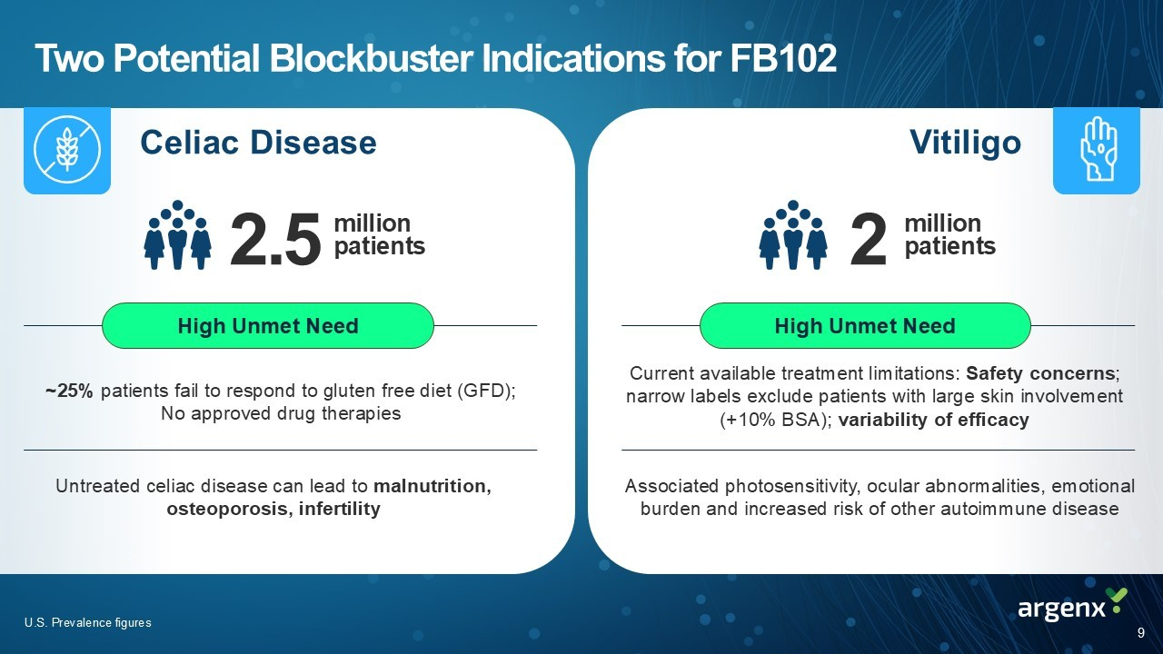
Two Potential Blockbuster Indications for FB102 Celiac Disease Vitiligo Untreated celiac disease can lead to malnutrition, osteoporosis, infertility ~25% patients fail to respond to gluten free diet (GFD); No approved drug therapies Associated photosensitivity, ocular abnormalities, emotional burden and increased risk of other autoimmune disease Current available treatment limitations: Safety concerns ; narrow labels exclude patients with large skin involvement (+10% BSA); variability of efficacy 2.5 million patients 2 million patients High Unmet Need High Unmet Need U.S. Prevalence figures 9

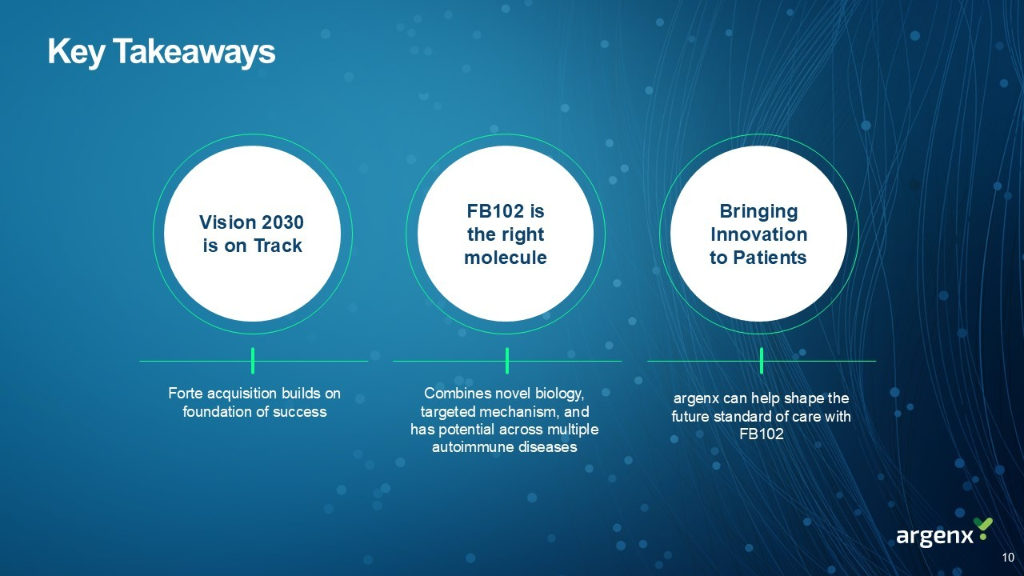
Key Takeaways Vision 2030 is on Track FB102 is the right molecule Bringing Innovation to Patients Forte acquisition builds on foundation of success argenx can help shape the future standard of care with FB102 Combines novel biology, targeted mechanism, and has potential across multiple autoimmune diseases 10

Exhibit 99.3

LinkedIn



