UNITED STATES
SECURITIES AND EXCHANGE COMMISSION
WASHINGTON, D.C. 20549

FORM 6-K
REPORT OF FOREIGN PRIVATE ISSUER
PURSUANT TO RULE 13a-16 OR 15d-16
UNDER THE SECURITIES EXCHANGE ACT OF 1934

For the Month of October 2026

Commission File Number: 001-38097

ARGENX SE
(Translation of registrant’s name into English)
Laarderhoogtweg 25
1101 EB Amsterdam, the Netherlands
(Address of principal executive offices)
Indicate by check mark whether the registrant files or will file annual reports under cover of Form 20-F or Form 40-F.

Form 20-F ⌧ Form 40-F ☐

Indicate by check mark if the registrant is submitting the Form 6-K in paper as permitted by Regulation S-T Rule 101(b) (1): ☐
Indicate by check mark if the registrant is submitting the Form 6-K in paper as permitted by Regulation S-T Rule 101(b)(7): ☐

EXPLANATORY NOTE
On October 22, 2026, argenx SE (the “Company’’) issued a press release and an investor presentation, copies of which are attached hereto as Exhibits 99.1 and 99.2, respectively, and are incorporated by reference herein.
The information contained in this Current Report on Form 6-K, including Exhibit 99.1 and Exhibit 99.2, shall be deemed to be incorporated by reference into the Company’s Registration Statements on Forms S-8 (File Nos. 333-225375, 333-258253, 333-274721, and 333-292200), and to be part thereof from the date on which this Current Report on Form 6-K is filed, to the extent not superseded by documents or reports subsequently filed or furnished.

EXHIBITS
Exhibit |  |  |  |  |  | Description
99.1 |  |  |  |  |  | Press Release dated October 22, 2026
99.2 |  |  |  |  |  | Investor Presentation dated October 22, 2026

SIGNATURES

Pursuant to the requirements of the Securities Exchange Act of 1934, the registrant has duly caused this report to be signed on its behalf by the undersigned, thereunto duly authorized.

 |  |  |  |  |  | ARGENX SE
Date: October 22, 2026 |  |  | By: |  |  | /s/ Hemamalini (Malini) Moorthy
 |  |  |  |  |  | Hemamalini (Malini) Moorthy
 |  |  |  |  |  | General Counsel



argenx Reports Third Quarter 2026 Financial Results and Provides Business Update
Continued strong VYVGART performance drives $1.7 billion in global product net sales, representing 54% year-over-year growth and 13% quarter-over-quarter growth

sBLA for VYVGART Hytrulo in IMNM on track for submission by year-end; pursuing additional registrational study in DM

Phase 3 MMN data for empasiprubart expected in December 2026

FB102 advancing to Phase 3 in celiac disease as potential new growth pillar in argenx’s next wave of immunology innovation

Management to host conference call today at 2:30 PM CET (8:30 AM ET)

October 22, 2026 7:00 AM CET

Amsterdam, the Netherlands – argenx SE (Euronext & Nasdaq: ARGX), the immunology innovation company, today announced its third quarter 2026 results and provided a business update.

“The story of argenx is one of continued innovation, growth and impact,” said Karen Massey, Chief Executive Officer. “VYVGART is the foundation of our business and continues to deliver strong performance across gMG and CIDP, with significant opportunity still ahead as we reach more patients, expand into new indications, and advance the next wave of FcRn medicines. The positive results from our Phase 3 ALKIVIA study further reinforce the potential of VYVGART beyond neurology, and underscore how much more it can deliver for patients. The upcoming Phase 3 readout for empasiprubart in MMN, the advancement of FB102, and progress across our emerging immunology pipeline are bringing the next chapter of argenx into focus as we build a global immunology innovator positioned for durable growth and value creation well beyond Vision 2030.”

Vision 2030

argenx remains on track to achieve its ‘Vision 2030’ anchored in the ambition to treat 50,000 patients globally with its medicines, secure 10 labeled indications, and progress five pipeline candidates into registrational development by 2030.

Realizing the full potential of VYVGART and advancing FcRn leadership

VYVGART® (IV: efgartigimod alfa-fcab; SC: efgartigimod alfa and hyaluronidase-qvfc) is the first-and-only approved treatment for all adult patients living with generalized myasthenia gravis (gMG). It is also approved for chronic inflammatory demyelinating polyneuropathy (CIDP) globally, and primary immune thrombocytopenia (ITP) in Japan. Building on VYVGART’s leadership in MG and CIDP, argenx is progressing multiple label and indication expansions, exploring VYVGART’s potential in additional autoimmune diseases through proof-of-concept studies, and advancing next-generation FcRn molecules and delivery modalities.
•Generated $1.7 billion in global product net sales in the third quarter of 2026, representing 54% year-over-year growth and 13% quarter-over-quarter growth
•Submitted a Supplemental Biologics License Application (sBLA) for VYVGART in ocular myasthenia gravis (oMG) to the U.S. Food and Drug Administration (FDA)
•sBLA for VYVGART and VYVGART Hytrulo in pediatric gMG accepted for priority review by the FDA, with a PDUFA target action date in February 2027
•VYVGART Hytrulo autoinjector expected to launch in second half of 2027 for all approved indications
•Reported positive Phase 3 ALKIVIA results with consistent and clinically meaningful treatment effects observed across immune-mediated necrotizing myopathy (IMNM) and dermatomyositis (DM); sBLA for VYVGART Hytrulo in IMNM on track for submission by year-end 2026, supported by Breakthrough Therapy Designation, with plans to conduct an additional registrational study in DM.
•Topline results from Phase 3 ADVANCE-NEXT study in primary ITP expected in first half of 2027
•Phase 3 VitaliThy studies in Graves’ disease ongoing;
•Advancing the future FcRn portfolio, including Phase 3-ready ARGX-213, designed for monthly dosing, and ARGX-124 currently in Phase 1 development

Advancing empasiprubart, argenx’s second pipeline-in-a-product opportunity

Empasiprubart (anti-C2) is argenx’s second pipeline-in-a-product opportunity and is being evaluated in Phase 3 studies in multifocal motor neuropathy (MMN) and CIDP, with additional Phase 2 studies exploring its potential in other indications and in combination with VYVGART in gMG.

•Topline results from the Phase 3 EMPASSION study (MMN) expected in December 2026
•Topline results from Phase 3 EMVIGORATE and EMNERGIZE studies in CIDP anticipated in the second half of 2027
•Phase 2 ADAPT-Forward platform study in gMG ongoing, evaluating empasiprubart as an add-on to efgartigimod and as monotherapy to support combination development pathway

Delivering next wave of immunology innovation

Beyond the FcRn portfolio and empasiprubart, argenx is advancing a differentiated immunology pipeline that includes FB102 (CD122), adimanebart (MuSK), ARGX-121 (IgA), ARGX-109 (IL-6), TSP-101 (Fn14), ARGX-118 (Galectin-10) and ARGX-125 (undisclosed target), together with additional candidates emerging from the Immunology Innovation Program. These programs support argenx’s ambition to build multiple pillars of sustainable growth beyond Vision 2030.

•Advancing FB102 to Phase 3 in celiac disease based on positive Phase 2 results, with ongoing programs in alopecia areata and vitiligo and potential across other autoimmune diseases
•Phase 3 study of adimanebart in congenital myasthenic syndromes (CMS) expected to begin in 2026; Phase 2 in spinal muscular atrophy (SMA) ongoing
•Phase 2 study of ARGX-121 in IgA nephropathy (IgAN) ongoing
•Advancing Phase 1 development of TSP-101, ARGX-118 and ARGX-125

THIRD QUARTER 2026 FINANCIAL RESULTS
argenx SE
UNAUDITED CONDENSED CONSOLIDATED INTERIM STATEMENTS OF PROFIT OR LOSS
 |  |  |  |  |  | Three Months Ended |  |  |  |  |  |  |  |  |  |  |  |  |  |  |  |  |  | Nine Months Ended
 |  |  |  |  |  | September 30, |  |  |  |  |  |  |  |  |  |  |  |  |  |  |  |  |  | September 30,
(in millions of $ except for per share data) |  |  |  |  |  | 2026 |  |  |  |  |  |  |  |  | 2025 |  |  |  |  |  |  |  |  | 2026 |  |  |  |  |  |  |  |  |  |  |  | 2025
Product net sales |  |  |  |  |  | $ |  |  | 1,721 |  |  |  |  |  | $ |  |  | 1,127 |  |  |  |  |  | $ |  |  | 4,534 |  |  |  |  |  | $ |  |  | 2,866
Other operating income |  |  |  |  |  |  |  |  | 30 |  |  |  |  |  |  |  |  | 24 |  |  |  |  |  |  |  |  | 71 |  |  |  |  |  |  |  |  | 60
Total operating income |  |  |  |  |  | $ |  |  | 1,751 |  |  |  |  |  | $ |  |  | 1,151 |  |  |  |  |  | $ |  |  | 4,605 |  |  |  |  |  | $ |  |  | 2,926
Cost of sales |  |  |  |  |  | $ |  |  | (165) |  |  |  |  |  | $ |  |  | (109) |  |  |  |  |  | $ |  |  | (431) |  |  |  |  |  | $ |  |  | (301)
Research and development expenses* |  |  |  |  |  |  |  |  | (503) |  |  |  |  |  |  |  |  | (359) |  |  |  |  |  |  |  |  | (1,432) |  |  |  |  |  |  |  |  | (1,001)
Selling, general and administrative expenses |  |  |  |  |  |  |  |  | (598) |  |  |  |  |  |  |  |  | (336) |  |  |  |  |  |  |  |  | (1,370) |  |  |  |  |  |  |  |  | (937)
Total operating expenses |  |  |  |  |  | $ |  |  | (1,266) |  |  |  |  |  | $ |  |  | (805) |  |  |  |  |  | $ |  |  | (3,233) |  |  |  |  |  | $ |  |  | (2,240)
Operating profit |  |  |  |  |  | $ |  |  | 486 |  |  |  |  |  | $ |  |  | 346 |  |  |  |  |  | $ |  |  | 1,372 |  |  |  |  |  | $ |  |  | 686
Financial income |  |  |  |  |  | $ |  |  | 45 |  |  |  |  |  | $ |  |  | 43 |  |  |  |  |  | $ |  |  | 137 |  |  |  |  |  | $ |  |  | 118
Financial expense |  |  |  |  |  |  |  |  | (1) |  |  |  |  |  |  |  |  | (1) |  |  |  |  |  |  |  |  | (3) |  |  |  |  |  |  |  |  | (3)
Exchange gains/(losses) |  |  |  |  |  |  |  |  | 8 |  |  |  |  |  |  |  |  | (2) |  |  |  |  |  |  |  |  | (11) |  |  |  |  |  |  |  |  | 74
Profit for the period before taxes |  |  |  |  |  | $ |  |  | 538 |  |  |  |  |  | $ |  |  | 386 |  |  |  |  |  | $ |  |  | 1,495 |  |  |  |  |  | $ |  |  | 875
Income tax expense |  |  |  |  |  | $ |  |  | (32) |  |  |  |  |  | $ |  |  | (42) |  |  |  |  |  | $ |  |  | (151) |  |  |  |  |  | $ |  |  | (116)
Profit for the period |  |  |  |  |  | $ |  |  | 506 |  |  |  |  |  | $ |  |  | 344 |  |  |  |  |  | $ |  |  | 1,344 |  |  |  |  |  | $ |  |  | 759
Profit for the period attributable to:
Owners of the parent |  |  |  |  |  | $ |  |  | 506 |  |  |  |  |  | $ |  |  | 344 |  |  |  |  |  | $ |  |  | 1,344 |  |  |  |  |  | $ |  |  | 759
Weighted average number of shares used for basic profit per share |  |  |  |  |  |  |  |  | 62,735,385 |  |  |  |  |  |  |  |  | 61,371,508 |  |  |  |  |  |  |  |  | 62,370,746 |  |  |  |  |  |  |  |  | 61,147,873
Basic profit per share (in $) |  |  |  |  |  |  |  |  | 8.07 |  |  |  |  |  |  |  |  | 5.61 |  |  |  |  |  |  |  |  | 21.54 |  |  |  |  |  |  |  |  | 12.41
Weighted average number of shares used for diluted profit per share |  |  |  |  |  |  |  |  | 64,886,406 |  |  |  |  |  |  |  |  | 66,441,326 |  |  |  |  |  |  |  |  | 64,578,235 |  |  |  |  |  |  |  |  | 65,944,952
Diluted profit per share (in $) |  |  |  |  |  |  |  |  | 7.80 |  |  |  |  |  |  |  |  | 5.18 |  |  |  |  |  |  |  |  | 20.81 |  |  |  |  |  |  |  |  | 11.51
*Comparative figures have been aligned with the presentation adopted in the current period, reflecting the combination of research and development expenses and loss from investment in a joint venture.

DETAILS OF THE FINANCIAL RESULTS
Total operating income for the three and nine months ended September 30, 2026 was $1.8 billion and $4.6 billion, respectively, compared to $1.2 billion and $2.9 billion, respectively, for the same periods in 2025, and mainly consisted of:
•Product net sales of VYVGART for the three and nine months ended September 30, 2026, were $1.7 billion and $4.5 billion, respectively, compared to $1.1 billion and $2.9 billion, respectively, for the same periods in 2025.

•Other operating income for the three and nine months ended September 30, 2026 was $30 million and $71 million, respectively, compared to $24 million and $60 million, respectively, for the same periods in 2025. The other operating income in these periods primarily related to research and development tax incentives and payroll tax rebates.
Total operating expenses for the three and nine months ended September 30, 2026 were $1.3 billion and $3.2 billion, respectively, compared to $0.8 billion and $2.2 billion, respectively, for the same periods in 2025, and mainly consisted of:
•Cost of sales for the three and nine months ended September 30, 2026 was $165 million and $431 million, respectively, compared to $109 million and $301 million, respectively, for the same periods in 2025. The cost of sales was related to the sale of VYVGART.

•Research and development expenses for the three and nine months ended September 30, 2026 were $0.5 billion and $1.4 billion, respectively, compared to $0.4 billion and $1.0 billion, respectively, for the same periods in 2025. The research and development expenses mainly related to advancing efgartigimod, empasiprubart, adimanebart and FB102 across multiple registrational studies, plus early-stage pipeline and preclinical programs.
•Selling, general and administrative expenses for the three and nine months ended September 30, 2026 were $0.6 billion and $1.4 billion, respectively, compared to $0.3 billion and $0.9 billion, respectively, for the same periods in 2025. The selling, general and administrative expenses mainly related to professional and marketing fees linked to the global commercialization of the VYVGART franchise, and personnel expenses. Selling, general and administrative expenses for the three- and nine-month periods ended September 30, 2026 included approximately $150 million of acquisition-related expenses associated with the Company’s acquisition of Forte Biosciences Inc.
Financial income for the three and nine months ended September 30, 2026 was $45 million and $137 million, respectively, compared to $43 million and $118 million, respectively, for the same periods in 2025.
Exchange gains/losses for the three and nine months ended September 30, 2026 were an $8 million gain and an $11 million loss, respectively, compared to a $2 million loss and a $74 million gain, respectively, for the same periods in 2025.
Income tax for the three- and nine-month periods ended September 30, 2026 and 2025 is detailed below:
 |  |  |  |  |  | Three Months Ended |  |  |  |  |  |  |  |  |  |  |  |  |  |  |  |  |  | Nine Months Ended
 |  |  |  |  |  | September 30, |  |  |  |  |  |  |  |  |  |  |  |  |  |  |  |  |  | September 30,
(in millions of $) |  |  |  |  |  | 2026 |  |  |  |  |  |  |  |  | 2025 |  |  |  |  |  |  |  |  | 2026 |  |  |  |  |  |  |  |  | 2025
Current tax expense |  |  |  |  |  | $ |  |  | (129) |  |  |  |  |  | $ |  |  | (52) |  |  |  |  |  | $ |  |  | (359) |  |  |  |  |  | $ |  |  | (122)
Deferred tax benefit |  |  |  |  |  |  |  |  | 97 |  |  |  |  |  |  |  |  | 10 |  |  |  |  |  |  |  |  | 208 |  |  |  |  |  |  |  |  | 6
Income tax expense |  |  |  |  |  | $ |  |  | (32) |  |  |  |  |  | $ |  |  | (42) |  |  |  |  |  | $ |  |  | (151) |  |  |  |  |  | $ |  |  | (116)

Profit for the three- and nine-month periods ended September 30, 2026 was $0.5 billion and $1.3 billion, respectively, compared to $0.3 billion and $0.8 billion, respectively, for the same periods in 2025. The basic profit per share was $8.07 for the three months ended September 30, 2026, compared to $5.61 for the same period in 2025. The basic profit per share was $21.54 for the nine months ended September 30, 2026, compared to $12.41 for the same period in 2025.

Cash, cash equivalents and current financial assets1 consisted of $2.6 billion in cash and cash equivalents and $1.1 billion in current financial assets which totaled $3.7 billion as of September 30, 2026 after paying approximately $2.1 billion for the acquisition of Forte Biosciences Inc., net of acquired cash, compared to $3.5 billion in cash and cash equivalents and $0.9 billion in current financial assets which totaled $4.4 billion as of December 31, 2025.

FULL YEAR EXPECTATIONS

Combined R&D and SG&A expenses are now expected to be approximately $4 billion for 2026, including the Forte transaction-related costs.

EXPECTED FINANCIAL CALENDAR
•February 25, 2027: Full-year 2026 Financial Results and Fourth Quarter 2026 Business Update
•April 29, 2027: First Quarter 2027 Financial Results and Business Update
•July 22, 2027: Half Year and Second Quarter 2027 Financial Results and Business Update
•October 21, 2027: Third Quarter 2027 Financial Results and Business Update

CONFERENCE CALL DETAILS
The third quarter 2026 financial results and business update will be discussed during a conference call and webcast presentation today at 2:30 PM CET/8:30 AM ET. A webcast of the live call may be accessed on the Investors section of the argenx website at argenx.com/investors.

Participants can access the conference call by dialing 800-590-8290 (United States and Canada) or 240-690-8800 (International). Country specific dial-in numbers are listed below:
Belgium |  |  | 32 2290 4635
France |  |  | 33 172 001717
Netherlands |  |  | 31 20 795 2683
United Kingdom |  |  | 44 203 393 1560
Japan |  |  | 81 3 4520 9761
Switzerland |  |  | 41 43 210 51 68
Use the access code 3810049 to join the call. Please dial in 15 minutes prior to the live call.

A replay of the webcast will be available on the argenx website.

1 A non-IFRS Alternative Performance Measure (APM). Refer to the “Alternative Performance Measures Statement” below for a reconciliation to the IFRS financial information.

About VYVGART

VYVGART® (efgartigimod alfa fcab) is a first-in-class human IgG1 antibody fragment that binds to the neonatal Fc receptor (FcRn), resulting in the reduction of circulating IgG autoantibodies. VYVGART Hytrulo® is a subcutaneous combination of efgartigimod alfa (VYVGART) and recombinant human hyaluronidase PH20 (rHuPH20), Halozyme’s ENHANZE® drug delivery technology to facilitate subcutaneous injection delivery of biologics. VYVGART is approved for generalized myasthenia gravis (gMG) and immune thrombocytopenia (Japan only). VYVGART Hytrulo is approved for gMG and chronic inflammatory demyelinating polyneuropathy (CIDP). VYVGART Hytrulo may be marketed under different proprietary names in other regions.

About argenx

argenx is the immunology innovation company, focused on turning immunology breakthroughs into medicines for patients. The company seeks novel biology wherever it emerges, co-creating with academic researchers through its Immunology Innovation Program (IIP) and investing in promising science, to develop treatments for people living with underserved diseases. By advancing molecules with the potential to reach multiple diseases and patient populations, argenx is building a world-class portfolio. This approach produced the first approved antibody fragment targeting the neonatal Fc receptor (FcRn) and today powers a growing pipeline of early and late-stage programs across several therapeutic areas. For more information, visit www.argenx.com and follow us on LinkedIn, Instagram, Facebook, and YouTube.

This press release contains inside information within the meaning of Article 7(1) of the EU Market Abuse Regulation (Regulation 596/2014).

Contacts:
Media:
Ben Petok
bpetok@argenx.com
Investors:
Alexandra Roy
aroy@argenx.com

Forward Looking Statements
The contents of this announcement include statements that are, or may be deemed to be, “forward-looking statements.” These forward-looking statements generally can be identified by the use of forward-looking words, such as “ahead”, “aim”, “ambition,” “anticipate”, “aspire”, “believe”, “can”, “continue”, “could”, “designed for”, “estimate”, “expect”, “entail”, “forecast”, “future”, “goals”, “hope”, “intend”, “is designed to”, “likely”, “may”, “might”, “objective”, “plan”, “possible”, “positioned”, “potential”, “pursue”, “project”, “predict”, “seek”, “should”, “strategy”, “target”, “upcoming”, “will” and other words and terms of similar meaning and expression, including in connection with any discussion of future operating or financial performance. By their nature, forward-looking statements involve risks and uncertainties and readers are cautioned that any such forward-looking statements are not guarantees of future performance. argenx’s actual results may differ materially from those predicted by the forward-looking statements as a result of various important factors, including but not limited to, uncertainties associated with the development of novel drug therapies; the initiation, timing, progress, development and results of preclinical and clinical trials of argenx’s product candidates, including new indications, alternative dosing regimens, treatment modalities, and methods of administration, including statements regarding when results or interim analysis of the clinical trials will be available or made public; the risk that early stage clinical trials may not be predictive of results in later stage or large scale clinical trials; the expansion of argenx’s business, including the further development of argenx’s sales and marketing abilities and its Immunology Innovation Program, and the value of its pipeline; the potential attributes, benefits, and side effects of argenx’s products and product candidates, including new indications, alternative dosing regimens and treatment modalities, and their competitive position with respect to other alternative treatments; argenx’s ability to advance product candidates into, and successfully complete, clinical trials; argenx’s estimates of the number of patients who suffer from the diseases it is targeting and the number of patients that will enroll in its clinical trials; the demand and commercialization of argenx’s products and product candidates, including new indications, alternative dosing regimens, treatment modalities, and methods of administration, if approved; the anticipated timing or likelihood of market or regulatory decisions relating to or of argenx’s products, including new indications, alternative dosing regimens, treatment modalities, and methods of administration; the anticipated pricing and reimbursement of argenx’s products and product candidates, if approved; argenx’s plans to have various programs to help patients afford its products, including patient assistance and co-pay coupon programs for eligible patients; argenx’s ability to establish sales, marketing and distribution capabilities for any of its products and product candidates that achieve regulatory approval; argenx’s regulatory strategy and its ability to establish and maintain manufacturing arrangements for its products and product candidates; the scope and duration of protection, including any exclusivity period, argenx is able to establish and maintain for intellectual property rights covering its products and product candidates, platform and technology, including its intention to seek patent term extensions where available; argenx’s estimates regarding expenses, future revenues, cash flow, capital requirements and its needs for additional financing; argenx’s expectation that it will benefit from the Belgian innovation income deduction; argenx’s financial performance, including potential volatility in the price of its ordinary shares and American Depositary Shares; the acquisition of Forte Biosciences Inc., including argenx’s ability to integrate the acquired business and realize its anticipated benefits; the competition argenx faces in its drug discovery, development, and commercialization efforts; the rate and degree of market acceptance of argenx’s products and product candidates, if approved, by its patients as safe, effective and cost-effective; the potential benefits of argenx’s current collaborations, including the possibility to access partner technology platforms or capabilities; argenx’s plans and ability to enter into or maintain current collaborations for additional programs or product candidates; argenx’s plans and ability to enter into or maintain current new distribution partnerships; argenx’s long-term growth strategy to develop and market additional products and product candidates, including but not limited to, efgartigimod for new indications, empasiprubart, adimanebart, and FB102; the impact of government laws and regulations, including tariffs, export controls, sanctions and other regulations on argenx’s business; argenx’s expectations with respect to the timing and amount of any dividends (if any); argenx’s plans regarding its supply chain, including its reliance on third parties, service providers and manufacturers; inflation and deflation and the corresponding fluctuations in interest rates; regional instability and conflicts; and argenx’s business strategies, including Vision 2030, plans, projects, goals and targets and the timing, outcomes and benefits thereof. A further list and description of these and other risks, uncertainties, and factors that could cause actual results to differ materially from those referred to in the forward-looking statements can be found in argenx’s U.S. Securities and Exchange Commission (SEC) filings and reports, including in argenx’s most recent annual report on Form 20-F filed with the SEC as well as subsequent filings and reports filed by argenx with the SEC. Given these risks and uncertainties, the reader is advised not to place undue reliance on such forward-looking statements. These forward-looking statements speak only as of the date of publication of this press release. argenx undertakes no obligation to publicly update or revise the information in this press release, including any forward-looking statements, except as may be required by law.

Alternative Performance Measures Statement
In this document, argenx's financial results are provided in accordance with IFRS® Accounting Standards (IFRS) and using a non-IFRS financial measure, cash, cash equivalents and current financial assets.
This value should not be viewed as a substitute for the company’s IFRS financial information and is provided as a complement to financial information provided in accordance with IFRS and should be read in conjunction with the most directly comparable IFRS financial information as set out below.
Management believes this non-IFRS financial measure is useful for securities analysts, investors and other interested parties to gain a more complete understanding of the company's available financial liquidities given that the company’s current financial assets are held in term accounts with an initial maturity of more than three months but less than twelve that may be used to meet its financial obligations. Such non-IFRS financial information, as calculated herein, may not be comparable to similarly named measures used by other companies and should not be considered comparable to IFRS financial measures. Non-IFRS financial measures have limitations as an analytical tool and should not be considered in isolation from, or as a substitute for, an analysis of the company's financial results as reported under IFRS.
A reconciliation of the IFRS financial information to non-IFRS financial information is included below:
Cash, cash equivalents and current financial assets totaled $3.7 billion as of September 30, 2026, compared to $4.4 billion as of December 31, 2025. The balance as of the period ended September 30, 2026 consisted of $2.6 billion in cash and cash equivalents and $1.1 billion in current financial assets and the balance as of the period ended December 31, 2025 consisted of $3.5 billion in cash and cash equivalents and $0.9 billion in current financial assets.


Leading a new era of innovation in immunology 3Q 2026 Financial Results Call | October 22,2026


Forward Looking Statements This presentation has been prepared by argenx se (“argenx” or the “company”) for informational purposes only and not for any other purpose. Nothing contained in this presentation is, or should be construed as, a recommendation, promise or representation by the presenter or the company or any director, employee, agent, or adviser of the company. This presentation does not purport to be all-inclusive or to contain all of the information you may desire. Certain information contained in this presentation relates to or is based on studies, publications, surveys and other data obtained from third-party sources and the company’s own internal estimates and research. While argenx believes these third-party studies, publications, surveys and other data to be reliable as of the date of this presentation, it has not independently verified, and makes no representation as to the adequacy, fairness, accuracy or completeness of, any information obtained from third-party sources. In addition, no independent source has evaluated the reasonableness or accuracy of argenx’s internal estimates or research, and no reliance should be made on any information or statements made in this presentation relating to or based on such internal estimates and research. The contents of this presentation include statements that are, or may be deemed to be, “forward-looking statements.” These forward-looking statements generally can be identified by the use of forward-looking words, such as “believe”, “can”, “could”, “estimate”, “expect”, “future”, “goals”, “if approved”, “likely”, “may, “opportunity”, “potential”, “pursue”, “predict”, “should”, “target”, and other words and terms of similar meaning and expression, including in connection with any discussion of future operating or financial performance. By their nature, forward-looking statements involve risks and uncertainties and readers are cautioned that any such forward-looking statements are not guarantees of future performance. argenx’s actual results may differ materially from those predicted by the forward-looking statements as a result of various important factors, including but not limited to, the timing and results of argenx’s clinical trials; uncertainties associated with the development of novel drug therapies; preclinical and clinical trial and product development risks and setbacks; interpretation of argenx’s clinical trial data by regulatory authorities and argenx’s ability to obtain regulatory approval; argenx’s estimates of the number of patients who suffer from the diseases it is targeting; the risk that early stage clinical trials may not be predictive of results in later stage or large scale clinical trials; the occurrence of adverse safety events or participant dropouts; the acceptance of its products and product candidates by its patients as safe, effective, and cost-effective; argenx’s ability to build deep partnerships with patients and physicians; the impact of governmental laws and regulations, including tariffs, export controls, sanctions and other regulations on its business; the impact of healthcare regulations, including rules on reimbursement for argenx’s products; argenx’s estimates regarding expenses and operating margin; the acquisition of Forte Biosciences Inc., including argenx’s ability to integrate the acquired business and realize its anticipated benefits; competition in drug discovery, development and commercialization efforts; argenx’s growth strategy to develop and market additional products and product candidates including but not limited to, efgartigimod for new indications, empasiprubart, adimanebart, and FB102; its reliance on third-party suppliers, service providers and manufacturers; and instability and conflicts in the regions in which the company has suppliers or markets for its products. A further list and description of these and other risks, uncertainties, and factors that could cause actual results to differ materially from those referred to in the forward-looking statements can be found in argenx’s U.S. Securities and Exchange Commission (SEC) filings and reports, including in argenx’s most recent annual report on Form 20-F filed with the SEC as well as subsequent filings and reports filed by argenx with the SEC. Given these risks and uncertainties, the reader is advised not to place undue reliance on such forward-looking statements. These forward-looking statements speak only as of the date of publication of this presentation. argenx undertakes no obligation to publicly update or revise the information in this presentation, including any forward-looking statements, except as may be required by law. This presentation contains trademarks, trade names and service marks of other companies, which are the property of their respective owners. 2

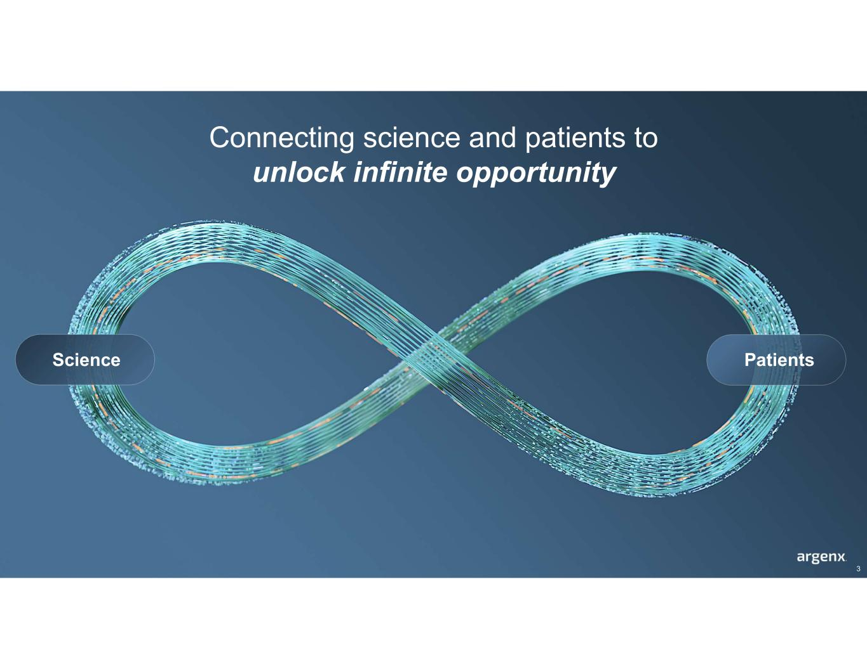
Connecting science and patients to unlock infinite opportunity Science Patients 3

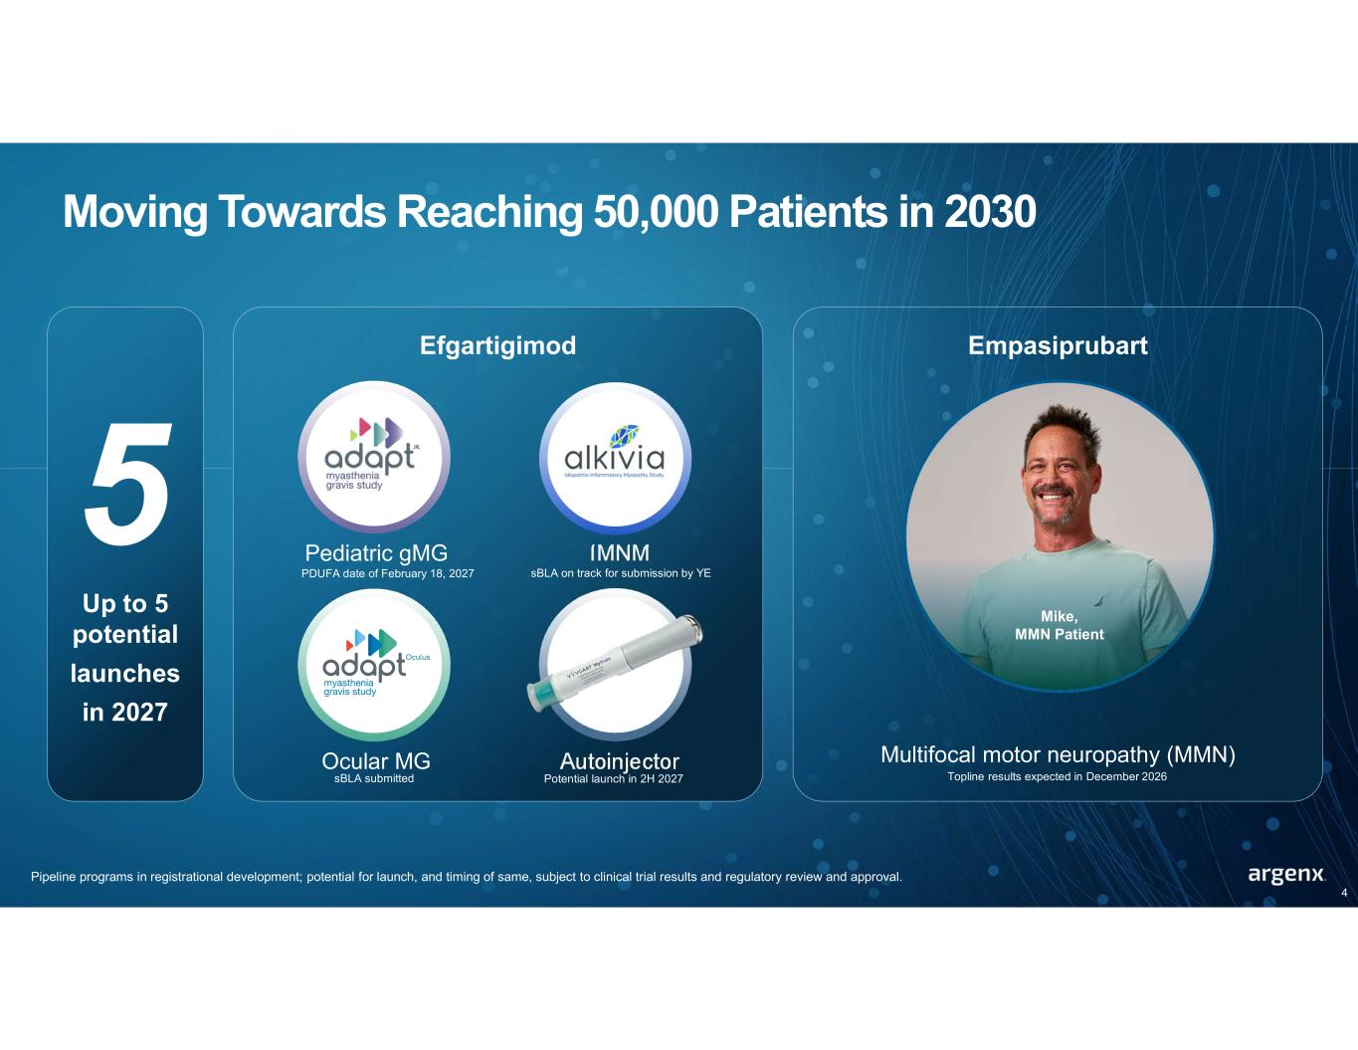
Moving Towards Reaching 50,000 Patients in 2030 Up to 5 potential launches in 2027 Pipeline programs in registrational development; potential for launch, and timing of same, subject to clinical trial results and regulatory review and approval. 4 Efgartigimod Pediatric gMG IMNM Ocular MG Autoinjector PDUFA date of February 18, 2027 sBLA on track for submission by YE sBLA submitted Potential launch in 2H 2027 Empasiprubart Multifocal motor neuropathy (MMN) Mike, MMN Patient Topline results expected in December 2026

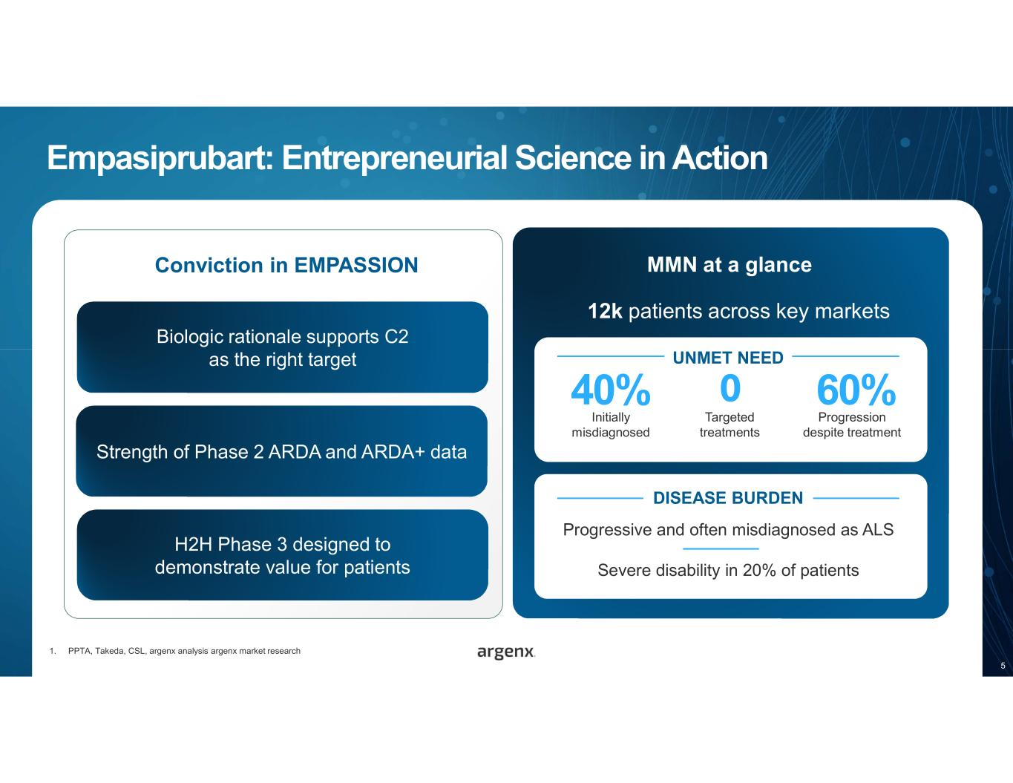
Empasiprubart: Entrepreneurial Science in Action 12k patients across key markets 1. PPTA, Takeda, CSL, argenx analysis argenx market research 60% Progression despite treatment 40% Initially misdiagnosed Targeted treatments 0 UNMET NEED Progressive and often misdiagnosed as ALS Severe disability in 20% of patients DISEASE BURDEN Conviction in EMPASSION Biologic rationale supports C2 as the right target Strength of Phase 2 ARDA and ARDA+ data MMN at a glance 5 H2H Phase 3 designed to demonstrate value for patients

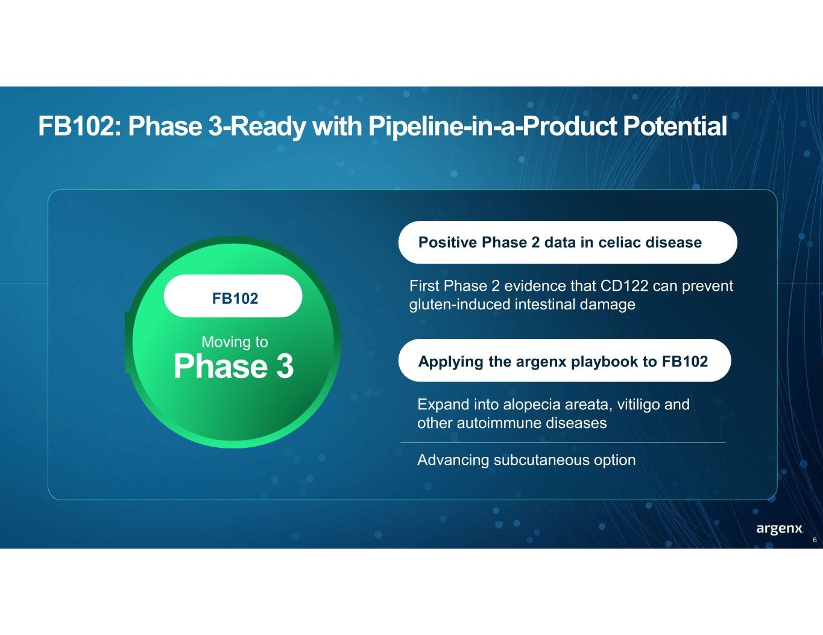
FB102: Phase 3-Ready with Pipeline-in-a-Product Potential Phase 3 Moving to 6 Expand into alopecia areata, vitiligo and other autoimmune diseases Advancing subcutaneous option Positive Phase 2 data in celiac disease Applying the argenx playbook to FB102 First Phase 2 evidence that CD122 can prevent gluten-induced intestinal damageFB102

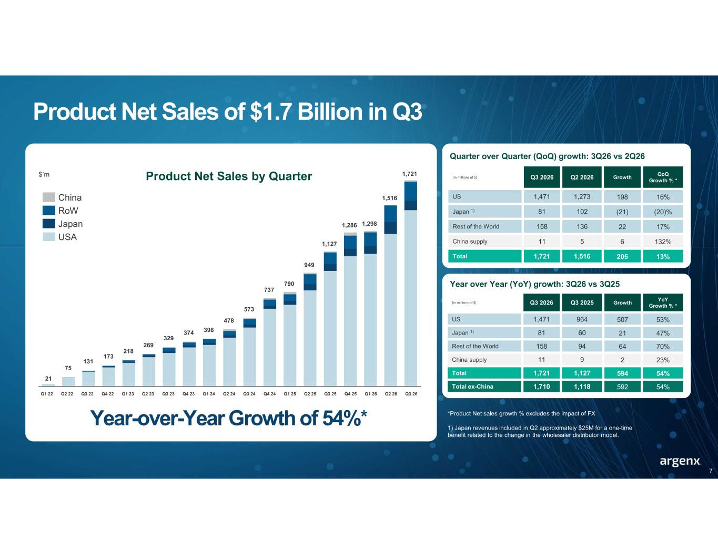
Year-over-Year Growth of 54%* Product Net Sales of $1.7 Billion in Q3 Year over Year (YoY) growth: 3Q26 vs 3Q25 YoY Growth % * GrowthQ3 2025Q3 2026(in millions of $) 53%5079641,471US 47%216081Japan 1) 70%6494158Rest of the World 23%2911China supply 54%5941,1271,721Total 54%5921,1181,710Total ex-China QoQ Growth % * GrowthQ2 2026Q3 2026(in millions of $) 16%1981,2731,471US (20)%(21)10281Japan 1) 17%22136158Rest of the World 132%6511China supply 13%2051,5161,721Total Quarter over Quarter (QoQ) growth: 3Q26 vs 2Q26 *Product Net sales growth % excludes the impact of FX 1) Japan revenues included in Q2 approximately $25M for a one-time benefit related to the change in the wholesaler distributor model. 21 Q2 22 Q3 22 Q4 22 Q1 23 Q2 23 Q3 23 Q4 23 Q1 24 Q2 24 Q3 24 Q4 24 Q1 25 Q2 25 Q3 25 Q4 25 Q1 26 Q2 26 Q3 26Q1 22 Product Net Sales by Quarter 131 173 218 269 329 374 398 478 573 737 790 949 1,127 1,286 1,298 1,516 1,721 75 $’m China RoW Japan USA 7

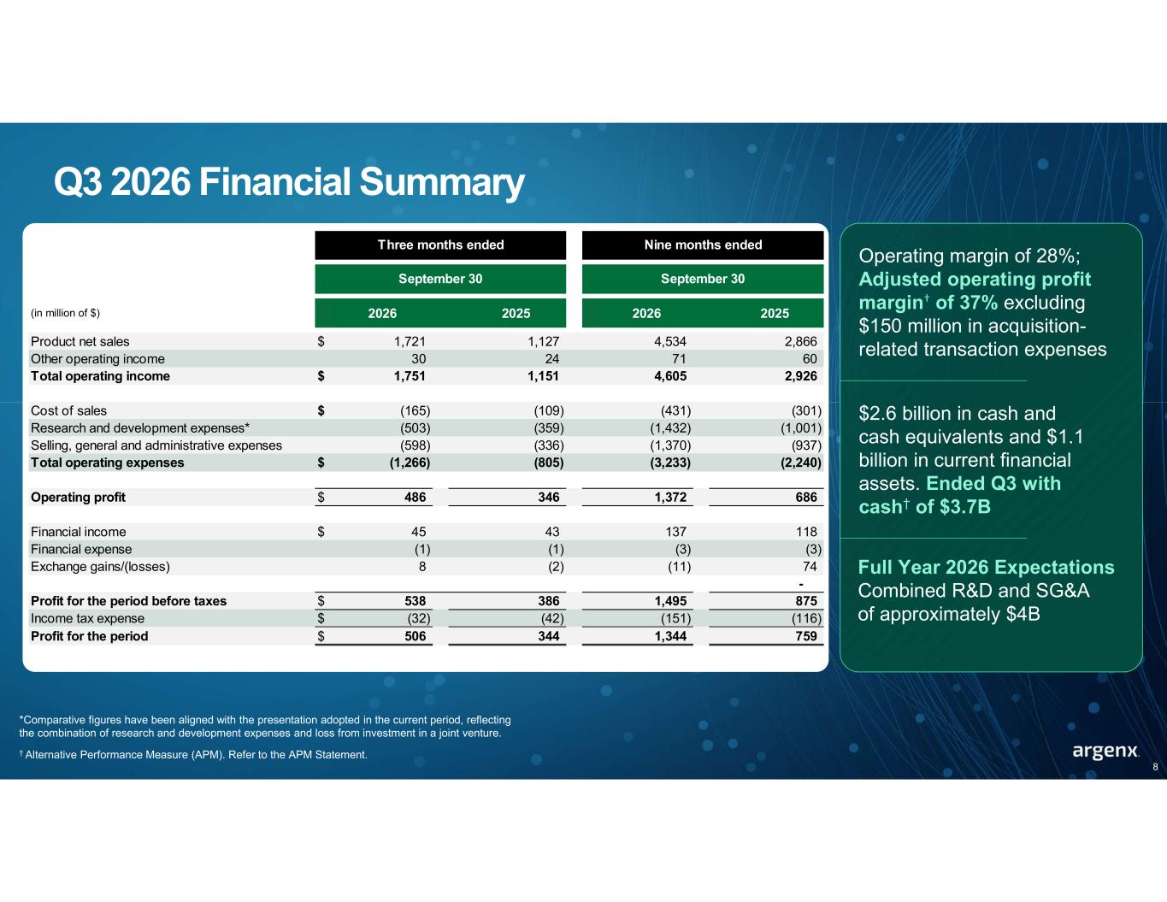
Q3 2026 Financial Summary *Comparative figures have been aligned with the presentation adopted in the current period, reflecting the combination of research and development expenses and loss from investment in a joint venture. † Alternative Performance Measure (APM). Refer to the APM Statement. (in million of $) 2026 2025 2026 2025 Product net sales $ 1,721 1,127 4,534 2,866 Other operating income 30 24 71 60 Total operating income $ 1,751 1,151 4,605 2,926 Cost of sales $ (165) (109) (431) (301) Research and development expenses* (503) (359) (1,432) (1,001) Selling, general and administrative expenses (598) (336) (1,370) (937) Total operating expenses $ (1,266) (805) (3,233) (2,240) Operating profit $ 486 346 1,372 686 Financial income $ 45 43 137 118 Financial expense (1) (1) (3) (3) Exchange gains/(losses) 8 (2) (11) 74 - Profit for the period before taxes $ 538 386 1,495 875 Income tax expense $ (32) (42) (151) (116) Profit for the period $ 506 344 1,344 759 Three months ended September 30 Nine months ended September 30 8 Operating margin of 28%; Adjusted operating profit margin† of 37% excluding $150 million in acquisition- related transaction expenses $2.6 billion in cash and cash equivalents and $1.1 billion in current financial assets. Ended Q3 with cash† of $3.7B Full Year 2026 Expectations Combined R&D and SG&A of approximately $4B

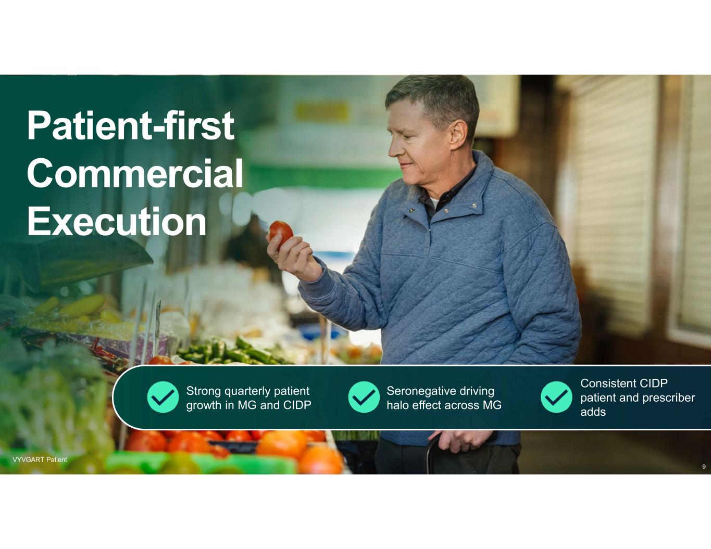
Patient-first Commercial Execution VYVGART Patient Strong quarterly patient growth in MG and CIDP Seronegative driving halo effect across MG Consistent CIDP patient and prescriber adds 9

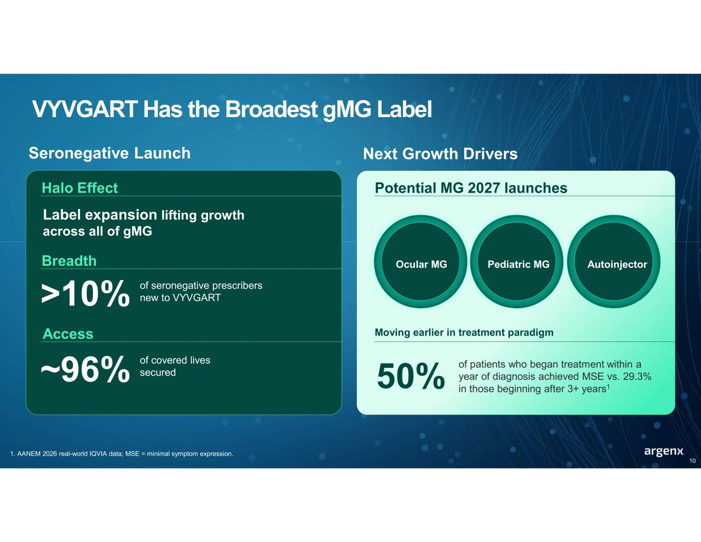
VYVGART Has the Broadest gMG Label 1. AANEM 2026 real-world IQVIA data; MSE = minimal symptom expression. Seronegative Launch Halo Effect Breadth >10% of seronegative prescribers new to VYVGART Access ~96% of covered lives secured Next Growth Drivers Potential MG 2027 launches Moving earlier in treatment paradigm 50% Ocular MG Pediatric MG Autoinjector 10 Label expansion lifting growth across all of gMG of patients who began treatment within a year of diagnosis achieved MSE vs. 29.3% in those beginning after 3+ years1

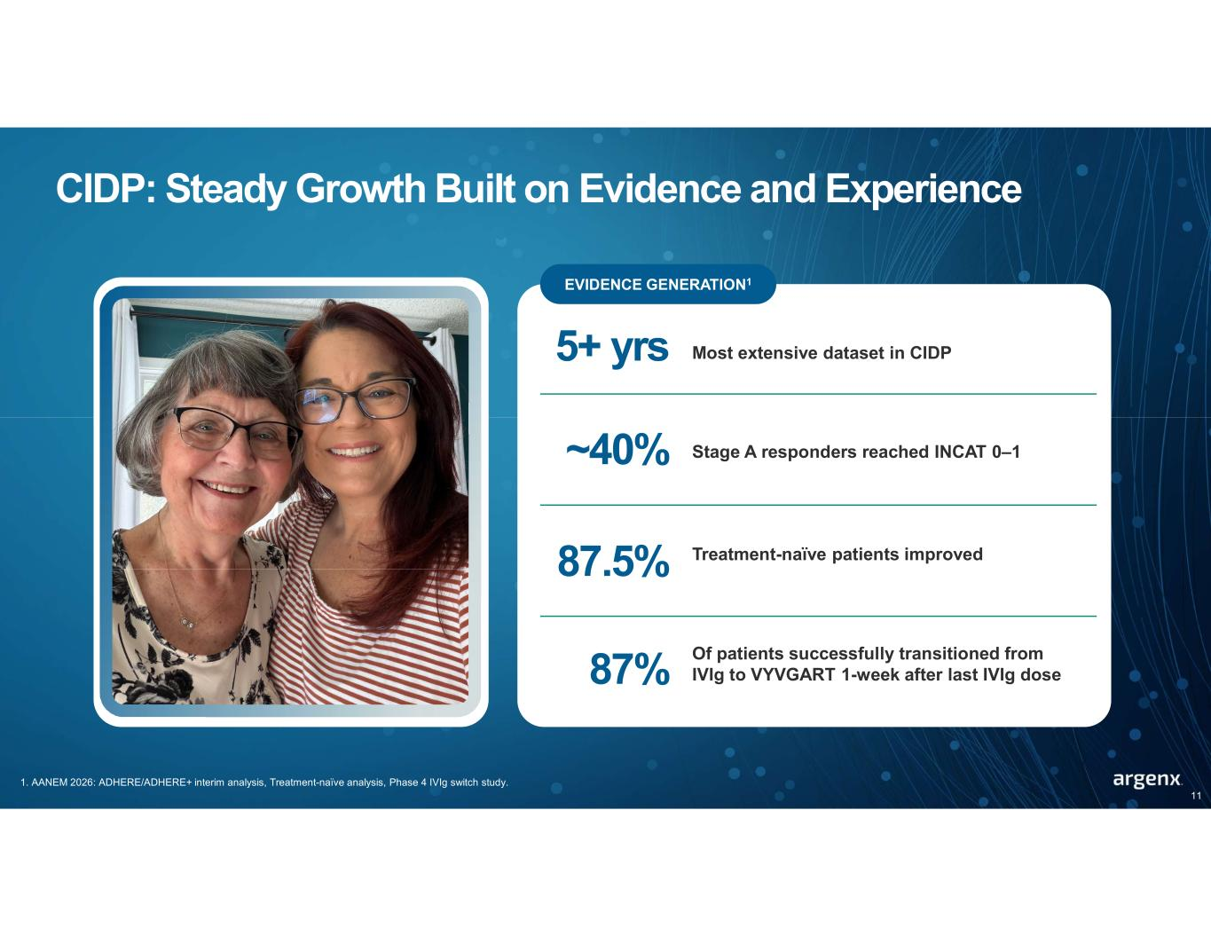
CIDP: Steady Growth Built on Evidence and Experience 1. AANEM 2026: ADHERE/ADHERE+ interim analysis, Treatment-naïve analysis, Phase 4 IVIg switch study. PHOTO: GAYLE Image to come from Cristian EVIDENCE GENERATION1 5+ yrs Most extensive dataset in CIDP ~40% Stage A responders reached INCAT 0–1 87.5% Treatment-naïve patients improved 11 87% Of patients successfully transitioned from IVIg to VYVGART 1-week after last IVIg dose

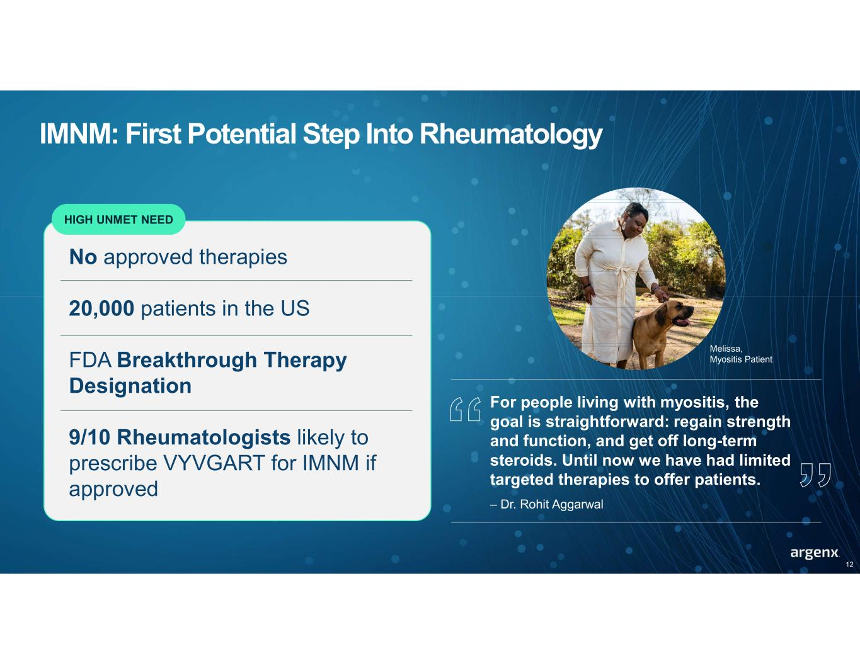
IMNM: First Potential Step Into Rheumatology HIGH UNMET NEED No approved therapies 20,000 patients in the US FDA Breakthrough Therapy Designation 9/10 Rheumatologists likely to prescribe VYVGART for IMNM if approved 12 For people living with myositis, the goal is straightforward: regain strength and function, and get off long-term steroids. Until now we have had limited targeted therapies to offer patients. – Dr. Rohit Aggarwal Melissa, Myositis Patient


We are on a Transforming the lives of patients with severe autoimmune disease through immunology innovation bold mission 13

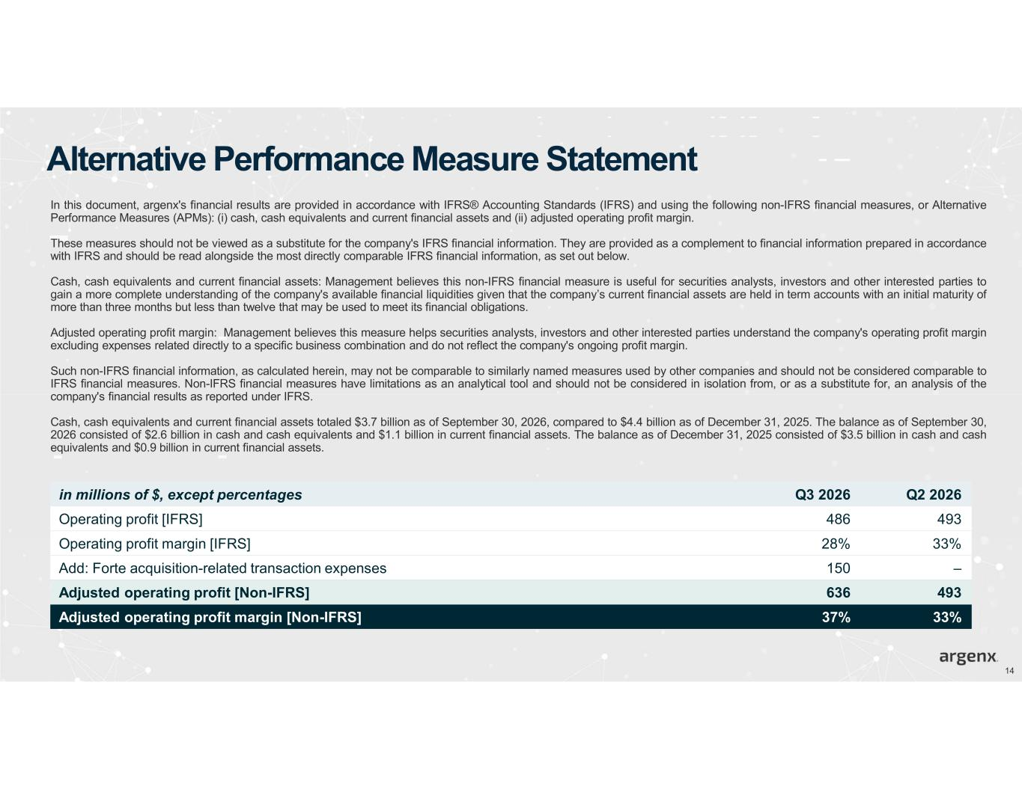
Alternative Performance Measure Statement In this document, argenx's financial results are provided in accordance with IFRS® Accounting Standards (IFRS) and using the following non-IFRS financial measures, or Alternative Performance Measures (APMs): (i) cash, cash equivalents and current financial assets and (ii) adjusted operating profit margin. These measures should not be viewed as a substitute for the company's IFRS financial information. They are provided as a complement to financial information prepared in accordance with IFRS and should be read alongside the most directly comparable IFRS financial information, as set out below. Cash, cash equivalents and current financial assets: Management believes this non-IFRS financial measure is useful for securities analysts, investors and other interested parties to gain a more complete understanding of the company's available financial liquidities given that the company’s current financial assets are held in term accounts with an initial maturity of more than three months but less than twelve that may be used to meet its financial obligations. Adjusted operating profit margin: Management believes this measure helps securities analysts, investors and other interested parties understand the company's operating profit margin excluding expenses related directly to a specific business combination and do not reflect the company's ongoing profit margin. Such non-IFRS financial information, as calculated herein, may not be comparable to similarly named measures used by other companies and should not be considered comparable to IFRS financial measures. Non-IFRS financial measures have limitations as an analytical tool and should not be considered in isolation from, or as a substitute for, an analysis of the company's financial results as reported under IFRS. Cash, cash equivalents and current financial assets totaled $3.7 billion as of September 30, 2026, compared to $4.4 billion as of December 31, 2025. The balance as of September 30, 2026 consisted of $2.6 billion in cash and cash equivalents and $1.1 billion in current financial assets. The balance as of December 31, 2025 consisted of $3.5 billion in cash and cash equivalents and $0.9 billion in current financial assets. 14 Q2 2026Q3 2026in millions of $, except percentages 493486Operating profit [IFRS] 33%28%Operating profit margin [IFRS] –150Add: Forte acquisition-related transaction expenses 493636Adjusted operating profit [Non-IFRS] 33%37%Adjusted operating profit margin [Non-IFRS]

